DATES

GROUP MEETING
NO GROUP MEETINGS UNTIL FURTHER NOTICE

FINANCES
Jane, our treasurer, reported that we raised £904.49 in 2019 and sent £865.42 to AIUK. Of this, £472 was for AIUK and £393.42 for AIUK Charitable Trust. £351.51 is carried over into 2020 and with the addition of £23.50 from the table top sale and a donation of £50 we now have £530.01 in our funds. We have agreed to send £300 to AIUK - under a scheme for match-funding this group donation should raise a further £300 for AIUK. The £175.67 raised in the January Tesco collection was sent to AIUK Charitable Trust.

INDIVIDUAL AT RISK – MADAGASCA

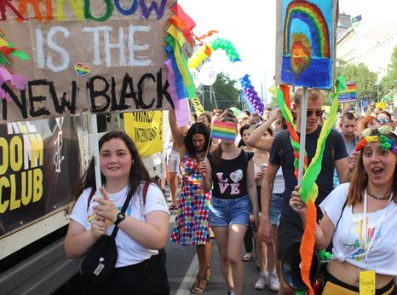
On 10 March, 33-year old Domoina was sent to pre-trial detention in Madagascar’s capital city’s prison, Antanimora. As exposed in Amnesty International’s 2018 report ‘Punished for Being Poor: Excessive, Unjustified and Prolonged Pre-trial Detention in Madagascar’, conditions of detention in Madagascar are inhumane, because of an excessive and prolonged use of pre-trial detention, which has in turn resulted in severe overcrowding across the country.
The charges brought against Domoina are that of ‘corruption of minors under 21 years old’, as she is accused of having a (consensual) relationship with her 19-year old girlfriend, Fyh. In Madagascar, the criminal code in its Article 331 punishes with up to five years imprisonment ‘anyone who has committed an indecent or unnatural act with a minor of their own sex, less than 21 years old’. Fyh and Domoina had decided to move in together, a decision which Fyh’s mother disapproved of, leading her to report Domoina to the police under this provision. In an interview with Amnesty International, Domoina’s girlfriend, Fyh, explained that she was raped by her father and grandfather, from the age 6 to 16, during which she had to undergo two abortions (also criminalized by Madagasy law). After meeting Domoina and sharing her problems with her, Fyh finally found the courage to sue her father, and this is when her relationship with her mother became strained, as her mother accused her of destroying the family unity. Fyh believes the lawsuit is driven by her mother seeking to take revenge by attacking her girlfriend. Because of the threat of COVID-19, Domoina was told that she can no longer receive visits from her lawyer or relatives, and that her trial, initially scheduled for 10 April, has been postponed to an undetermined date. As exposed by Amnesty International’s previous research, the government of Madagascar abusively uses pre-trial detention, constraining detainees to live in unhygienic and overcrowded conditions, and with the new threat of COVID-19, pre-trial detainees will have to wait for their trials for even longer periods, while risking falling sick.
Please send the attached letter if you are able.
RUSSIA - YULIA TSVETKOVA RELEASED FROM HOUSE ARREST

Russian women’s and LGBTI rights activist, Yulia Tsvetkova, was released from house arrest on 16 March.
While she remains under travel restrictions and continues to face criminal and administrative proceedings for her women and LGBTI rights work, this is a positive development.

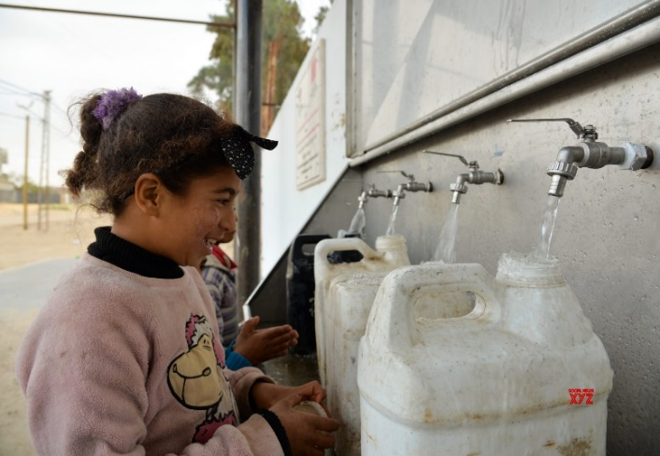
Yulia, an artist and activist from Komsomolsk-on-Amur, Russia’s Far East region, has been the target of an overtly homophobic campaign since March 2019. In reaction to her public campaigning for women’s and LGBTI rights, she has faced harassment and unfounded prosecution from authorities.

Yulia was placed under house arrest on 22 November 2019, after being charged with “production and dissemination of pornography”, a crime which carries a penalty of up to six years in prison, for creating body-positive drawings of the female body. Administrative proceedings have been also been launched against Yulia Tsvetkova, under the homophobic “gay propaganda” legislation, which expressly discriminates against LGBTI people and violates their right to freedom of expression.

PALESTINIANS BENEFIT FROM CHINA-FUNDED DESALINATION PLANTS

Two water desalination plants funded by the Chinese gov't opened this month in a poor Palestinian village in the Israeli-blockaded Gaza Strip, allowing the villagers instant access to free clean water.

Abdul-Rahim Abu Gouda, a Palestinian living in a small village in the Gaza Strip's southern border town of Rafah, breathed a sigh of relief after two China-funded water desalination plants opened this month in his impoverished al-Naser village.
"This is a joyful day for my family and we can now get drinking water instantly and for free. We no longer need to wait for trucks selling filtered drinking water," said Abu Gouda, a father of 12, as he observed his kids filling a small water container from the new plant in front of his home.

Palestinian are allowed 83 cubic meters per person per year. Israelis consume 333 each per year. Illegal Israeli settlers are allocated 1,450 each per year.
The recommended (WHO) minimum per capita consumption of water per day is 100 litres. The average Palestinian consumes 50, with some communities falling much below this.

