DATES

GROUP MEETING & AGM
Nora Street Community House, HOWLEY WA1 2JG
Thursday 20th Feb. @ 7.30pm
TABLE-TOP SALE @ PADGATE METHODIST
Sat.7th March 10am to 12 noon

Individual at Risk - ARGENTINA

Jorge Gonzalez Nieva - labour rights activist

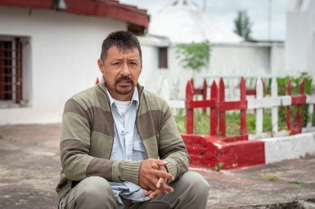
Jorge Gonzalez Nieva, a taxi driver, was going home after work in July 2006 when police arrested him and beat him and accused him of robbing a bank and of killing someone in the bank. But Jorge was not involved in those crimes. The police had forced someone at the crime scene to incriminate Jorge. There is recent evidence to prove that Jorge is innocent.
Jorge has been illegally held in pre-trial detention for 12 years. Argentina’s law sets a temporary limit for pre-trial detention at two years. The police officers who arrested him were later convicted of organising a cover-up, giving false testimony and attempted extortion.
In October 2019, after months of global campaigning on his behalf, Jorge was allowed to continue pre-trial detention in his own home in Argentina improving his detention conditions considerably but not freeing him.

National Conference
Saturday 20 - Sunday 21 June

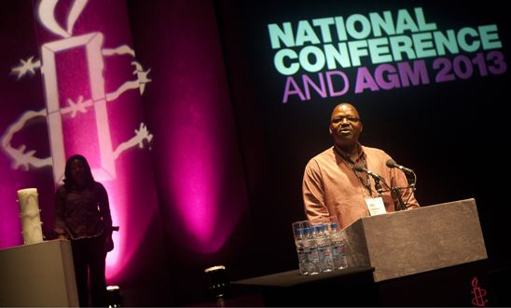

The National Conference and AGM is the biggest event in the Amnesty UK calendar.
Bringing together members from all across the UK, this is your opportunity to meet like-minded activists, share campaigning stories, and hear from incredible speakers. You can also vote and debate at our Annual General Meeting
We will be in the same location as 2019, so for those of you who missed coming to Nottingham in April 2019 you’ll get the chance to make up for it with a little more sunshine
Website bookings open at the end of January

Dawood al-Marhoon

Dawood al-Marhoon has spent six birthdays on death row in Saudi Arabia. The human rights crisis in Saudi Arabia is getting worse despite promises of reform. In 2019 a total of 184 executions in the Kingdom. That number includes the execution of 37 people on 23 April 2019, including at least three who were children at the time of their alleged offences. Dawood was just 17 when he was arrested for allegedly participating in an anti-government protest in Saudi Arabia. He refused to spy on protestors for the security forces. So, he was arrested, tortured and forced to sign a blank document - into which the authorities would later write Dawood’s ‘confession’.

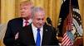

This is no plan for peace for the Palestinians. The plan seems more like permission for Israel to annex more of Palestinian territory. The Trump administration denied that permission had been given for an immediate annexation even though it had stated that "Israel does not have to wait at all" and "we will recognize it."
Immediately after the press conference announcing the plan Netanyahu declared that the Israeli government would immediately annex the Jordan Valley and West Bank settlements while committing not to create new settlements in areas left to the Palestinians for at least four years. The Likud spokesman tweeted that Israeli sovereignty over settlements would be declared on the following Sunday.
The Trump administration then declared that no decision would take place before new elections and a new government had been formed in Israel.
The statement that ‘no settlements will be built in ‘the areas left to the Palestinians for 4 years presupposes that Israel will then build more settlements on the land which under this peace settlement has been designated to the Palestinians.
The British government welcomed the publication of the peace plan but so far has not endorsed the contents.
The creation of the State of Israel under the Balfour Declaration gave away land which before 1947 belonged to Palestine.
The UK needs to send a clear message that any future negotiations must be rooted in international law and respect for the rights of all. The Trump plan fails on both counts.

The Palestinians are right to reject this plan outright. Rejecting the Trump Peace Plan in spite of our desire to make more trade deals with Israel could be a test of UK integrity.

Oppositin to the Trump plan
A cross party group of 133 MPs co-signed a letter to Boris Johnson, slamming the contents of the Trump plan.
“That so many MPs and peers from across the house have so rapidly signed this letter demonstrates the real depth of concern felt in Westminster about this reckless plan and the agenda of annexation it promotes,”

US Opposition to plan - Democratic members of the House
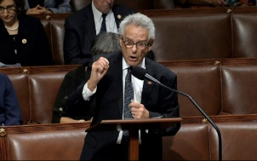
Two Jewish lawmakers spearheaded a letter to US President Donald Trump signed by 107 Democratic members of the House expressing “strong disapproval” of his Israeli-Palestinian peace plan.
“Our concern is both with the substance of your plan, which will exacerbate and entrench conflict rather than resolve it, and with the timing of its release,” said the letter, initiated by Andy Levin of Michigan and Alan Lowenthal of California. Another seven Jewish Democrats also signed.
Palestinian Protests
Clashes broke out at the West Bank’s contact points with the Israeli occupation forces after massive marches roamed the streets of the cities of Ramallah and Al-Bireh, Hebron, Jerusalem and Bethlehem, in protest against the announcement. The Israeli occupation forces fired “rubber bullets” and tear gas canisters towards the youths who set tires on the road leading to the military checkpoint located at the entrance, wounding a young man in the face, according to the Palestinian Red Crescent Society.

