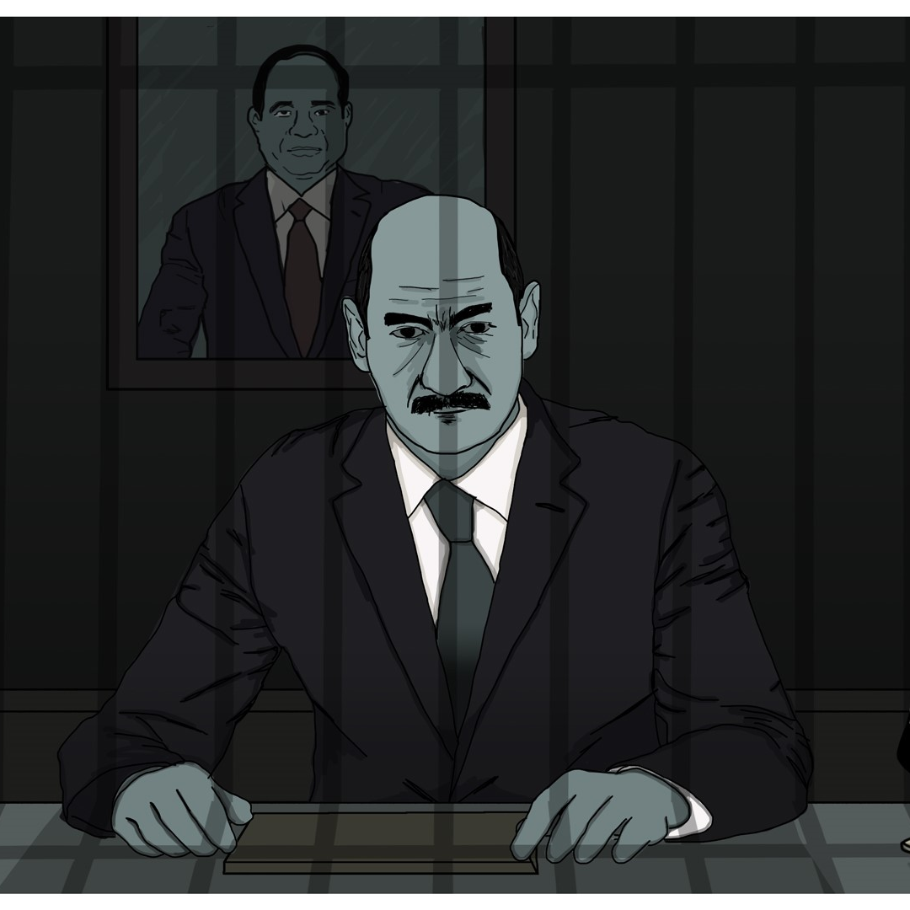
Permanent State of Exception
Abuses by the Supreme State Security Prosecution

Amnesty International is a global movement of more
than 7 million people who campaign for a world
where human rights are enjoyed by all.
Our vision is for every person to enjoy all the rights
enshrined in the Universal Declaration of Human Rights
and other international human rights standards.
We are independent of any government, political
ideology, economic interest or religion and are funded
mainly by our membership and public donations.

contents

Glossary 5
Executive summary 7
Methodology 11
Background 13
Supreme State Security Prosecution 16
Jurisdiction 16
History 17
Violations of fair trial guarantees 20
Arbitrary detention 21
Denial of effective legal representation 28
Coercive questioning 32
Prolonged pre-trial detention 34
Denial of right to challenge detention 39
Complicity in police violations 42
Enforced disappearances 42
Torture 46
Hostile environment for lawyers 49
Arrests and detention 49
Threats and harassment 52
Conclusion and recommendations 55
Conclusion 55
Recommendations 56
To the President 56
To the Public Prosecutor 56
To the Parliament 57
To the National Human Rights Council 58
To the international community 58

Glossary
word | Description
Code of Criminal Procedures | Law no. 150/1950 regulating judicial proceedings.
First Public Defender | The head of the Supreme State Security Prosecution, who reports to the Public Prosecutor
Forensic Medical Authority | The department of the Ministry of Justice responsible for conducting autopsies and medical examinations of suspects and plaintiffs in judicial cases, including ones in which there are allegations of sexual violence.
Guidelines to the Public Prosecution | Set of guidelines issued by the Public Prosecutor on how prosecutors should conduct investigations and prosecutions.
Ministry of Interior | The ministry tasked with law enforcement in Egypt.
National Council for Human Rights (NCHR) | Egypt’s national human rights institution, responsible for promoting human rights in the country. Its members are chosen by the parliament and approved by the President.
National Security Agency (NSA) | A specialized police agency operating under the Egyptian Ministry of Interior tasked with maintaining national security and co-operating with other bodies to fight terrorism.
Public Prosecution | The branch of the judiciary responsible for investigating criminal complaints, filing charges when it considers that the evidence justifies a trial and prosecuting cases in court.
Public Prosecutor | The head of the Public Prosecution and therefore Egypt’s top prosecutor. Following constitutional amendments in 2019, the role is appointed by the President and serves for a maximum of four years.
Supreme Judicial Council | The governing body responsible for the administrative affairs of the judiciary.
Supreme State Security Prosecution (SSSP) | A special branch of the Public Prosecution responsible for prosecuting crimes that relate to “state security”.

Executive summary
“The hand of prompt justice is shackled by laws.”
President Abdelfattah al-Sisi at the funeral of former Public Prosecutor Hisham Barakat, assassinated in June 2015
The Supreme State Security Prosecution (SSSP), a special branch of the Public Prosecution responsible for prosecuting crimes that relate to “state security”, has an expanding role in Egypt’s justice system. The authorities justify this as a response to violent attacks by armed groups in the country. However, Amnesty International’s research demonstrates how it functions as a tool of repression by misusing recently enacted counter-terrorism legislation to detain individuals for acts that should not even be criminalized, such as peacefully expressing critical views of the authorities, engaging in human rights work or waving a rainbow flag.
The growing role of the SSSP, along with the related use of a special police force, the National Security Agency (NSA), and special courts, also points to the emergence of what can be described as a parallel justice system. This comes in a context where a state of emergency is renewed continuously by President Abdelfattah al-Sisi. Since he took over power in 2013, the human rights situation in Egypt has deteriorated. The authorities have arbitrarily detained thousands, prosecuted hundreds in unfair trials, leading in many cases to death sentences, repressed protests and clamped down on civil society.
To investigate the role of the SSSP, Amnesty International documented through interviews and, in some cases, official records the experiences of 138 individuals investigated by the SSSP in 54 judicial cases between 2013 and 2019. It conducted over a hundred interviews, mainly with lawyers and former detainees. Most were conducted remotely for security reasons; some were conducted in person in Istanbul in April and May 2019. It examined official documents, including court decisions, police investigations and medical records, relating to five of the 54 judicial cases which had already been referred to trial. In addition, it drew on government statements, newspaper articles, videos of protests, and reports by NGOs and UN agencies. Amnesty International communicated its findings to the Egyptian authorities on 12 November 2019, but had not received a response by the time of publication.
Supreme State Security Prosecution
Established in 1953, the Supreme State Security Prosecution (SSSP) is responsible for investigating and prosecuting a wide range of activities that could constitute threats to “state security”. Unusually, its prosecutors have powers that are usually reserved for judges when it comes to detaining suspects. The SSSP works in tandem with the NSA, a specialized police agency which conducts investigations, either initiating them itself or following SSSP instructions. Over the past two decades, the percentage of prosecutors who were educated at the Police Academy or who had previously served in the Ministry of Interior, including at the NSA, has grown significantly. Several prosecutors at the SSSP are former NSA officers; others are relatives of President al-Sisi and other top government officials. Since 2013, the numbers of those detained by the SSSP pending investigation has increased markedly.
Violations of fair trial guarantees
Amnesty International found that the SSSP is responsible, on a significant scale, for arbitrary detention on the basis of the misuse of vague national security legislations. Although most individuals whose cases it documented were detained pending investigation for “membership in” or “aiding” “terrorist” or “banned groups”, the actual reason for their detention seemed to be their peaceful participation in protests, public statements they had made, such as posts on social media criticizing the President, or their political or human rights activities or backgrounds. Prosecutors based accusations against suspects mainly on NSA investigations case files, according to interviewees, even though Egypt’s highest court has ruled that, on their own, they do not constitute “evidence”.
Policemen arrested Zyad el-Elaimy, a human rights lawyer and leading member of the Egyptian Social Democratic Party, Hisham Fouad, a journalist and member of the Revolutionary Socialists group, and Hossam Moanes, a journalist and spokesperson for the al-Karama party, on 25 June 2019 in Cairo. Eight other men and three women were arrested on different dates. The Ministry of Interior announced that it had uncovered “a joint plot between the Muslim Brotherhood’s exiled leadership and the civil opposition [in Egypt] to target the state and its institutions in order to oust it”. All 14 individuals were placed in pre-trial detention pending investigations relating to a string of accusations that included “membership of terrorist groups”, “aiding terrorist groups” and “publishing false information”. According to lawyers, the SSSP questioned the suspects based on NSA investigation case files that they were not allowed to examine, asking them about their political opinions and activities, and relationship to political parties, politicians and labour movements. They were presented with no evidence that they had undertaken any activity constituting a recognizable crime under international law. The case later grew to include at least 105 individuals from across the political spectrum. Among them is Egyptian-Palestinian Ramy Shaath, who was arrested by police from his home in Cairo on 5 July 2019 and detained in relation to his legitimate political activities with Egyptian political parties and as co-ordinator of the Boycott, Divestment and Sanctions (BDS) movement in Egypt. Amnesty International considers Zyad, Hisham, Hossam and Ramy to be prisoners of conscience.
Amnesty International’s research showed that suspects are being systematically denied the right to effective legal representation. In 42 of the 138 cases documented by Amnesty International, including those of four boys, interviewees reported that SSSP prosecutors questioned them without lawyers and did not ask them if they wanted to call one. In the case of three suspects, the SSSP assigned lawyers who were not of the accused’s own choosing and did not provide effective representation. In all documented cases, detainees were not allowed to consult with their lawyers in private ahead of questioning or examine NSA investigation case files.
An analysis of documented cases revealed that suspects are never informed of their rights by either the police or the SSSP. Further, 60 victims said they were subjected to coercive methods at the SSSP, including by being blindfolded until reaching a prosecutor, subjected to verbal insults and derogatory comments that amounted to ill-treatment and threatened with being returned to the NSA, which is notorious for torturing detainees and interrogating them afterwards.
Amnesty International found that SSSP prosecutors systematically order suspects to be detained after questioning and repeatedly renew their detention every 15 days up to the maximum period available to them, 150 days. They then keep suspects in detention through requests to judges to renew it. The SSSP has the power to release them at any time, but invariably chooses not to do so. In the cases documented for this report, as of 5 November 2019, 43 detainees had been released without ever being referred to trial following an average of 345 days in pre-trial detention; one was held for 1,263 days. A total of 89 individuals remained detained pending investigation in SSSP cases having spent on average 332 days in pre-trial detention.
Defence lawyers told Amnesty International that release orders issued by judges are implemented only following an “NSA approval”. In the cases examined, release orders were implemented after an average of 11 days – in one case after 35 days – following the court’s decision. When the NSA does not give this “approval”, the detainee may find themselves added as a suspect to a new or existing SSSP case or even subjected to enforced disappearance. In at least five of the 138 cases documented by Amnesty International, detainees who were the subject of court orders to release them were not in fact released but detained on new, unfounded accusations. Three other individuals, instead of being released following court orders, were subjected to enforced disappearance.
The SSSP limits judicial review and oversight of detention orders. Amnesty International found that it regularly prevented defendants from appealing against detention orders, in violation of their rights under Egyptian and international law. Lawyers said they never received a written explanation for a refusal, although on occasion SSSP clerks cited “security concerns” as a reason. Some requests were never responded to at all. Between December 2018 and September 2019, the SSSP did not accept a single request to make appeals against detention orders by the SSSP or by judges. Since September 2019, lawyers have been able to appeal in some cases against decisions by judges, but not those by the SSSP.
Complicity in police violations
Amnesty International found that SSSP prosecutors were complicit in enforced disappearance and torture and other ill-treatment by systematically neglecting to investigate allegations of such practices by Egyptian police, particularly the NSA, and admitting confessions extracted under torture as evidence in trials. In some cases, such evidence led to defendants being sentenced to death and executed.
Information gathered by Amnesty International indicated that, of the 138 cases it documented, 112 individuals were subjected to enforced disappearance by the police, mostly the NSA. They said they were detained for periods of up to 183 days. During their time in detention, their families or lawyers inquired at police stations about their whereabouts but were told they were not in custody. No news emerged of their fate until they appeared in the SSSP building.
Amnesty International found that SSSP prosecutors systematically failed to address the falsification of arrest dates by the police, particularly the NSA. In 87 of the 112 cases, lawyers said that the arrest date prosecutors said the NSA had recorded corresponded to the day immediately prior to the SSSP questioning, even though telegrams sent by family members documenting the dates of arrest and examined by Amnesty International, interviews with suspects, family members, lawyers and witnesses indicated that detainees were detained before then. When lawyers and detainees challenged the NSA’s recorded arrest date, prosecutors took no action to investigate allegations that the date of arrest had been falsified, as far as they were aware.
The lack of investigations into allegations of enforced disappearances is evident in official documents as well. According to the files of five judicial cases seen by Amnesty International, 339 of the 381 defendants who were in custody told prosecutors that they were subjected to enforced disappearances, but prosecutors took no action to investigate NSA officers for these allegations.
Hoda Abdelmoniem, a 60-year-old human rights defender, was arrested on 1 November 2018. She was detained for 20 days in an NSA building in Greater Cairo. During that time, her family and lawyers inquired about her whereabouts at several police stations in Greater Cairo; at each one they were told she was not in custody. The SSSP prosecutor reportedly dismissed the concern by saying that her right to contact them had been suspended under the counter-terrorism law. According to her family, the SSSP is detaining Hoda pending investigations for “membership in a terrorist group”, although they have not presented evidence against her. Instead the claim is based on an NSA investigation file, which neither Hoda nor her lawyers have been allowed to examine. Hoda is a former member of Egypt’s national human rights institution. Amnesty International believes that Hoda’s human rights work is the real reason behind her arrest and considers her a prisoner of conscience.
Information gathered by Amnesty International indicated that 46 of the 138 individuals whose cases it documented were subjected to torture or other ill-treatment in police custody, particularly in NSA detention. The most common methods of torture reported were the application of electricity to parts of the body, beating and suspension by the limbs. In three cases, victims reported that male doctors forced them to undergo forced anal tests or a sex determination test. In three other cases, detainees said that NSA officers had threatened them with rape. In only one case did the SSSP refer a detainee alleging torture to the Forensic Medical Authority. Further, to Amnesty International’s knowledge, SSSP prosecutors have not investigated a single police officer for such abuse.
Hostile environment for lawyers
Lawyers representing individuals prosecuted by the SSSP work in a hostile work environment, which undermines detainees’ right to an effective defence. Of the 29 lawyers Amnesty International interviewed, 17 reported that they had decided to stop working on SSSP cases because they feared arrest and prosecution, threats and harassment.
Among the 138 cases that Amnesty International documented, 17 lawyers – 14 men and three women – have been arrested and prosecuted by the SSSP since September 2017. In at least nine cases, their prosecution appears to be in response to their work representing clients before the SSSP. The remaining eight were prosecuted because of their legitimate political activities.
On 22 September 2019, plain-clothes policemen arrested human rights lawyer Mahienour el-Masry. She had been representing another human rights lawyer before the SSSP. The next day, an SSSP prosecutor questioned Mahienour on her work and ordered her detention pending investigation in connection with a protest that took place in March 2019. She was accused of “aiding a banned group in achieving its goals”. One week later, Mohamed el-Baqer, another human rights lawyer, was arrested as he was going to represent a fellow human rights defender and was told that he had been accused in the same case. The prosecutor questioned him about his work providing legal representation to detainees in SSSP cases and ordered his detention pending investigation for “membership in a banned group”, “disseminating false information” and “funding a terrorist group”. Neither lawyer has been able to examine the NSA investigation case files on them. Amnesty International considers them both to be prisoners of conscience.
Thirteen lawyers with whom Amnesty International spoke said they had been threatened or harassed during their work representing clients in front of the SSSP, either by prosecutors or by police officers operating there. Some reported being threatened by policemen at the SSSP with prosecution in SSSP cases because they were insisting on providing effective legal representation. Three female lawyers said they experienced demeaning comments, some with sexual connotations, by prosecutors, such as on their appearance and choice of clothes.
Recommendations
Egypt’s Public Prosecutor should ensure that individuals being investigated by the SSSP are afforded fair trial guarantees. They must be able to meet with lawyers of their choice ahead of interrogations; have access to NSA investigation case files and any other documents relating to their case; and be able to challenge the lawfulness of their detention at all times before an ordinary judge. The Public Prosecutor should also ensure that lawyers are protected from threats and reprisals and that all lawyers detained solely for carrying out their work are released.
At the same time, the Public Prosecutor should open an independent commission of inquiry into the role of the SSSP in arbitrary detention, violations of fair trial guarantees and complicity in enforced disappearances and torture. The “assumption of judicial powers” by SSSP prosecutors should be ended and any pre-trial detention decisions should be taken by a judge. Allegations of violations by officials, including NSA officers, should be independently investigated and those responsible held accountable in the context of a fair trial. All those detained for peacefully expressing their opinions or for carrying out human rights or journalistic work should be immediately and unconditionally released; other detainees should be brought to trial promptly before a fair and impartial tribunal, or released.
Egypt’s President should institute a system of independent national monitoring of all places of detention, including those run by the NSA. He should also ensure that accurate figures are published on the number of detainees in Egypt.

Methodology
This report is based on research that Amnesty International conducted between April and October 2019, complemented by its documentation over years of monitoring the human rights situation in Egypt.
In total, Amnesty International documented through interviews and, in some cases, official records the experiences of 138 individuals – 83 men, 50 women, four boys and one girl – investigated by the Supreme State Security Prosecution (SSSP) in 54 separate judicial cases between December 2013 and October 2019 that involved several thousand accused. It selected the 138 based on the availability and willingness of the individuals and their lawyers to speak to the organization. This report provides detailed information about 19 of those individuals, whose cases reflect diversity in age, gender and the nature of the violations.
Amnesty International conducted interviews with 104 individuals across seven countries. It interviewed 47 former detainees – 32 men and 15 women – among the 138 individuals who had been investigated by the SSSP. Two of the 32 men were children at the time of their interrogation. Some of the former detainees were living in Egypt when interviewed; others had left the country following their detention and were residing in Canada, Turkey, the UK and the USA, as well as other countries that are not named for security reasons. Amnesty International also interviewed 29 lawyers – 19 men and 10 women – who have represented one or more of the 138 individuals brought before the SSSP, with regard to the experiences of both their clients and themselves. The lawyers interviewed represented all but 17 of the 138 individuals. In addition, the organization interviewed family members and close friends of 28 of the 138 individuals brought before the SSSP – 17 men, nine women, one boy and one girl – who were detained pending the result of SSSP investigations.
To interview victims and witnesses residing in Turkey, Amnesty International conducted a field mission there in April and May 2019. It interviewed individuals residing in Egypt and other countries mentioned above via secure applications for messaging, voice and video calls. Interviewees came from different socioeconomic backgrounds and geographic regions and were aged between 12 and 80 years old. All interviews were conducted in Arabic with no interpretation required.
Due to security concerns, given the well-documented reprisals by the Egyptian authorities against human rights defenders, lawyers, journalists and individuals who speak out against human rights violations, including some instances reflected in this report, Amnesty International has gone to great length to protect the identities of individuals believed to be at risk. This includes omitting the name, age, gender and, in some cases, other details such as place of residence and profession that could help identify the interviewee. Where such information is omitted, and a pseudonym is used, Amnesty International has specified this in a footnote. For the same reasons, as well as out of concern for the security of its staff, Amnesty International did not seek access to Egypt to conduct investigations on the ground.
The seriousness of these security concerns has been illustrated by the Egyptian authorities’ failure to respect their own guarantees to protect individuals who co-operate with human rights organizations or UN human rights mechanisms. On 4 December 2018, Leilani Farha, the Special Rapporteur on the right to adequate housing as a component of the right to an adequate standard of living publicly stated that Egypt had failed to adhere to the assurances provided to her “that no person would be harassed, intimidated or subjected to reprisal for meeting or providing information to [her] or [her] delegation in the context of [her fact-finding] visit.” Given such security concerns, many individuals prosecuted by the SSSP and their legal representatives were understandably unwilling to talk to Amnesty International.
In addition, Amnesty International examined official documents, including court decisions, referral orders, police investigations and official medical records, relating to five of the 54 judicial cases it documented; these were cases that had already been referred to trial. These cases involved a total of 715 individuals, 381 of them in custody at the time of their trials, who were investigated by the SSSP between 2016 and 2019 and subsequently indicted. Three of the 138 individual cases Amnesty International documented belonged to these five judicial cases. The case files were obtained and analysed by the Egyptian Front for Human Rights, which then shared them with Amnesty International. For the purpose of this report, Amnesty International only analysed the role of the SSSP up to the referral of the cases to trial.
Amnesty International was unable to examine such documents for the other 49 judicial cases as these had not been referred to trial yet and the SSSP does not allow lawyers or defendants to acquire copies of official documents relating to ongoing investigations. For these cases, Amnesty International was limited to statements issued by the Public Prosecutor, sometimes in comments to media, for an understanding of the position of the prosecution.
The report also draws on a wide range of official documents and statements published on the official websites and social media accounts of government bodies, other social media content, newspaper articles, public and private videos of protests, and reports by Egyptian and international NGOs, as well as UN agencies. The report builds on findings and recommendations made by the UN Special Rapporteur on torture and other cruel, inhuman or degrading treatment or punishment, the UN Special Rapporteur on the promotion and protection of human rights and fundamental freedoms while countering terrorism, the UN Special Rapporteur on extrajudicial, summary or arbitrary executions, the UN Working Group on Arbitrary Detention, the UN Working Group on Enforced or Involuntary Disappearances and the UN Committee against Torture. Amnesty International also analysed Egypt’s obligations under the Egyptian constitution, Egyptian laws and decrees, as recorded in the official gazette, and international treaties and standards.
Amnesty International wrote to the offices of the Egyptian President, Public Prosecutor, Deputy Assistant Minister of Foreign Affairs for Human Rights and President of the National Council for Human Rights on 12 November 2019, enclosing a memorandum with its findings. It requested comments on the concerns and cases presented. No response had been received by the time of publication.
The research conducted for this report would not have been possible without the support and co-operation of many Egyptian human rights defenders and lawyers whose names and the exact nature of the assistance they provided are omitted for security concerns. Amnesty International is very grateful for their help and wishes to extend its gratitude to all victims and witnesses who agreed to share their experiences.

Background
“Beware! What happened seven, eight years ago will not happen again.”
President Abdelfattah al-Sisi speaking about the 25 January 2011 uprising
On 3 July 2013, the Egyptian military under the leadership of then Colonel General Abdelfattah al-Sisi ousted President Mohamed Morsi, following mass protests against his rule. The military suspended the 2012 Constitution and installed the head of the Supreme Constitutional Court, Adly Mansour, as interim President. The authorities then commenced a crackdown unprecedented in recent Egyptian history against supporters of Mohamed Morsi and political opponents and critics of the new government. In one day, security forces killed at least 900 people protesting the army’s ousting of Mohamed Morsi, when they forcibly dispersed two major sit-ins in Rabaa al-Adawiya and al-Nahda squares in Greater Cairo. Not a single Egyptian official has been held accountable for these killings to date. Months later, in December 2013, the government declared the Muslim Brotherhood a “terrorist group”, and hundreds of its members and leaders, as well as real and perceived supporters, were rounded up and detained. Former President Morsi was himself arrested and subjected to enforced disappearance, after which he was detained in solitary confinement until he died during a court hearing nearly six years later.
In January 2014 Egypt adopted a new constitution, approved by 98.13% of voters in a referendum. Although the new constitution addressed some of the 2012 Constitution’s shortcomings, it still fell short of meeting Egypt’s international human rights obligations. In May 2014, Abdelfattah al-Sisi, who by then had been promoted to the rank of field marshal, won 96.1% of votes in presidential elections and was officially sworn in as President on 8 June that same year. He ruled by decree until the election of a new parliament in December 2015 and passed, during this time, some of the most restrictive laws of his presidency. The authorities clamped down on freedoms, imposed mass death sentences following unfair trials and resumed executions after a hiatus since 2011.
In parallel, Egypt saw a rise of violent attacks by armed groups, which claimed the lives of at least 2,918 individuals between July 2013 and September 2019. The attacks have been concentrated in North Sinai and have mostly been directed at members of the police, military and judiciary, as well as other state officials, although religious minorities and foreign nationals have also been targeted. In two particularly shocking incidents, militants from the Sinai Province armed group killed at least 305 worshippers in a mosque in northern Sinai in November 2017, and all 224 passengers on board a Russian aeroplane after they placed a bomb in it in October 2015. Egyptian Christians have also been targeted by militants in a series of church bombings and attacks that have forced them out of their homes in Sinai. In June 2015, Hisham Barakat, the former Public Prosecutor, was killed by a car bomb.
Since then, the human rights situation has deteriorated further as the authorities have arbitrarily detained thousands, prosecuted hundreds in unfair trials, leading in many cases to death sentences, repressed protests and clamped down on civil society. At the same time, the authorities have passed repressive legislation, including Law no. 94/2015 on counter-terrorism (the counter-terrorism law). In April 2017, President al-Sisi declared a state of emergency and has renewed it continuously ever since. The crackdown on peaceful opponents spiked ahead of the March 2018 presidential elections, which President al-Sisi won with 97.08% of votes, as security forces detained hundreds in a wave of arbitrary arrests and imposed severe restrictions on the rights to free expression, association and political participation.
In April 2019, parliament approved constitutional amendments that undermined the independence of the judiciary, expanded the role of military courts in prosecuting civilians and shielded security forces from accountability. They also allow President al-Sisi to stay in power until 2030, by changing the length of the presidential term from four to six years and allowing him to run for another term. The amendments were approved in a public referendum with 88.3% of votes, according to the Egyptian National Elections Commission, amid a continued crackdown on freedom of expression and assembly, severe restrictions on access to information on the counting process. In September 2019, rare mass protests against President al-Sisi took place across several parts of Egypt, following allegations by a former army contractor regarding corruption by the President and the military. The authorities met the protests with force and thousands of arrests, the largest such wave since President al-Sisi began his tenure in 2014.
Some of those who have been subjected to arbitrary detention have been victims of enforced disappearance by the National Security Agency (NSA), a specialized police agency operating under the Egyptian Ministry of Interior tasked with maintaining national security and co-operating with other bodies to fight “terrorism”, for periods of up to seven months. During this time, individuals are held in an undisclosed location without official acknowledgement of their detention or whereabouts, in violation of Egyptian law. Although the exact scale of enforced disappearances is unknown, Amnesty International has documented its widespread use against hundreds of perceived members of the Muslim Brotherhood, as well as protesters, perceived peaceful critics and their family members.
The use of enforced disappearances by the NSA appears to be systematic and on the rise since March 2015. Amnesty International’s research, as well as that by Egyptian NGOs, has documented consistent allegations by victims from different political, social and economic backgrounds, and residing in different geographic areas. In 2018, the UN Working Group on Involuntary or Enforced Disappearances noted that, “notwithstanding repeated calls to address what appears to be a systemic problem relating to short-term enforced disappearances, the situation does not seem to have improved”.
Although torture is criminalized in both international law and Egyptian law, where it is punishable by up to 10 years in prison, it is being used systematically by security forces against perceived opponents. In 2017, the UN Committee against Torture concluded, based on its examination of reports of torture in Egypt received since 2012, that “torture is a systematic practice in Egypt”, taking place in prisons and police stations. Amnesty International has documented routine torture in official and unofficial places of detention against men, women and children by the police including the NSA. Egyptian NGOs have also reported on torture in Egypt. Methods of torture reported include electric shocks, suspension, beating and sexual assault.
The crackdown has forced many Egyptian activists and critics of different political persuasions to leave Egypt out of fear of persecution, some due to court verdicts against them. Many have sought asylum abroad.

Supreme State Security Prosecution
“The Supreme State Security Prosecution [SSSP] relies on fear. Suspects are usually transferred to the SSSP after being subjected to torture or enforced disappearance and are then coerced into incriminating themselves, before they are able to speak to lawyers.”
A lawyer who has represented individuals before the SSSP

Jurisdiction
Established as a special branch of the Public Prosecution, the branch of the judiciary responsible for investigating criminal complaints, filing charges when it considers that the evidence justifies a trial and prosecuting cases in court, the Supreme State Security Prosecution (SSSP) is responsible for investigating and prosecuting a wide range of activities that could constitute threats to “state security”. These cover crimes that relate to internal and external security, explosives, assembly and strikes. They also cover crimes over which Emergency State Security Courts, special courts that are only active during a state of emergency, have jurisdiction. As defined by a 2019 decree, these include crimes related to “terrorism”, protest, assembly, strikes and places of worship.
Geographically, the SSSP has sole jurisdiction over these crimes in Greater Cairo and is required to investigate and prosecute cases related to its jurisdiction in that area. Other prosecutors can investigate such cases outside Greater Cairo, and assume SSSP powers to do so, but are required to inform the SSSP of developments in them. The SSSP can then decide to take over these cases and must decide on whether to refer them to trial or not. The SSSP has a single location, in New Cairo, one of a number of new cities in the Greater Cairo area and 27km away from downtown Cairo.
SSSP prosecutors, unlike those of other specialized branches of the Public Prosecution, have powers that are usually reserved for judges when it comes to detaining suspects.
Under the Code of Criminal Procedures, prosecutors have the power to investigate crimes and can issue binding judicial decisions such as arrest warrants, summons for questioning, and search and seizure warrants. They can also order the pre-trial detention of individuals without a judge’s decision for up to four days, before referring the individual to a judge to rule on the renewal of their detention.
The Code of Criminal Procedures and the 2015 counter-terrorism law allow prosecutors with the rank of Prosecution Director to assume the power of judges to order suspects in cases related to state security crimes to be held in pre-trial detention for up to 150 days. They can also order the monitoring of conversations, the examination of financial records, the closure of buildings and the censorship of websites when conducting investigations in “terrorism” cases, powers normally residing with judges. As the SSSP has primary jurisdiction over these crimes, it is the prosecution body that most often assumes these powers.
The SSSP works in tandem with the NSA. The NSA conducts investigations, either initiating them itself based on information available to it or following SSSP instructions. The results of these investigations are usually then submitted to the SSSP. A prosecutor determines whether to instruct the NSA to summon the suspect or arrest them. In cases of arrest, the prosecutor issues an arrest warrant and the NSA must bring the suspect before the SSSP within 24 hours. The SSSP can then decide to order the individual’s pre-trial detention pending investigation, to release them on probation or bail pending investigation, or to drop the case and release them unconditionally.
In case of indictment, defendants are referred to one of three categories of special courts: Emergency State Security Courts, terrorism circuits or military courts – all of whose proceedings fail to meet the threshold of fair trial standards.
The SSSP is headed by a role known as the First Public Defender, who reports to the Public Prosecutor, the head of the Public Prosecution. The current post holder is Khaled Diaa el-Din, who was appointed in September 2016.
Recruitment to the SSSP lacks transparency. Nominally, appointments to the SSSP, and to the Public Prosecution more broadly, are governed by the Supreme Judicial Council, the body responsible for the administrative affairs of the judiciary, which does not explain the grounds for appointment. Over the past two decades, the percentage of prosecutors who were educated at the Police Academy or who had previously served in the Ministry of Interior, including at the NSA, has grown significantly. Several prosecutors at the SSSP are former NSA officers; others are relatives of President al-Sisi and other top government officials.
Although Egyptian law does not preclude women from joining the Public Prosecution, as of August 2019 there was not a single woman serving as a prosecutor in the SSSP, or the Public Prosecution more generally, despite some extremely limited appointments of women to other judicial bodies.

History
On 8 March 1953, months after the military took power in Egypt in July 1952, the Minister of Justice issued an executive decision to establish the State Security Prosecution as a special judicial body under the Public Prosecution. Its early activities focused on prosecuting workers, students and journalists in an effort to repress strikes, protests and political opposition in the media at a time when the military was still consolidating its power. Under President Gamal Abdel Nasser, it targeted his political opponents, especially the Muslim Brotherhood and communists. President Anwar el-Sadat renamed it the SSSP in 1970 and used it to prosecute initially Nasser-era officials and later students, workers and leftists who opposed his economic liberalization policies and moves to secure peace with Israel, as well as members of the newly reinstituted political parties in Egypt.
Under President Hosni Mubarak, the SSSP handled mostly cases of militant attacks and individuals accused of membership in militant groups, including the “Victorious Sect” case in 2006 and the “Zeitoun cell” case in 2010. It also prosecuted several cases related to freedom of religion, sectarian violence and sexual orientation, including the “Queen Boat” case in 2001. The SSSP played a similar role between the removal of Hosni Mubarak as President following the 25 January 2011 Revolution and the ousting of former President Morsi in July 2013.
In June 2013, the Supreme Constitutional Court, which has exclusive jurisdiction to decide issues regarding the constitutionality of laws, repealed Article 3(1) of Egypt’s state of emergency law, which had allowed the authorities to detain individuals suspected of endangering security or public order without complying with the Code of Criminal Procedures. The provision had an enormous impact on Egyptians from all walks of life, facilitating the indefinite administrative detention without charge or trial of tens of thousands of people, including political opponents and government critics, on the basis of secret investigations; some were held for up to 20 years without any means to defend themselves. The Supreme Constitutional Court's ruling stated:
“Article 3(1)… on the authorization to arrest and detain individuals and to search them and places without a reasoned judicial order has disregarded citizens’ personal rights and infringed the sanctity of their homes, which amounts to a violation of the principle of the rule of law…”
Since then, the number of those detained by the SSSP pending investigation has increased markedly. Although the authorities do not officially report the number of cases or individuals being prosecuted by the SSSP, the Egyptian media regularly obtains statistics from SSSP officials on an informal basis and reports on them. A comparison between the number of SSSP cases reported as starting each year reveals an approximately threefold increase in the number of cases prosecuted by the SSSP each year between 2013 and 2018. In 2013, the latest case number for the SSSP that was reported by media was 529, indicating that it was the 529th case to have been initiated by the SSSP that year. In 2018, the latest available case number was 1,739. As of 30 October 2019, the latest available SSSP case number was already 1,470. Each case often contains multiple individuals. In one case, the SSSP is investigating at least 3,715 individuals in relation to protests.
Figure 1: Number of investigations by the SSSP between 2013 and 2018
Publicly available data on the number of SSSP cases reported as starting each year.

Violations of fair trial guarantees
“The SSSP has absolutely no respect for fair trials. It is as if they read the first chapter of Amnesty International’s Fair Trial Manual and decided to do the exact opposite.”
A human rights lawyer who has represented individuals brought before the SSSP
Amnesty International documented the experiences of 138 people – 83 men, 50 women, four boys and one girl – investigated by the SSSP in 54 separate judicial cases between 2013 and 2019. Based on interviews with those accused and their lawyers, as well as family members and close friends, in these cases, as well as official documents in some cases, Amnesty International found that the SSSP systematically used prolonged pre-trial detention based on arbitrary accusations, sometimes circumventing the absolute time limit set by Egyptian law on pre-trial detention, subjected them to coercive questioning techniques and denied them the rights to effective legal representation and to judicial review.
The 54 judicial cases involved several thousand accused (the total number is not possible to ascertain because the SSSP does not allow lawyers to examine case files of ongoing investigations). Only five of these cases had been referred to trial; the rest are all ongoing investigations. These involved a total of 715 defendants, 381 of them in custody at the time of their trials. Four of the judicial cases comprised individuals charged with murder or attempt to murder government officials; the fifth case comprised individuals charged with possession of arms and destruction of property. Three cases were referred to military courts and two to terrorism circuits. Three of the 138 individual cases Amnesty International documented belonged to these five judicial cases.
Regarding the 138 individual cases documented, Amnesty International collected information on the accusations for which they were being investigated, including the questions the SSSP asked them and the evidence presented to them. At least 12 individuals were being investigated in relation to two judicial cases and two others in relation to three cases. Each suspect generally faced more than one accusation.
Figure 2: Accusations against 138 individuals whose cases Amnesty International documented
Data based on interviews with those accused, their lawyers and family members in the 138 cases, as well as official documents in some of them. Note that each of the individuals faced more than one accusation.
The 138 individuals whose cases Amnesty International documented included political opponents, government critics, artists, journalists, human rights defenders, LGBTI individuals and even supporters of former President Hosni Mubarak.

Arbitrary detention
“The SSSP has turned Egypt into one big terrorist group.”
A lawyer who has represented individuals brought before the SSSP
Amnesty International found that the SSSP is responsible, on a significant scale, for arbitrary detention on the basis of the misuse of vague national security legislation.
Amnesty International analysed the accusations against the 138 individuals whose cases it documented and concluded that the cases could be clustered into three broad groups: 56 cases (32 men, 23 women and one boy) in which the accusations related to involvement in specific protests or specific public statements they had made, such as posts on social media; 76 cases (48 men, 27 women and one girl) in which the accusations related not to any specific incident but more generally to the individuals’ political or human rights activities or backgrounds; and six cases (three men and three boys) in which the accusations related to involvement in incidents of violence. Amnesty International then examined the evidence brought against suspects, or the lack of it.
Lawyers and suspects in these cases reported that that questioning before the SSSP generally started with open-ended questions on the beliefs, political convictions, economic and social backgrounds of suspects and then diverged depending on the case. In cases in which the accusations related to involvement in protests or public statements, suspects were questioned on their participation in the protests and ownership of the content of published material. In cases with no specific incidents, prosecutors questioned suspects on their knowledge of certain public figures, the nature of their political, journalistic or human rights work.
Interviewees stated that NSA investigation case files were used as the basis on which the SSSP ordered the detention of suspects following their initial questioning. The six NSA investigation case files Amnesty International was able to examine consisted of information it had gathered citing unnamed sources, including informants, and its analysis of them. In Egypt, the judicial authority ordering detention must have “evidence” to establish that the suspect committed the crime in order to detain them. However, even Egypt’s Court of Cassation does not recognize NSA investigation case files as “evidence”, reasoning in a verdict that struck down a sentence by a terrorism circuit court:
“[NSA] investigations [may] corroborate what has been cited as evidence, but on their own do not constitute evidence as such… The verdict made use of the investigations as the sole evidence to confirm the charge… It must then be annulled.”
Amnesty International documented the prosecution of 24 individuals by the SSSP in six separate cases related to participation in peaceful protests on separate dates in December 2014, December 2017, May 2018 and March, April and September 2019 in Greater Cairo. In all these cases, suspects and their lawyers reported that they were told they were being investigated for membership in or aiding terrorist or other illegal groups with the aim of suspending the constitution or harming public order or security. In two cases suspects stated that, in addition to the original accusation, they were also being investigated for “participating in an unauthorized protest”. According to interviewees representing the 26 individuals, prosecutors questioned them on whether they participated in the protests or incited them and why, as well as their political history. According to interviewees, 19 of the 26 individuals said they did not take part in the protests, while the other seven said they did, but in no case did prosecutors question them about any violence during the demonstrations. Amnesty International has examined videos of each of the protests, which did not indicate violence on the part of protesters. Many, if not all, of the individuals detained in this case are likely to have been detained arbitrarily.
Case no. 1338/2019
Following rare protests that broke out in several cities in Egypt on 20 September 2019 and ahead of calls for further protests on 27 September, the Egyptian authorities launched a wave of mass arrests against protesters, politicians, lawyers, journalists and many bystanders. According to the Egyptian Center for Social Economic Rights, at least 3,715 individuals (3,509 men, 122 women, 81 boys and three girls) are being prosecuted by the SSSP in this case, making it, to Amnesty International’s knowledge, the protest-related judicial case with the highest number of accused in the history of Egypt. Due to the number of suspects, the SSSP drafted in prosecutors from non-SSSP prosecutions to assist with the case. Prosecutors have been investigating suspects for “aiding a terrorist group in achieving its goals”, “disseminating false information”, “misuse of social media” and “participating in an unauthorized protest”. A statement issued by the Public Prosecutor admitted that the reason for their questioning is their alleged participation in protests. Prosecutors initially ordered the detention of all suspects and only started releasing suspects gradually afterwards. None of the suspects has been told that they are being investigated for any internationally recognizable crime. Many, if not all, of the individuals detained in this case are likely to have been detained arbitrarily.
Amnesty International also documented the prosecution of 32 other individuals in several other cases between 2014 and 2019 in relation to content they published on social media or statements they made during interviews. Suspects in these cases were accused with membership of or aiding terrorist or other illegal groups with the aim of suspending the constitution or harming public order or security, as well as “disseminating false news”. Interviewees reported that the questioning focused on their political beliefs and history, as well as on the content of their social media posts. SSSP prosecutors showed screenshots or videos of these posts to the suspects and asked them if they were responsible for producing them. Amnesty International reviewed the content of these posts and found that they did not include any incitement to hatred or violence, but rather presented opinions on political, social and economic issues, criticism of the Egyptian authorities and a parody of President al-Sisi. Many, if not all, of the individuals detained in this case are likely to have been detained arbitrarily.
Example of evidence brought by the SSSP in one case
Screenshot of the opening sequence of the video of the song “Balaha” by Ramy Essam, which is critical of the Egyptian authorities. He released the song and video on 26 February 2018 and posted them on social media. The SSSP pointed to the song as evidence in one of the cases examined..© Ramy Essam

Amal Fathy
Amal Fathy, a 35-year-old human rights defender, was arrested at around 2.30am on 11 May 2018 along with her husband, Mohamed Lotfy, a former Amnesty International researcher and the current director of the Egyptian Commission for Rights and Freedoms. Policemen raided the couple’s Cairo home and took them both to a police station, along with their three-year-old child. Amal was arrested over a video that she made recounting her experience of sexual harassment and denouncing the failure of the Egyptian authorities to address the practice. She was initially detained in a misdemeanour case pending investigation into accusations of “publishing a video calling for the overthrow of the regime”, “spreading false news that harms national security” and “misuse of the internet”. The following day the police took her to the SSSP, where a prosecutor questioned her and ordered her detention in another case pending investigation into accusations of “membership of a terrorist group”, “broadcasting ideas calling for terrorist acts” and “publishing false news”. The only evidence against her consisted of the video, which did not contain any incitement to violence or discrimination, and NSA investigation case files that neither Amal nor her lawyers were able to examine. A misdemeanour court sentenced Amal to a suspended two-year prison sentence in September 2018, which was upheld on appeal. After a judge ordered her release in that case, an SSSP prosecutor ordered her detention until another judge issued a decision to release her on probation on 18 December 2018. She is still facing the SSSP case. Amnesty International considers that Amal was a prisoner of conscience subjected to arbitrary detention.
In the 76 cases in which individuals were told they were being investigated in relation to accusations of membership of or aiding terrorist or other illegal groups with the aim of suspending the constitution or harming public order or security, the accused and their lawyers told Amnesty International that SSSP prosecutors questioned them about legitimate political activities and opinions without presenting any evidence to them. In none of these cases did any prosecutor question them about violent acts. In 14 of the 76 cases, interviewees reported being investigated for “disseminating false information”, but in no case did the SSSP prosecutors present any evidence that they acted in this way. Interviewees reported that detainees were questioned for their activities in relation to political parties and groups that have not carried out violence or incited or promoted its use, including political parties like the Egyptian Social Democratic Party, the Popular Current, the Dostour (Constitution) party, the al-Karama (Dignity) party, the al-Wasat (Centre) party and the Misr el-Qawia (Strong Egypt) party and political groups like the Revolutionary Socialists group and the April 6 Youth Movement. Moreover, following research using public and non-public sources, Amnesty International is satisfied that none of the 76 individuals in question is connected to any group that uses or promotes violence.
‘Amal’ (Hope) cell
Policemen arrested Zyad el-Elaimy, a 39-year-old human rights lawyer and leading member of the Egyptian Social Democratic Party, Hisham Fouad, a journalist and member of the Revolutionary Socialists group, and Hossam Moanes, a journalist and spokesperson for the al-Karama party, on 25 June 2019 in Cairo. Eight other men and three women were arrested on different dates between 9 June and 9 July 2019. In a statement issued on the day of the arrests, the Ministry of Interior announced that it had uncovered “a joint plot between the Muslim Brotherhood’s exiled leadership and the civil opposition [in Egypt] to target the state and its institutions in order to oust it on 30 June [2019]”, which it designated the “Amal” (Hope) cell. All 14 individuals were placed in pre-trial detention pending investigations relating to a string of accusations that included “membership of terrorist groups”, “aiding terrorist groups” and “publishing false information”. According to lawyers, the SSSP questioned the suspects based on NSA investigation case files that they were not allowed to examine, asking them about their political opinions and activities, and relationship to political parties, politicians and labour movements. They were presented with no evidence that they had undertaken any activity constituting a recognizable crime under international law. During a detention renewal hearing on 5 August 2019, Zyad el-Elaimy was quoted as saying: “I have been detained for 45 days without a single piece of evidence against me, but my detention is being renewed without any grounds… There is no evidence against me, only the NSA investigation file, which my lawyers and I have been denied from examining.” All of the detainees in this case are likely to have been detained arbitrarily. Amnesty International considers Zyad, Hossam and Hisham as prisoners of conscience.
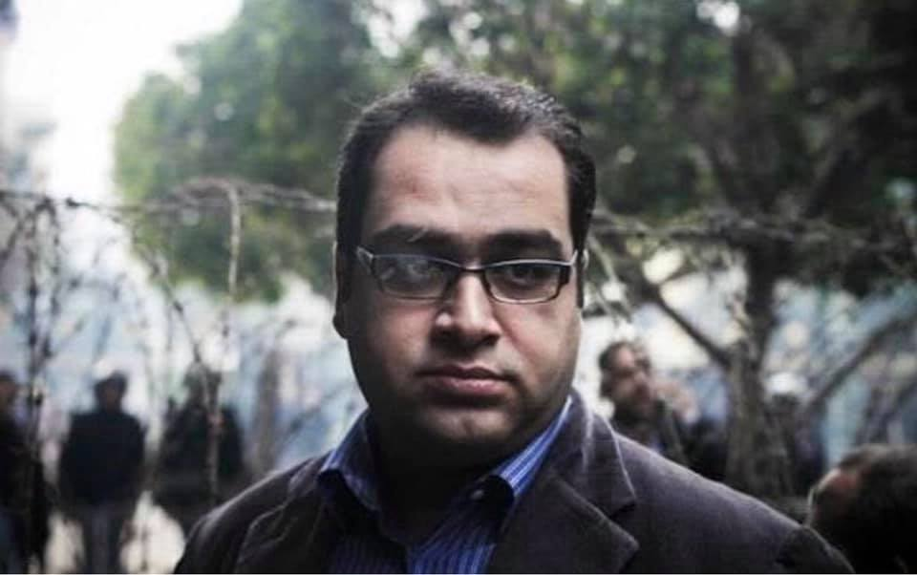
Zyad el-Elaimy © Private

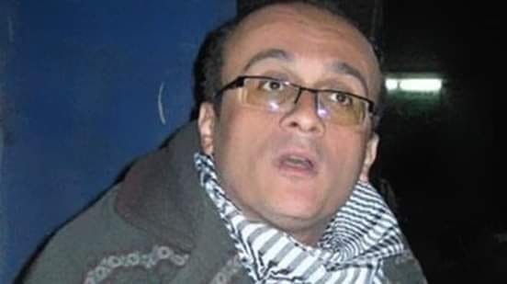
Hisham Fouad © Private
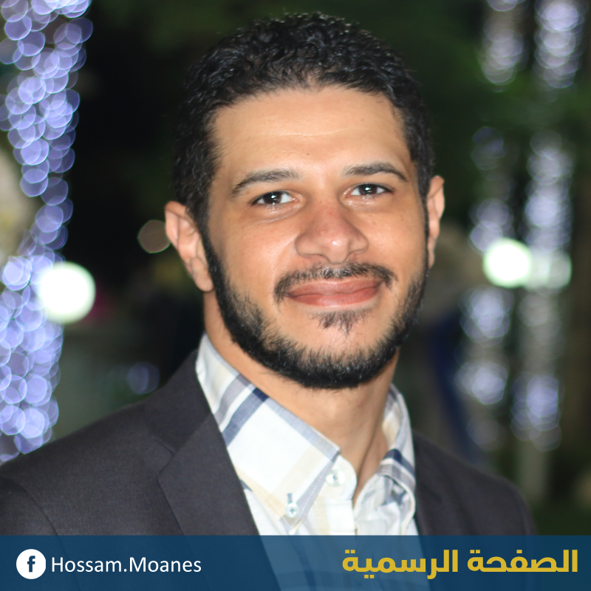
Hossam Moanes © Private

The case later grew to include at least 105 individuals from across the political spectrum. Among them is Egyptian-Palestinian Ramy Shaath, who was arrested by police from his home in Cairo on 5 July 2019 and detained in relation to his legitimate political activities with Egyptian political parties and as co-ordinator of the Boycott, Divestment and Sanctions (BDS) movement in Egypt. Amnesty International considers him a prisoner of conscience.

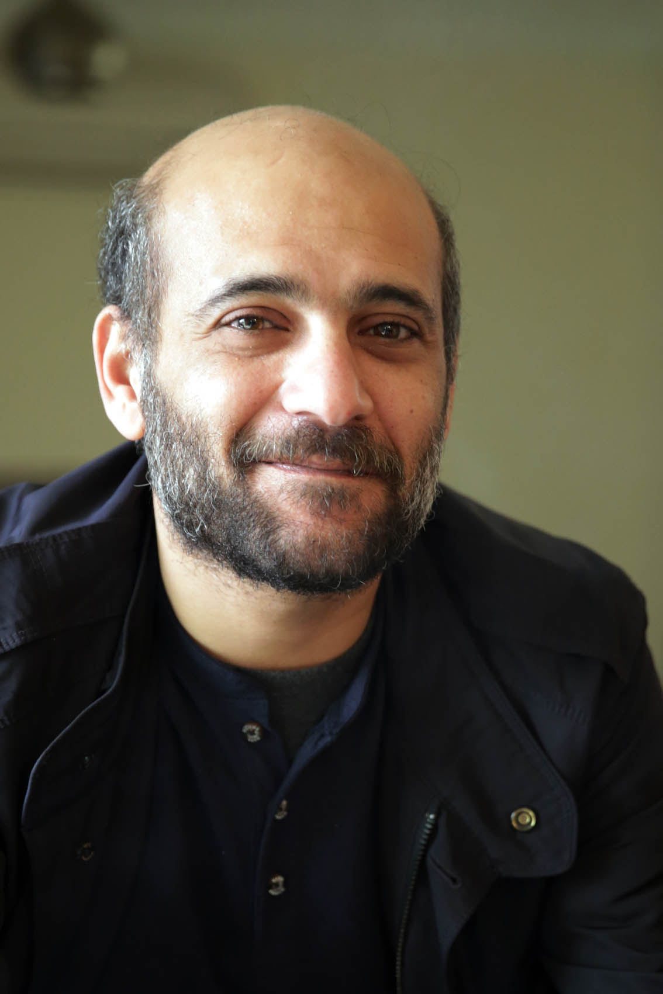
Ramy Shaath © Private

Research done by Egyptian and international NGOs backs Amnesty International’s findings on the arbitrary detention of individuals investigated by the SSSP. UN special rapporteurs have expressed grave concern that detained human rights defenders have been subjected to prolonged periods of detention “reportedly arising from their peaceful and legitimate defence of human rights” and that “the Egyptian Government is operating a zero-tolerance approach to dissent, which is often suppressed under the pretext of countering terrorism”, a role associated with the SSSP.
The Egyptian authorities have repeatedly denied claims that they detain individuals on politically motivated charges. Instead, they consistently claim that detained critics, opponents, journalists and human rights defenders are prosecuted on charges that relate to membership of, or aiding, “terrorist” or other unnamed banned groups and undermining state security. For example, in early 2019, President al-Sisi stated:
“We do not have political prisoners or prisoners of opinion. We are trying to stand against extremists who impose their ideology on the people. Now they are subject to a fair trial and it may take years, but we have to follow the law.”
However, the fact that accusations or charges used to detain individuals are based on national legislation is not sufficient in and of itself to qualify them as legitimate. The definitions of “terrorism” and “crimes against state security” in Egyptian law are overly broad and vague, leaving them open to abuse, and can be used to imprison individuals for exercising their rights to freedom of expression, association and assembly as guaranteed under the Egyptian constitution and international law. The 2015 counter-terrorism law criminalizes, as a “terrorist act”, “any use of force, violence, threat, or intimidation domestically or abroad for the purpose of disturbing public order, or endangering the safety, interests, or security of the community;... harms national unity, social peace, or national security;... prevents or impedes public authorities… from carrying out their work or exercising all or some of their activities, or resists them or disables the enforcement of any of the provisions of the Constitution, laws, or regulations”. The law also criminalizes “incitement to commit” these acts, “regardless of the method used, and even if such incitement does not result in any impact”. Further, “any person who facilitates… by any direct or indirect means… the perpetration or preparation” of such acts “shall be punished as an accomplice”. The Penal Code criminalizes, in a section on terrorism and threats to state security, some similar acts.
The UN Working Group on Arbitrary Detention has found that detention can be arbitrary even when allowed by domestic law if it contravenes international standards, or is incompatible with other human rights such as the rights to freedom of expression, assembly or belief.
The rights to freedom of peaceful assembly, expression and association are all protected by international law and standards, notably the International Covenant on Civil and Political Rights, to which Egypt is a party. The UN Human Rights Committee states in its General Comment no. 34 that “in circumstances of public debate concerning public figures in the political domain and public institutions, the value placed by the Covenant upon uninhibited expression is particularly high.” Any restrictions placed on the rights need to be provided for by law, necessary and proportionate. The restrictions Amnesty International has documented were instigated on the basis of the misuse of vague national security legislation, cannot be considered necessary and are clearly disproportionate. The UN Special Rapporteur on the promotion and protection of human rights and fundamental freedoms while countering terrorism found that:
“Failure to restrict counter-terrorism laws and implementing measures to the countering of conduct which is truly terrorist in nature also pose the risk that, where such laws and measures restrict the enjoyment of rights and freedoms, they will offend the principles of necessity and proportionality that govern the permissibility of any restriction on human rights.”

Denial of effective legal representation
“The SSSP reduced our role as lawyers to simply providing [emotional] support to defendants. We cannot do our jobs properly. We go to the SSSP knowing the result in advance. When we see new defendants, our only hope is that they are not coerced into incriminating themselves.”
A lawyer who has represented individuals brought before the SSSP
Amnesty International found that the SSSP systematically violates the right to effective legal representation in the initial questioning, by preventing most suspects from obtaining legal representatives of their choice and preventing lawyers from speaking with their clients in private ahead of questioning and providing legal advice during it. Prosecutors often refuse to allow suspects or lawyers to examine NSA investigation case files or take written notes during questioning, citing security grounds.
In 42 of the 138 cases documented by Amnesty International, including those of four boys, interviewees reported that SSSP prosecutors questioned them without lawyers and did not ask them if they wanted to call one. In 81 cases, lawyers attended the interrogation after they saw the suspects at the SSSP by chance and offered their services on the spot. In the case of 12 high-profile suspects, the SSSP informed lawyers that the detainees would be questioned by the SSSP and allowed lawyers to attend with them. In the case of three suspects, the SSSP assigned lawyers who were not of the accused’s own choosing and did not provide effective representation. In all documented cases, detainees were not allowed to consult with their lawyers in private ahead of questioning. Lawyers were also not allowed to consult suspects during questioning in any case.
A review of the five court files obtained by Amnesty International relating to cases prosecuted between 2016 and 2019 showed that SSSP prosecutors questioned at least 260 out of the 381 individuals detained in these judicial cases without a lawyer present. The prosecutors cited one of the following reasons: “due to necessity”, “because the defendant was confessing and out of fear of losing evidence”, “for fear of losing evidence”, “the lack of available lawyers”, “we checked with the lawyers’ syndicate and they were closed” or “for fear of the detention period coming to an end”.
A lawyer who has represented individuals brought before the SSSP said:
“As lawyers, all we can do initially is to hope that defendants know their rights and do not incriminate themselves or others, as we cannot tell them what their rights are.”
Figure 3: Individuals questioned by SSSP prosecutors without a lawyer among 381 defendants whose case files Amnesty International examined
Data based on examination of files relating to 381 individuals detained in five judicial cases.
Four lawyers told Amnesty International that SSSP security guards did not allow them to attend the questioning of six of the 41 individuals questioned without lawyers, despite the lawyers knowing that a client of theirs was inside the room. More commonly, suspects were transferred from places of detention to the SSSP building and held for hours in a room where lawyers were unable to see them and therefore unable to attend the questioning with them.
All interviewees, with the exception of one, a lawyer, told Amnesty International that prosecutors prevented them from examining the NSA investigation case files on them or their clients. Lawyers explained that prosecutors sometimes cited security reasons for their refusal and sometimes gave no reason. A human rights lawyer told Amnesty International:
“I stopped asking to see the [NSA] investigation case files, as, whenever I asked, the prosecutor would tell me, ‘There is no examination, sir.’”
In mid-2015, the SSSP began to prevent lawyers from entering the SSSP building unless their clients were due to be questioned or brought before a detention renewal hearing; the decision was taken in the absence of a written order. Although the Administrative Court in Cairo struck down the decision on 21 June 2016 and the State Council, Egypt’s highest administrative court, rejected the government’s appeal against this on 9 September 2017, the SSSP has refused to comply with these rulings and lawyers remain barred from the building until today unless their clients are due to be questioned or brought before a detention renewal hearing. The court based its ruling on safeguards on the right to legal representation, and on the right to a fair trial more generally, in the Egyptian constitution:
“If the right to defence is a constitutional right, then the legislator cannot, when regulating it, limit it in a manner that undermines its foundation or essence… The imposition of restrictions on lawyers’ access to court and Public Prosecution buildings and on administrative activities which are guaranteed to them by law does not only prejudice the right of the lawyer, but also impairs the rights of the defendants.”
‘Hany’
“Hany”, a lawyer with a history of political activism, was arrested in May 2018 in relation to a protest which he says he did not attend. His testimony was corroborated by a family member and a friend who were aware of his whereabouts at the time. He described how NSA officers broke into his house and arrested him without showing a warrant: they ransacked his apartment and confiscated several of his belongings, including papers that were not connected to political activities. He said that officers put him in a car, blindfolded him once inside and took him to an NSA building. There, NSA officers questioned him without a lawyer for 48 hours, while he was still blindfolded. During that time, his family and lawyers contacted the police station of the area where he was last seen, but the police there denied that he was in custody. After two days, he was taken to the SSSP building but was still denied the right to call his family or a lawyer. When a lawyer who knows him saw him and asked to be allowed to attend the questioning, the prosecutor denied the request without providing a reason. “Hany” recounted how the questioning began:
“The prosecutor asked me: ‘What the hell did you do this time?’ When I denied my involvement in anything, he threatened to return me back to where I came from [the NSA building].”
The prosecutor ordered “Hany” to be taken outside the room and forced him to wait in the corridor, before he was taken inside for the questioning to resume, again without a lawyer. This time, there were two prosecutors and they asked him about a statement made by a political group in relation to austerity measures, before ordering him to leave the room again. When “Hany” was asked to enter the room for a third time, the lawyer who had seen him earlier was allowed to accompany him inside the interrogation room for the formal questioning. The prosecutor told him that he was being investigated for “membership in a terrorist group”, without naming the group in question, as well as for attending an “unauthorized protest”. However, the questioning revolved around his history of political activism from school to the moment of his arrest, as well as his family and his work as a lawyer. He was not allowed to consult with his lawyer during the questioning.
“Hany” remained in pre-trial detention for six months, during which he was never questioned again. His lawyer was not allowed to visit him in his place of detention during that period as the SSSP did not grant them the necessary approval. A court ordered his release, but he was taken to an NSA building again, where he was detained blindfolded for 19 days in incommunicado detention, while he waited for the NSA to “approve” his release. Amnesty International considers that “Hany” was a prisoner of conscience subjected to arbitrary detention.
In three documented cases, the SSSP provided lawyers to suspects during questioning but refused to allow them to call lawyers of their choosing. The interviewees told Amnesty International that the appointed lawyers did not provide effective representation: they provided minimal assistance such as calling for their release, but did not attempt to probe into widespread concerns, such as potential mismatches between actual arrest dates and those logged in official arrest records and allegations of torture or other ill-treatment, even when these had been flagged by the detainees. They also reported that those lawyers gave counter-productive advice, including by encouraging them to “confess” or incriminate themselves.
‘Samy’
“Samy” was prosecuted in 2014 in relation to his work as a journalist. He told Amnesty International that NSA officers had tortured him during his detention at an NSA building including by beating him with a wooden stick and suspending him for hours. Following this, “Samy” said that he was taken, blindfolded, to the SSSP building. When he entered the room, he immediately asked the prosecutor whether he was still in the NSA building. The prosecutor said, in an apparent attempt to fool him that they were, at which point Samy corrected him. He said that the prosecutor then dealt with him respectfully, unlike his two co-detainees, who he said were threatened by prosecutors with being beaten and treated as if they were in the NSA building to get them to “confess” to taking part in a plot to undermine the state. “Samy” told Amnesty International that the prosecutor started by asking him if he was a member of the Muslim Brotherhood, which he denied, and went on to ask about his political beliefs.
“Samy” told Amnesty International that the prosecutor then summoned a lawyer, who advised him to “confess” to the prosecutor. “Samy” refused to “confess” and instead asked the lawyer to leave the room. He said that he did not ask for another lawyer because he did not trust the SSSP to provide one whom he could trust to represent him effectively. When he asked the prosecutor to allow him to call his family, the prosecutor said that he could not allow him to do so. Amnesty International considers that “Samy” was a prisoner of conscience subjected to arbitrary detention.
The denial of effective legal representation before the SSSP has been widely documented by Egyptian NGOs. The Adalah Center for Rights and Freedoms recorded the questioning by the SSSP of at least 356 individuals without a lawyer in 28 judicial cases between 2013 and 2016. It also noted that, when prosecutors appointed lawyers, they rarely provided effective legal aid. An analysis of case files by the Egyptian Front for Human Rights revealed that at least 450 individuals were questioned without lawyers by the SSSP in 14 judicial cases between 2014 and 2018.
UN bodies have also raised concerns about the SSSP’s practice of preventing detainees from accessing legal representation during their initial questioning and from being allowed communication with their lawyers. In addition, they have raised concerns about the authorities hindering access to effective legal aid in recent cases that have resulted in death sentences, which were prosecuted by the SSSP.
Both the Code of Criminal Procedures and the Guidelines to the Public Prosecution require that suspects be accompanied by their lawyers or, if they do not have a lawyer, that they be provided one by a prosecutor. However, both texts also allow for the conduct of interrogations without a lawyer if there is a “fear of losing evidence”. Egyptian law does not provide special protection to children when it comes to legal representation as it allows prosecutors to question children without lawyers as well.
The Code of Criminal Procedures requires that anyone who is detained is informed of the reason for their detention and is allowed to contact who they see fit and a lawyer. However, the counter-terrorism law allows for the right to call a lawyer or family member to be suspended for up to 28 days, in order to protect the interest of the investigation. This goes far beyond the permissible expectations in international law to the right to counsel, which only allow for the temporary denial of access to a lawyer in exceptional circumstances, which are prescribed by law and limited to occasions when it is considered indispensable in the particular case in order to maintain security and good order. The decision to delay access to a lawyer should be made by a judicial or other authority. However, even in such cases, access should begin no later than 48 hours from the time of arrest or detention.
The right to effective legal representation is protected by international human rights law and standards and has a number of constituent elements. Every person who is arrested or detained must be informed of their right to have the assistance of legal counsel and, if they chose to avail themselves of this right, their decision must be honoured and counsel provided. Such guarantees are considered fundamental elements of the right to a fair trial. The right to the assistance of a lawyer without delay pre-trial enables an individual suspected of or charged with a criminal offence to protect their rights and begin to prepare their defence. For detainees such assistance is important to enable them to challenge their detention and serves as an important safeguard against torture and other ill-treatment, coerced “confessions”, enforced disappearance and other human rights violations.
International standards are quite clear in requiring the presence of a lawyer with defendants. The right to a lawyer starts at the beginning of criminal proceedings and applies even if the defendant decides to remain silent. The ban on questioning children under 18 years old without lawyers is absolute. Internationals standards also require that detainees be provided with adequate opportunities, time and facilities to be visited by and to communicate and consult with a lawyer, without delay, interception or censorship and in full confidentiality. The UN Special Rapporteur on the promotion and protection of human rights and fundamental freedoms while countering terrorism found that:
“giving access to case files or providing the exact content of the charges only during the first session in trial to lawyers defending terrorist suspects before military or emergency courts renders illusory the right of the accused to an adequate defence.”

Coercive questioning
“They took me to a separate room, where no one could see me and I couldn’t see any lawyers… When the prosecutor started asking me questions, I didn’t ask for a lawyer because I didn’t know I had the right to.”
Former detainee who was questioned by the SSSP in 2014
Amnesty International found that SSSP prosecutors systematically fail to inform detainees of their rights. It also found that they regularly subject detainees to coercive questioning, which amounts to ill-treatment.
In all 138 documented cases, former detainees, families of victims and lawyers said that neither SSSP prosecutors nor police officers who had questioned them earlier informed detainees of their rights. In 117 of the 138 cases, interviewees indicated that the questioning took place immediately after the defendant was forcibly disappeared or while they were held incommunicado. While some detainees are knowledgeable about their rights, whether due to their previous experience, education or training, others are not, making them more vulnerable to coercive questioning by the SSSP.
In 60 of the documented cases, suspects reported being subjected to coercive methods at the SSSP. These included prosecutors threatening to send them back to the NSA, which is notorious for torturing detainees and interrogating them afterwards, deliberately offending detainees’ personal, cultural or religious sensitivities, and deceiving suspects into incriminating themselves in initial “informal chat”. They also included police at the SSSP keeping detainees blindfolded until they were taken for questioning by SSSP prosecutors; the practice is known to the prosecutors, as all interviewees confirmed that blindfolded detainees could be easily seen across the SSSP building. These methods constitute ill-treatment, as they represent physical and moral coercion.
When detainees are transferred to the SSSP, they are generally kept waiting in a holding cell in the basement of the SSSP building, sometimes for hours, before being taken upstairs, often blindfolded, to a prosecutor’s office. Detainees described the cell as “inhumane”: overcrowded, without ventilation and with foul-smelling toilets they reported as unfit for use. If they have a blindfold on, it is removed before they enter the prosecutor’s office.
In the cases Amnesty International documented, interrogation sessions lasted on average between two and five hours, although one detainee reported being questioned for up to 18 continuous hours. Interviewees reported that questioning usually started with an “informal chat” between the prosecutor and the suspect in the prosecutor’s office, without the presence of a lawyer or someone to transcribe. They said that, during these “chats”, prosecutors asked them about their life history and opinions, informing them that these conversations are not admissible evidence in court. Twelve interviewees said that, during these “chats”, prosecutors voiced opinions favouring the current government’s policies, denounced opponents as “traitors”, “terrorists” or “misled youth” and expressed their opinions on gender roles, gender identity and sexual orientation. Some also reported that prosecutors offered to release them if they co-operated. All interviewees confirmed that at no point did prosecutors tell them that they had the right not to answer questions or to refuse to talk without legal representation.
Sarah Hegazi
Police forces arrested LGBTI activist Sarah Hegazi on 2 October 2017 as part of a crackdown on the Egyptian LGBTI community following a concert in Cairo during which some people waved the rainbow flag. During her detention in a police station, an officer applied an electric shock near her ears and threatened to harm her mother if she ever recounted that experience. The following day, Sarah was taken to the SSSP for questioning. She described her initial arrest and questioning as “the most traumatic days in my life”. Initially, the prosecutor questioned Sarah without her lawyers as part of an “informal chat”. During the “chat”, the prosecutor said that he usually investigated people involved in serious crimes and did not have time for her case. Sarah told Amnesty International that the prosecutor used degrading language with her during the informal chat, asking about her “virginity” and her sexual orientation, including through the use of homophobic terms, and saying that he would not tolerate such immoral behaviour from his daughter. The “chat” evolved into questioning, which went on for six hours. At no point did the prosecutor inform Sarah of her rights or allow her to communicate with her lawyers ahead of the questioning. Lawyers were also not allowed to speak during the questioning. The prosecutor ordered Sarah’s detention for 15 days pending investigation related to “membership in an illegal group” and “promoting the ideas of this group” but did not name the group. He kept renewing her detention every 15 days until a judge ordered her release without charge on 2 January 2018.
Despite assurances to the contrary, lawyers told Amnesty International that prosecutors regularly included elements from these initial “chats” into the session’s transcripts, raising the risk of self-incrimination. In some cases, interviewees reported being intimidated by the prosecutors, for example by being told that they would be returned to the NSA. The “chat” is followed by the start of the official questioning in the presence of someone to transcribe and sometimes in the presence of one or more defence lawyers.
‘Ibrahim’
“Ibrahim” was only 15 when he was arrested, along with his father, from their home in Cairo at 2am on 6 December 2014. He was taken to a police station, where he said NSA officers beat him, subjected him to electric shocks, suspended him from his limbs and threatened to rape his mother and sister as they interrogated him and his father about their participation in protests and knowledge of individuals active in the Muslim Brotherhood: “One officer put his boots on my face as he asked me if I ever went to protests and how many times. Another officer threatened to rape my mother and sister,” “Ibrahim” said. He said that neither he nor his father was allowed to use the toilet during their detention at the police station, leading his father to urinate in his own clothes.
“Ibrahim” recounted that he was transferred blindfolded and assumed he was being taken to a NSA building. When he arrived at the SSSP building, security officers took off his blindfold but handcuffed his wrists behind his back and took him to a room reserved for policemen. After being taken to the prosecutor’s office, according to “Ibrahim” the prosecutor was initially respectful, offering him chocolate and a drink and saying: “We are friends here. You can talk freely before the investigation starts.” The prosecutor then started asking him about his political activities and individuals from the Muslim Brotherhood. “Ibrahim” said that the prosecutor neither informed him of his rights, nor provided him with access to a lawyer. Similarly, he neither allowed him to call anyone to inform them of his situation, nor ensured that his parents were informed of the legal proceedings against him. The prosecutor also failed to ask “Ibrahim” about his treatment at the police station. As a result, “Ibrahim” said he did not realize he could ask for a lawyer or report his torture. He told Amnesty International:
“I was 15 and half at that time. I did not ask for a lawyer, because I did not know that there is something called a prosecution and I did not know that the SSSP was a prosecution office. I thought that the person in front of me was an NSA officer and that this was a new interrogation tactic. I did not tell him about the beating, because I thought that the SSSP was part of the NSA where I was beaten before.”
The questioning went on for five hours and focused on his political activities and beliefs and knowledge of politically active individuals from his neighbourhood. The prosecutor then ordered his detention, where he would spend two years without charge. After his initial interrogation he was not questioned again. On the second occasion “Ibrahim” had his detention renewed by the SSSP, he had a lawyer with him who asked the prosecutor to conduct the original questioning again, since it had occurred without a lawyer present, but the prosecutor refused. In December 2016, a judge ordered “Ibrahim” to be released pending investigation.
Several other NGOs have documented the use of coercion against suspects by SSSP prosecutors, including the use of threats by prosecutors.
The Egyptian constitution requires that detainees “shall be immediately informed of the causes” of their detention, “notified of their rights in writing”, “allowed to immediately contact their family and lawyer” and that questioning “may only begin once their lawyer is present”. The Code of Criminal Procedures similarly requires the presence of a lawyer when an accused is questioned. The Guidelines to the Public Prosecution stipulate that prosecutors must ensure that the parents of children under 18 are informed of the legal proceedings against them.
However, Egyptian law does not explicitly provide guarantees against coercion during interrogations, in violation of international standards. In Egyptian law there is no guarantee of the right to silence, although the Guidelines to the Public Prosecution ban the use of certain coercion techniques including torture, insulting or degrading defendants, asking misleading questions, making untrue promises or lying in order extract confessions.
Under international law, the prohibition on coercion during questioning is understood to include broadly any form of physical or psychological methods to lead the person to confess guilt or testify against themselves. Such coercion includes, but is not limited to, torture and other cruel, inhuman or degrading treatment. The UN Human Rights Committee has stated that the prohibition of coerced confessions requires “the absence of any direct or indirect physical or psychological pressure from the investigating authorities on the accused, with a view to obtaining a confession of guilt”. The UN Convention against Torture and Other Cruel, Inhuman or Degrading Treatment or Punishment obliges states parties to “keep under systematic review interrogation rules, instructions, methods and practices” with a view to preventing torture and other ill-treatment.
The extent of the protection against and prohibition of other ill-treatment can be gleaned from the Geneva Conventions which bind all states and which, in the extreme emergency that is armed conflict, prohibit “in all circumstances” ill-treatment of detainees including “all acts of violence or threats thereof… insults and public curiosity” and any “physical or moral coercion… against protected persons, in particular to obtain information from them or from third parties.” It cannot reasonably be argued that the protection against ill-treatment which states must provide in peacetime under human rights law is weaker, or narrower, than such protection during war.

Prolonged pre-trial detention
“We’re forbidden from [leading] our lives by a decision from the State Security Prosecution.”
Jihad Khaled speaking about the impact of the detention of her mother on her family
Amnesty International found that SSSP prosecutors systematically order suspects to be detained after questioning and renew their detention for the maximum period available to them. They then keep suspects in detention through requests to terrorism circuit judges to renew their detention. The SSSP has the power to release them at any time, but invariably chooses not to do so. In some cases, the SSSP has even circumvented judicial release orders by detaining suspects in relation to new cases. The detention decisions are often based on NSA investigation case files that lawyers and their clients cannot examine and are justified on “security grounds” that cannot be challenged.
SSSP prosecutors can detain suspects for a total of 150 days in pre-trial detention through repeated renewals of 15 days. After 150 days has elapsed detention can then only be extended by a judge, who can renew detention in 45-day intervals. In felony cases, the absolute total must not exceed 18 months if the crime is punishable by a prison term less than life imprisonment, or two years if the crime is punishable by life in prison or death. All the SSSP cases examined in this report are felony cases.
In 133 out of the 138 documented cases, SSSP prosecutors ordered the detention of suspects in pre-trial detention for the full 150 days permitted without judicial oversight. Only five individuals were released before the end of the 150 days. One was released by the SSSP. The other four were released by a judge after they successfully appealed against their detention.
SSSP prosecutors never give pre-trial detention orders in writing to lawyers or suspects. Instead, lawyers are informed of the decision orally through clerks. Lawyers interviewed by Amnesty International said that, when they requested the grounds for the decision, prosecutors provided two standard replies: “to continue investigations” or “on security grounds”. However, they said it was very rare for a detainee to be interrogated again or new evidence brought against them. Whenever prosecutors cite “security grounds” as the basis for pre-trial detention, they claim that they need to prevent the suspects from interfering with the ongoing investigation. However, they do not explain how they have come to this conclusion and thereby give suspects a claim to challenge. Further, suspects have no recourse to a judicial body that can examine the merits of such a claim for the first five months of their detention. As a result, according to lawyers interviewed by Amnesty International, following the first interrogation, the renewal process becomes almost automatic, with lawyers calling for the release of their clients during sessions and the SSSP prosecutor ordering the renewal of their detention regardless.
Figure 4: Status of 138 individuals whose cases Amnesty International documented
Data based on interviews with those accused and their lawyers, as well as family members and close friends, in the 138 cases, as well as official documents in some of them. Data valid as of 5 November 2019.
As of 5 November 2019, in the 138 cases documented by Amnesty International, 43 detainees had been released. They had on average been held for 345 days in pre-trial detention, in one case for 1,263 days. A total of 89 individuals remained detained pending investigation in SSSP cases, having been held for an average of 332 days in pre-trial detention.
Figure 5: Length of pre-trial detention of 132 individuals whose cases Amnesty International documented
Data based on interviews with those accused, their lawyers and family members in the 132 out of the 138 cases documented by Amnesty International in which individuals had not been referred to trial. The combined pre-trial detention period has been calculated; in 89 cases this is ongoing. Data valid as of 5 November 2019.
Ola al-Qaradawi
Ola al-Qaradawi, 57-year-old daughter of Islamic scholar Youssef al-Qaradawi, has been in pre-trial detention since 30 June 2017. Ola and her husband, Hossam Khalaf, an engineer and member of the al-Wasat party were arrested together by NSA officers from their summer house on the north coast of Egypt. NSA officers imprisoned them for two days in Burj al-Arab police station, before referring them both to the SSSP in Cairo on 3 July 2017. A prosecutor questioned them, then ordered their detention for 15 days pending investigation into accusations of “membership of a terrorist group” and “funding a terrorist group”. According to their family, the questioning focused on Youssef al-Qaradawi. Their lawyers have not been able to examine the evidence gathered through NSA investigations and have only been questioned once since their arrest. Prosecutors renewed Ola’s detention every 15 days for a total of 150 days. Following that, a judge renewed her detention every 45 days. Eventually, a judge ordered her release on 2 July 2019, following more than two years of detention, which she spent in indefinite solitary confinement. Such a prolonged period in solitary confinement amounts to torture.
However, the next day, a SSSP prosecutor questioned Ola and ordered her detention for another 15 days pending investigation into new accusations of “membership of a terrorist group” and “funding a terrorist group through her connections in the place of detention”. Ola was returned to Qanater women’s prison, where she has remained since then. A court ordered Hossam’s release on 29 July 2019, but he remains in detention awaiting NSA “approval”. Both Ola and Hossam have been subjected to prolonged arbitrary detention.
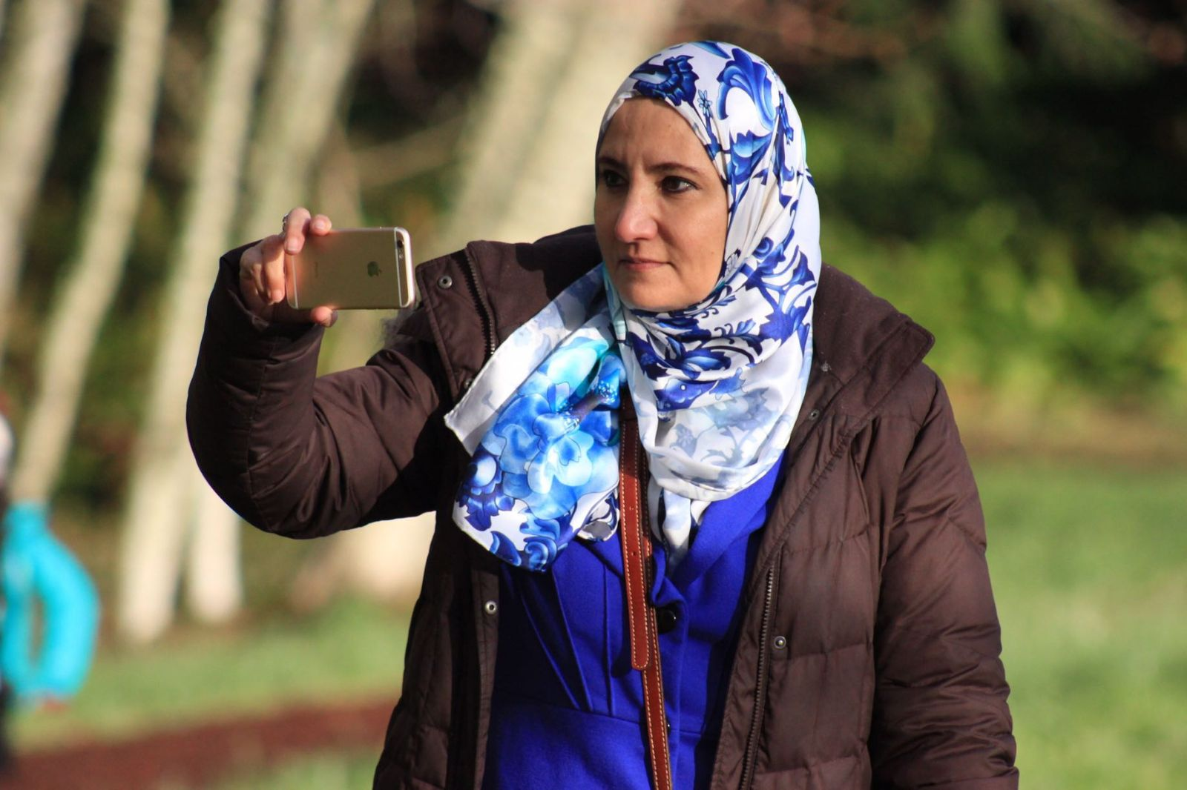Ola Ola al-Qaradawi © Private

Defence lawyers told Amnesty International that release orders issued by courts in SSSP cases are only implemented after NSA “approval”, according to what policemen regularly tell them at police stations. Among the 138 cases documented by Amnesty International, the 43 individuals released spent on average 11 days after the initial order in arbitrary detention waiting for “NSA approval”; in one case, the period was 35 days. When the NSA does not give this “approval”, the detainee may find themselves added as a suspect to a new or existing SSSP case or even subjected to enforced disappearance. In five of the 138 cases documented by Amnesty International, detainees who were the subject of court orders to release them were not in fact released but detained on new, unfounded accusations. Three other individuals, instead of being released following court orders, were subjected to enforced disappearance. A court ordered the detention of two of them later for violating their probation terms, despite the fact that they were actually in police custody at that time. In one case the victim remained subjected to enforced disappearance as of 5 November 2019.
Mahmoud Hussein
Al Jazeera producer and journalist Mahmoud Hussein has been in pre-trial detention since 23 December 2016. On 20 December 2016, he travelled to Cairo for a vacation, but security officers stopped him at the airport, questioned him and seized his passport, before telling him to report to the NSA building on 23 December to retrieve it. When he obliged, NSA officers apprehended him, took him to his house in handcuffs and searched it, according to his family. He was then taken to the SSSP, where a prosecutor questioned him without a lawyer and ordered his detention pending investigation into accusations of “publishing false information”, “receiving foreign funding” and “membership in a banned group”. In a statement issued on 25 December 2016, Egypt’s Ministry of Interior said that Mahmoud Hussein was being held on accusations of “incitement against state institutions and broadcasting false news with the aim of spreading chaos”. It said he worked with Al Jazeera to produce “fake documentaries” about the country’s institutions. The prosecutor renewed his detention repeatedly every 15 days up to a total of 150 days. He was then brought before a judge, who renewed his detention in intervals of 45 days until 21 May 2019, when a judge ordered his release on probation. Two days later another judge upheld the decision against an appeal brought by the SSSP.
The police then moved him to Abu el-Nomros police station in Giza, Greater Cairo, while he waited for NSA “approval” for his release. However, instead of releasing him, they took him to the SSSP building again, where a prosecutor questioned him once again without a lawyer. His detention was renewed for another 15 days pending investigation into in a new case in which he was accused of “membership of a banned organization”, “receiving foreign funding” and “working for international organizations”. He was returned to Tora prison. As of 5 November 2019, Mahmoud had been held for 1,077 days in pre-trial detention. Such a prolonged period of pre-trial detention constitutes arbitrary deprivation of liberty in violation of international human rights law and is well over the limit set by Egyptian law.
The use of pre-trial detention in SSSP cases has also been well documented by Egyptian human rights NGOs and media. UN bodies have repeatedly noted its excessive use. In a decision by the UN Working Group on Arbitrary Detention on the case of journalist Mahmoud Hussein it found that:
“The near-automatic extension of Mr. Hussein’s pretrial detention by courts with no regard for his due process and fair trial rights, and his confinement with convicted felons in Tora prison, are also symptomatic of the violation of the presumption of innocence.”
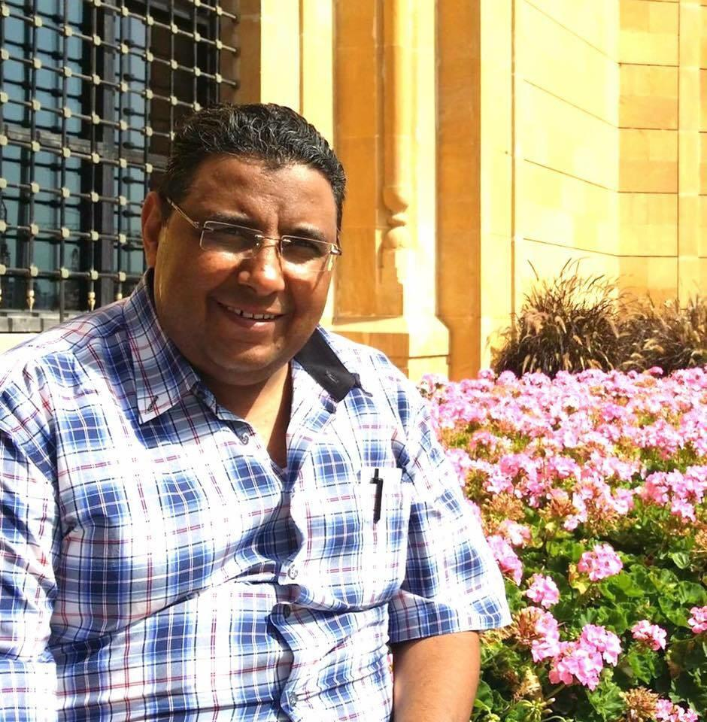
Mahmoud Hussein © Private

Egypt’s Code of Criminal Procedures allows for the pre-trial detention of suspects on five grounds. The Guidelines to the Public Prosecution state that prosecutors must detain suspects in cases of felonies and other crimes that harm public security, whenever there is evidence that establishes guilt.
International law requires that pre-trial detention be used only as a last resort. The presumption of release pending trial is based on the presumption of innocence, which is enshrined in international law and recognized in the Egyptian constitution. To justify pre-trial detention, the authorities are required to prove there is a public interest in doing so and a substantial concern that the defendant may escape, interfere with the investigation or commit a serious offence. International law is clear that detention which is not necessary and proportionate constitutes an arbitrary deprivation of the right to liberty. An individual has a right to be brought to trial within a reasonable period of time, and detention pending a trial that has not been brought in such a time frame is unlawful under international law.

Denial of right to challenge detention
“When I insisted on making an appeal on behalf of the accused, as is his right, the employee said to me, ‘Are you new here, sir? I said the door for appeals is closed.’”
A lawyer who has represented individuals brought before the SSSP
Amnesty International found that the SSSP regularly prevents suspects from challenging their pre-trial detention.
The legal framework is problematic in the first place. SSSP prosecutors assume the powers of judges when it comes to issuing pre-trial detention decisions, such that, for the first 150 days of pre-trial detention, the only way for suspects to have their detention reviewed by a judge is by seeking to lodge an appeal against their detention. However, it is the SSSP prosecutors themselves who decide whether to allow lawyers to appeal against their clients’ detention, whether lawyers are appealing detention decisions by the SSSP or by judges.
In practice, SSSP prosecutors are able to block suspects’ access to judges who could examine the lawfulness of their detention. Lawyers interviewed by Amnesty International said that, when they made applications to appeal against detention orders, they had to stick to a changing schedule that was announced in a document posted outside the SSSP building. Since 2015, lawyers have had to submit appeal requests in writing at a counter outside the building and then SSSP clerks have informed them orally of the decision.
Lawyers told Amnesty International that appeals are allowed in some cases but not others. In cases of refusal, they said they never received a written explanation, although on occasion SSSP clerks cited “security concerns” as a reason. Some requests were never responded to at all. Between December 2018 and September 2019, the SSSP did not accept a single request to make appeals against detention orders by the SSSP or by judges, according to suspects detained during that time, as well as lawyers and family members. Since September 2019, lawyers have been able to appeal in some cases against decisions by judges, but not those by the SSSP.
Waleed Shawky
NSA officers arrested Waleed Shawky, a 32-year-old dentist and one of the founding members of the banned April 6 Youth Movement, at 7pm on 14 October 2018 from his clinic in Sayeda Zainab, a neighbourhood of Cairo. For six days, the authorities detained Waleed in Sayeda Zainab police station. During that time, when his family asked about his whereabouts, the authorities denied that he was in custody, thereby subjecting him to enforced disappearance. They sent letters to the Public Prosecutor and Minister of Interior on 15 October 2018 but did not receive a response. On 20 October, the NSA transferred Waleed to the SSSP. A lawyer spotted him and attended the questioning session with him; it was the first time he had seen a lawyer since his arrest. The prosecutor stated that, according to the police arrest report, his arrest had taken place on 19 October. Although Waleed challenged the date of arrest, as far as Amnesty International is aware, the prosecutor did not take action to investigate the mismatch in arrest dates or the related concern of enforced disappearance.
The prosecutor said he was accused of “membership of a banned group” and “disseminating false information”. When Waleed’s lawyers asked to examine the NSA investigation file on which the accusations were based, the prosecutor refused citing security concerns. His questioning focused mostly on Waleed’s previous activities with the April 6 Youth Movement and his opinions on current affairs.
The prosecutor ordered his detention for 15 days and continued to renew it for five months. During that time, the SSSP prevented his lawyers from appealing their decisions in front of a judge. At the end of the initial five months, a terrorist circuit judge started renewing his detention every 45 days. His lawyers told Amnesty International that the SSSP refuses to allow them to challenge the detention and, every time they request to submit an appeal, SSSP clerks tell them they cannot do so. He has not been referred to trial, nor has he been summoned for questioning again since his detention. On 22 October 2019, a judge ordered Waleed’s release. However, the prosecutor appealed, and a different judge accepted the appeal and ordered Waleed’s detention for 45 more days. Amnesty International considers him a prisoner of conscience, detained solely for peacefully exercising his rights to freedom of expression and association.
Waleed Shawky © Private

Egyptian law does not require that a detainee be promptly brought before a judge. In general, prosecutors can order the detention of individuals facing terrorism-related accusations for up to 28 days, after which their cases must be examined by a judge. As already mentioned, SSSP prosecutors assume the powers of judges when it comes to issuing pre-trial detention decisions, such that, for the first 150 days of pre-trial detention, the only way for suspects to have their detention reviewed by a judge is by lodging an appeal against their detention. This is in clear violation of the right to be brought promptly before a judge, which requires that if the detainee is brought before a judicial officer other than a judge, the officer must be authorized to exercise judicial power and must be objective, impartial and independent of the executive and the parties. The CCP states that suspects can appeal against their pre-trial detention once every 30 days. However, in practice, this is left up to the SSSP to decide.
International law and standards recognize that individuals deprived of their liberty have the right to take proceedings to challenge the lawfulness of their detention before a court. The court must rule without delay and order release if the detention is unlawful. International standards require that individuals be brought before a judge promptly after arrest or detention. The UN Human Rights Committee has indicated that the right to be brought promptly before a judge should not be restricted during times of emergency. However, international law does not recognize prosecutors as judicial officers. The UN Human Rights Committee has previously found, when reviewing the situation in Hungary, that it was not satisfied that the public prosecutor could be regarded as having the institutional objectivity and impartiality necessary to be considered an ‘officer authorized to exercise judicial power’ within the meaning of article 9(3)” of the International Covenant on Civil and Political Rights and made a universal point that “it is inherent to the proper exercise of judicial power, that it be exercised by an authority which is independent, objective and impartial in relation to the issues dealt with”.

Complicity in police violations
“When I insisted that he [the prosecutor] discipline the officer, he said: ‘Of course, I am not going to discipline an officer.’”
“Yasmin Hossam”, a human rights lawyer who has represented clients at the SSSP
Amnesty International found that SSSP prosecutors were complicit in enforced disappearance and torture and other ill-treatment by systematically neglecting to investigate allegations of such practices by Egyptian police, particularly the NSA, and admitting confessions extracted under torture as evidence in trials. In some cases, such evidence led to defendants being sentenced to death and executed. By ignoring allegations of enforced disappearances and torture, the SSSP also prevents victims from receiving justice and ensures impunity for perpetrators.
Under Egyptian law, prosecutors have the responsibility to investigate allegations of abusive acts by members of the police, including the NSA, in cases that are under their jurisdiction. Individuals cannot sue police officers; rather it is up to prosecutors to do so.
International standards also clarify these duties. Article 16 of the UN Guidelines on the Role of Prosecutors states:
“When prosecutors come into possession of evidence against suspects that they know or believe on reasonable grounds was obtained through recourse to unlawful methods, which constitute a grave violation of the suspect's human rights, especially involving torture or cruel, inhuman or degrading treatment or punishment, or other abuses of human rights, they shall refuse to use such evidence against anyone other than those who used such methods, or inform the Court accordingly, and shall take all necessary steps to ensure that those responsible for using such methods are brought to justice.”

Enforced disappearances
Information gathered by Amnesty International through interviewees indicated that, of the 138 cases it documented, 112 individuals – 63 men, 44 women, four boys and one girl – were subjected to enforced disappearance by the police, mostly the NSA. They said they were detained for periods ranging between two and 183 days. Following their arrest, the individuals said they were taken either directly to NSA buildings in Greater Cairo or to police stations, where, in some cases, they were held in NSA “fridges”, an informal term used to refer to cells located in police stations but managed by NSA officers. There they were questioned. NSA buildings are not official places of detention. The judiciary has no access to them and so is unable to inspect them.
During their time in detention, their families or lawyers inquired at police stations about their whereabouts but were told they were not in custody. No news emerged of their fate until they appeared in the SSSP building. Families of 71 of the 112 victims submitted telegrams (postal messages) to the Public Prosecutor’s office and Minister of Interior to document that their family members were arrested on a particular date and filed complaints with police stations that Amnesty International was able to examine. In no case did they receive a response to their complaint. In all cases, the detainees reported their treatment to the SSSP prosecutor. However, as far as Amnesty International is aware, in no case has a SSSP prosecutor opened such an investigation.
Examination of the files of the five judicial cases seen by Amnesty International that were investigated by the SSSP and referred to trial revealed a similar story. According to the official documents in the files, 339 of the 381 defendants who were in custody told SSSP prosecutors that they were subjected to enforced disappearances. The case files provided no indication that the SSSP had opened a single investigation into these allegations.
Amnesty International found that SSSP prosecutors systematically failed to address the falsification of arrest dates by the police, particularly the NSA. In 87 of the 112 cases, the arrest date prosecutors said the NSA had recorded corresponded to the day immediately prior to the SSSP questioning, even though telegrams sent by family members documenting the dates of arrest and examined by Amnesty International, interviews with suspects, family members, lawyers and witnesses indicated that detainees were detained before then. When lawyers and detainees challenged the NSA’s recorded arrest date, prosecutors took no action to investigate allegations that the date of arrest had been falsified, as far as they were aware.
Figure 6: Mismatches between arrest dates recorded by police and detainee for 381 defendants whose case files Amnesty International examined
Data based on examination of files relating to 381 individuals detained in five judicial cases.
Abeer el-Safty
On 22 April 2019, 26-year-old journalist Abeer el-Safty was travelling in a microbus from Cairo to Alexandria, Egypt’s second city, from where she planned to continue her journey to the nearby city of Kafr el-Dawar, when security forces arrested her. According to Abeer’s representative, police forces stopped the microbus and ordered passengers to go and vote in the public referendum on constitutional amendments. When Abeer refused, police officers arrested her and took her to Karmoz police station in Alexandria, where she was detained for six days, before being brought before a SSSP prosecutor on 28 April. During that time, when her lawyers inquired about her whereabouts at police stations in Alexandria, including Karmoz police station, they denied having her in custody. When Abeer told the prosecutor that she was arrested on 22 April, the prosecutor replied that, according to the police report, she was arrested on 27 April. For these reasons, Abeer’s detention before she appeared before the SSSP amounted to enforced disappearance.
The prosecutor ordered her detention for 15 days and told her that she was being investigated for “membership of the banned Muslim Brotherhood”. Abeer denied the charge, citing several op-eds in which she had expressed her strong opposition to the group and arguing that, more broadly, she had a history of opposing the group when it was in power and after. Amnesty International believes that the charges against Abeer are unfounded and stem solely from her refusal to be coerced into voting and that she is therefore a prisoner of conscience. Abeer remains detained in Qanater women’s prison.
Abeer el-Safty © Private

In at least seven of the 112 cases, detainees said they were taken to the SSSP during the period of their enforced disappearance. Despite they and their lawyers informing the SSSP that they were being detained in an unofficial place of detention without contact with their lawyers or families, who had no means of establishing their fate or whereabouts, SSSP prosecutors took no action to either investigate these allegations or remedy their situation. In some cases, they justified the fact that lawyers or families had no knowledge of their fate or whereabouts on the basis that the detainee’s right to contact them was suspended under Article 40 of the counter-terrorism law.
Hoda Abdelmoniem
Hoda Abdelmoniem, a 60-year-old human rights defender, was arrested on 1 November 2018. She was detained for 20 days in the NSA building in 6th October, a city in the west of Greater Cairo, but did not know where she was being held. During that time, her family and lawyers inquired about her whereabouts at several police stations in Greater Cairo; at each one they were told she was not in custody. According to her daughter, Jihad Badawy, she was spotted by a lawyer at the SSSP building on 21 November. The SSSP prosecutor reportedly explained that the reason for her family and lawyers’ inability to ascertain her whereabouts was that her right to contact them had been suspended under the counter-terrorism law. During questioning, Hoda said she told the SSSP prosecutor that she did not know where she was being detained. He neither clarified this nor ordered her transfer to an official place of detention where she would have access to the outside world for three months. Until 30 January 2019, she was returned to the NSA building, after every detention renewal hearing at the SSSP, then the prosecutor ordered her transfer to Qanater women’s prison.
According to her family, the SSSP is detaining Hoda pending investigations for “membership in a terrorist group”, although they have not presented evidence against her. Instead the claim is based on an NSA investigation file, which neither Hoda nor her lawyers have been allowed to examine. Hoda is a lawyer and former member of the National Council for Human Rights who volunteers as a consultant for the Egyptian Coordination for Rights and Freedoms, a prominent human rights organization. In the last five years, Hoda’s documentation has included cases of enforced disappearances. Amnesty International believes that Hoda’s human rights work is the real reason behind her arrest and considers her a prisoner of conscience.
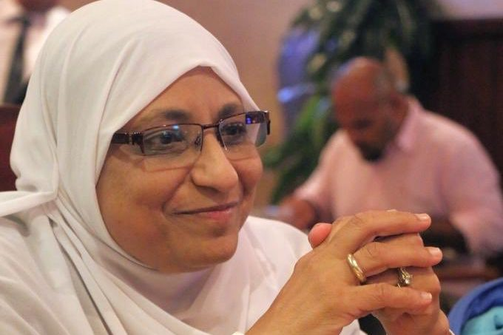
Hoda Abdelmoniem © Private

The Egyptian Commission for Rights and Freedoms has documented a total of 1,719 cases of enforced disappearance between August 2015 and June 2019. The organization found that, of 647 individuals who disappeared and later appeared in front of prosecutors, 287 of them were brought before the SSSP and alerted the prosecutor to their situation. However, in none did the SSSP investigate the allegations.
Egyptian law prohibits holding detainees in unofficial places of detention. Article 54 of the Constitution and Article 36 of the Code of Criminal Procedures require that security forces present detainees before a prosecutor promptly following arrest and grant them access to lawyers. However, Article 3 bis (a) of the state of emergency law allows police officers to detain suspects for seven days, with approval by the Public Prosecution. Articles 40 and 41 of the counter-terrorism law allow prosecutors to detain individuals facing terrorism-related charges for up to 28 days and, during that time, to suspend their right to contact their family members and lawyers.
Enforced disappearances constitute continuous violations of several rights, including non-derogable rights, such as the right to freedom from torture. Although Egypt is not a party to the International Convention for the Protection of All Persons from Enforced Disappearance, that Convention requires states to find criminally liable any individual who is an accomplice or a superior and fails to take all necessary measures within his or her power to prevent enforced disappearances.

Torture
“After she told the prosecutor that NSA officers threatened to rape her, the prosecutor responded: ‘So, they only threatened you?’”
A human rights lawyer who represented a client in front of the SSSP
Information gathered by Amnesty International through interviewees indicated that 46 of the 138 individuals whose cases it documented – 23 women, 18 men, four boys and one girl – were subjected to torture or other ill-treatment in police custody, particularly in NSA detention, between December 2013 and June 2019. Victims were aged between 12 and 60 years old. The most common methods of torture reported were the application of electricity to different parts of the body, beating using hands and feet and sticks and suspension by the limbs. In three cases, victims reported that male doctors forced them to undergo forced anal tests or a sex determination test. In three other cases, detainees said that NSA officers had threatened them with rape.
In only one case did the SSSP refer a detainee alleging torture to the Forensic Medical Authority. However, to Amnesty International’s knowledge, SSSP prosecutors have not investigated a single police officer for such abuse.
Esraa Abdelfattah
Esraa Abdelfattah, a 41-year-old human rights defender, was stopped when she was in her car, assaulted and abducted by security forces in plain clothes on 12 October 2019, according to two Amnesty International sources. She was taken into NSA custody. The next day, Esraa appeared in front of the SSSP and described how she was tortured. After her detention one NSA officer threatened her with torture after she refused to grant him access to her mobile phone. Several men then entered the room and began beating her on her face and body. The NSA officer then returned and repeated his request for her to unlock her phone. Esraa refused again and the officer took off her sweatshirt and strangled her with it, saying: “Your life in exchange for the phone.” He persisted until she gave him her password. The officer then handcuffed her hands together and legs together and kept her in that position for almost eight hours. Another officer warned that she would face further torture if she reported what had happened to the prosecutor. Although the SSSP referred Esraa to the Forensic Medical Authority, which examined her on two occasions, they neither summoned the NSA officers responsible for Esraa’s treatment for questioning, nor, as far as Amnesty International is aware, opened an investigation into it.
The prosecutor ordered her detention for a further 15 days while she was investigated for “joining a terrorist group in achieving its goals”, “disseminating false news” and “misusing social media”. The prosecutor did not produce any evidence against her, other than an NSA investigation file that neither she nor her lawyers were able to examine. Amnesty International believes these accusations are completely unfounded and solely stem from the peaceful practice of her rights to freedom of expression and association and to participation in public affairs, and that she is consequently a prisoner of conscience.
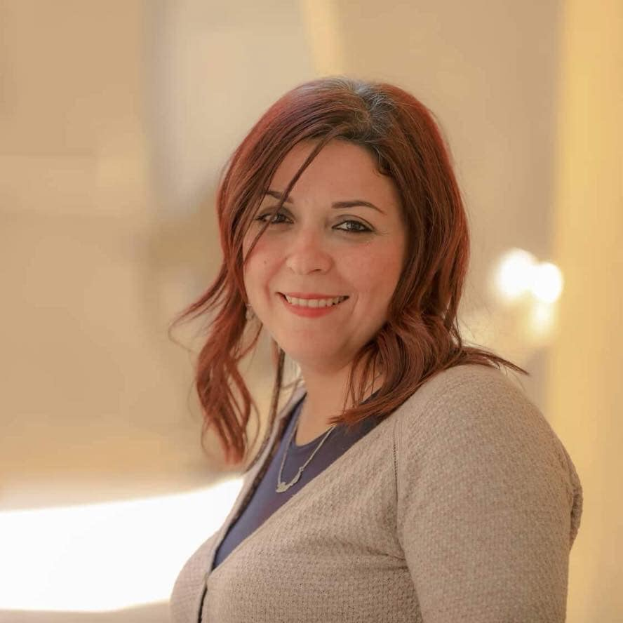
Esraa Abdelfatah © Private

Examination of the files of the five judicial cases seen by Amnesty International that were investigated by the SSSP and referred to trial revealed a similar story. According to the official documents in the files, 247 of the 381 defendants who were in custody told them that they were tortured. Of these, prosecutors referred only 118 to the Forensic Medical Authority. However, forensic doctors were unable to determine the origin of the injuries because the physical signs had already disappeared. In one case, a prosecutor noted that the defendant had an injury in the right elbow; the Forensic Medical Authority did not conduct an examination until 12 days later, when it noted that the injury had evolved and that it was not possible to ascertain that it was due to torture. The case files provided no indication that the SSSP opened a single investigation into the torture allegations.
Among the 247 individuals who told prosecutors they had been subjected to torture and appeared within the five judicial cases seen by Amnesty International were a group of 12 men who were sentenced to death in relation to the assassination of Hisham Barakat, the former Public Prosecutor, on 29 June 2015. Nine were subsequently executed in February 2019, despite saying that the confessions used to convict them were extracted under torture while in NSA custody.
Abu Bakr Ali
Abu Bakr Ali was one of nine people executed after being convicted of playing a role in the assassination of Hisham Barakat. His sister Hend el-Shaify recalled his torture allegations:
“When Abu Bakr was arrested, he was unable to walk, because he had had surgery on a posterior cruciate ligament [in the knee] 10 day earlier. They had to carry him to the police car. During the 15 days that he was forcibly disappeared in the NSA building, NSA officers tortured him using electric shocks all over his body. They would strip him naked and put him in ice-cold water in a barrel and [leave him] all night like that in February, when it is extremely cold. In addition to threatening his family, they would suspend him from his injured knee for long hours and apply electric shocks.”
His sister recalled that he was examined by an SSSP prosecutor on 9 March 2016. The prosecutor interrogated him without the presence of his lawyer, out of fear of losing evidence, according to the court verdict. The prosecutor did not refer him to the Forensic Medical Authority. During his trial, Abu Bakr stated that he was forced under torture to give a detailed “confession” in which he admitted to involvement in the assassination of the Public Prosecutor. The “confession” in which he appeared along with three other men was videotaped and shown by several TV channels in Egypt, which Amnesty International viewed. According to the verdict, Abu Bakr stated: “I was forced to make that confession under torture for 15 days, and I did not deny it in previous interrogations, because I did not have a lawyer with me.”
Egyptian NGOs have also noted that the SSSP routinely fails to adequately investigate allegations of torture. Analysis by the Egyptian Front for Human Rights of the files of 14 judicial cases that took place between 2014 and 2018 found that 417 individuals reported being subjected to torture and that the SSSP failed to refer at least 261 of them to the Forensic Medical Authority.
In 2017 the UN Committee against Torture found that the use of torture in Egypt is systematic and that torture has been facilitated by prosecutors in Egypt, noting:
“Prosecutors, judges and prison officials also facilitate torture by failing to curb practices of torture, arbitrary detention and ill-treatment or to act on complaints.”
Torture is a crime without a statute of limitations under Egyptian law. The Guidelines to the Public Prosecution require prosecutors to examine allegations of torture through an examination of the body of the claimant and then refer them to the Forensic Medical Authority to produce a medical report on their situation, including the reasons behind their injuries.
Under international law, torture and other ill-treatment are prohibited absolutely, in all circumstances and without exception. The UN Convention against Torture and Other Cruel, Inhuman or Degrading Treatment or Punishment, to which Egypt is party, requires the criminalization of complicity in torture. Further, it requires that the “competent authorities”, such as the SSSP, investigate allegations of torture.

Hostile environment for lawyers
Amnesty International found that lawyers were subjected to arrests and detention in connection with their work representing clients before the SSSP, as well as threats and harassment. Such a hostile environment has led lawyers to fear arrest and intimidation. Five lawyers interviewed by Amnesty International reported suffering as a result from stress and anxiety that led them to seek psychological support.
Of the 29 lawyers Amnesty International interviewed, 17 had decided to stop working on SSSP cases due to the hostile environment. Such decisions impact not only lawyers, but also the right to legal representation of suspects. They have access to fewer lawyers, particularly in a context where the number of individuals investigated by the SSSP cases has risen. This concern was evident following the wave of arrests in the aftermath of the 20 September protests, when only several dozen lawyers attempted to represent hundreds of suspects and communicate with their families.

Arrests and detention
“He [a detainee] told the prosecutor, ‘My lawyer is Mohamed el-Baqer,’ So he [the prosecutor] responded, ‘Mohamed el-Baqer is being questioned in the next room.’”
A lawyer who has represented clients in front of the SSSP
Among the 138 cases that Amnesty International documented, 17 lawyers – 14 men and three women – have been arrested and prosecuted by the SSSP since September 2017. In at least nine cases, their prosecution appears to be in response to their work representing clients before the SSSP. The remaining eight were prosecuted because of their legitimate political activities.
Ezzat Ghoniem
Security forces arrested Ezzat Ghoniem, a 41-year-old human rights lawyer and co-founder of the Egyptian Coordination for Rights and Freedoms on 1 March 2018, while he was walking in a street in Cairo. Following his arrest, Ezzat was taken to the NSA building in Abbaseya, a Cairo neighbourhood, where he was blindfolded and subjected to enforced disappearance, according to a representative from his NGO. Two days later, a lawyer spotted him in the SSSP building, where a prosecutor questioned him and ordered his detention pending investigation for “membership in a terrorist group” and “publishing false information for the purpose of harming national security”. On 15 March 2018, NSA officers took Ezzat from his cell in the Tora Prison Complex, south of Cairo, and forced him to give a “confession”, which was videotaped, saying that he belonged to the Muslim Brotherhood. The SSSP prosecutor kept renewing his detention every 15 days, until a judge ordered his release on probation on 4 September 2018. However, instead of releasing him, the authorities moved him to Haram police station in Giza, Greater Cairo, and, on 14 September 2018, denied that he was in custody, when his lawyers inquired about him. On 20 October 2018, a judge ordered his detention for failing to adhere to his probation terms, even though he had never been released. An Egyptian government response dated 15 October 2018 to an inquiry from the UN Working Group on Enforced or Involuntary Disappearances confirmed that he had been in custody since his arrest.
The response also claimed that he was a member of a “terrorist group called the Coordination of Rights and Freedoms”, a reference to the name of his NGO, even though the authorities have not designated the human rights group as a “terrorist organization”. On 28 July 2019, the SSSP questioned Ezzat in a new case in which he was accused of “membership in a terrorist organization” and ordered his detention for a period of 15 days that would start immediately following his release in the first case. Amnesty International believes that the accusations against Ezzat are unfounded and considers him a prisoner of conscience, detained solely for peacefully exercising his rights to freedom of expression and association and for his work as a lawyer, as well as that of his organization in reporting on human rights violations. Furthermore, it believes that the cases against him are linked to his representation of detainees in front of the SSSP. Just days before his arrest, he attempted to provide legal assistance before the SSSP to a mother who alleged that her daughter had been subjected to enforced disappearance and rape.
Another lawyer was also arrested and prosecuted by the SSSP after he attempted to represent the same woman. A further two lawyers said they were threatened by policemen at the SSSP that they might be arrested and added as a suspect in the same SSSP case as her if they represented her.
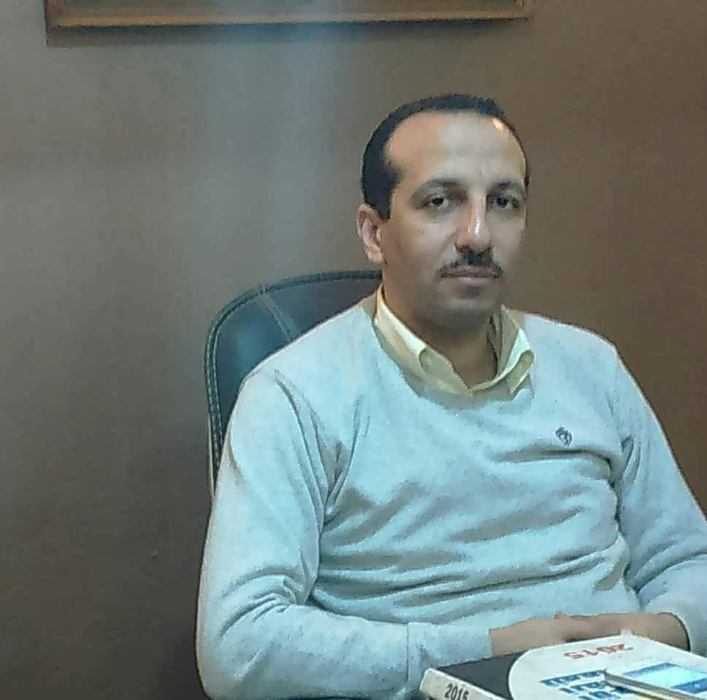
Ezzat Ghoniem © Private
Amnesty International has also documented the arrest of three lawyers in or in the vicinity of buildings of official institutions, including the SSSP and the police, while conducting work in relation to SSSP cases.
Mahienour el-Masry and Mohamed el-Baqer
On 22 September 2019, plain-clothes policemen arrested lawyer and human rights defender Mahienour el-Masry from outside the SSSP building and took her to an undisclosed location in a van. She had been representing another human rights lawyer, who was arbitrarily detained, before the SSSP and was going to represent detainees who were due to appear in front of the SSSP following their arrest in relation to anti-government protests in September 2019. The First Public Defender, the head of the SSSP, told lawyers that there was an arrest warrant against her and that she would be questioned the next day by the SSSP. The next day, an SSSP prosecutor questioned Mahienour on her work and ordered her detention pending investigation in connection with a case that relates to a protest that took place back in March 2019. She was accused of “aiding a banned group in achieving its goals”.
One week later, on 29 September, Mohamed el-Baqer, a human rights lawyer and director of the Adalah Centre for Rights and Freedoms, a human rights NGO, was arrested from inside the SSSP building as he was going to represent a fellow human rights defender and was told that he had been accused in the same case. The prosecutor questioned him about his and his organization’s work in providing legal representation to detainees in SSSP cases. The prosecutor ordered his detention pending investigation for “membership in a banned group”, “disseminating false information” and “funding a terrorist group”.
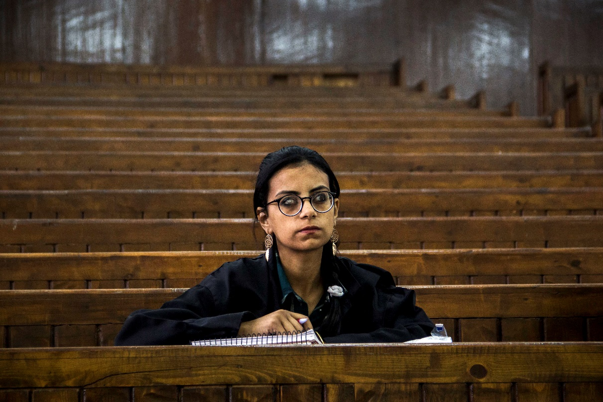
Mahienour el-Masry © Alaa el-Kamhawy
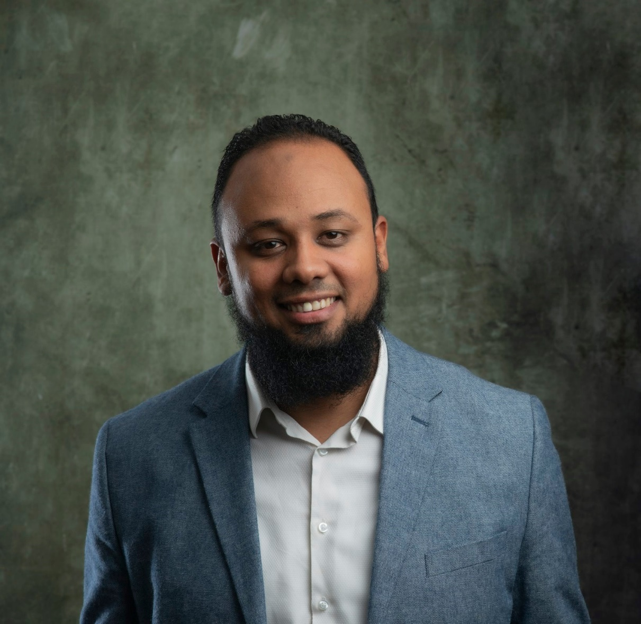
Mohamed el-Baqer ©Hossam Sarhan

Neither lawyer has been able to examine the NSA investigation case files on them. Amnesty International considers that they are both arbitrarily detained in relation to their legitimate defence of human rights and are therefore prisoners of conscience.

Threats and harassment
“I am anxious most of the time. I have to think about any word that I say or write on social media because I am worried about retaliation. It started with panic attacks, now it is impacting me even physically. I have to go to therapy to be able to handle this.”
A human rights lawyer who has represented clients in front of the SSSP
Thirteen lawyers with whom Amnesty International spoke said they had been threatened or harassed during their work representing clients in front of the SSSP, either by prosecutors or by police officers operating there.
Four lawyers reported being threatened by policemen at the SSSP with prosecution in SSSP cases because they were insisting on providing effective legal representation. One told Amnesty International how a policeman at the SSSP kept telling him that he would soon be added to one of the open cases as a suspect. Another said that he was told by a policeman to be careful about what he wrote on his social media accounts.
Seven lawyers reported being threatened with being ejected from hearings and possibly facing sanctions. A lawyer who stopped practising in front of the SSSP told Amnesty International that, when she kept trying to talk to her client before the questioning started, the prosecutor threatened to prevent her from attending the questioning and to report her, without clarifying in what way.
Twelve lawyers said that they often faced harassment, including gender-based harassment, by both prosecutors and police at the SSSP building. The harassment included derogatory remarks by prosecutors about lawyers’ backgrounds. One lawyer who worked with SSSP cases until 2018 recalled how, when he sought to be present during the questioning of his client at the SSSP, faced a senior prosecutor challenging him by saying: “Did you come here from [name of his village] to harass us?” The prosecutor was clearly making a demeaning reference to his rural background, a common means of expressing disrespect in Egypt.
Three female lawyers reported not only being stared regularly at by SSSP security guards, but also facing demeaning comments, some with sexual connotations, by prosecutors, including on their appearance and choice of clothes and on their very presence at the SSSP late at night. One female lawyer said she faced, on several occasions, degrading comments from prosecutors about her clothes. On one occasion, a prosecutor told her to cover her legs in front of him. “I felt so humiliated... that day” she said. She now avoids taking cases at the SSSP unless “absolutely necessary”.
Another female lawyer, Yasmin Hossam, described how, in 2015, she was at the SSSP when a police officer accompanied by several junior police agents attempted to frighten her with a barking dog. When she complained to a prosecutor, he said he would reprimand the agent responsible. Yasmin told Amnesty International: “I told him it was an officer, not an agent, and he replied, ‘And what do you want me to do, madam? Of course, we are not going to reprimand a police officer.’”
Egyptian law provides minimal protections for lawyers. Article 50 of Law no. 17/1983 on the legal profession provides guarantees against being arrested or held in pre-trial detention for certain infringements that take place during hearings or in relation to actions that relate to the profession or speech, without the approval of the Public Prosecutor. However, Egyptian law provides insufficient guarantees protecting lawyers from retaliation for providing legal representation. In practice lawyers have found themselves detained and facing “terrorism” related accusations for providing legal aid, for peaceful expression and for membership in legitimate organizations. The Guidelines to the Public Prosecution set out more extensive protections for lawyers, as they require that any investigation into lawyers must be conducted by the Public Prosecution not the police, that prosecutors call lawyers for interrogations, rather than summoning them through the police, and that any questioning of a lawyer must be conducted solely by a prosecutor with the presence of a representative from the lawyers’ syndicate.
International standards require that lawyers be enabled to do their work without interference or hindrance. The UN Basic Principles on the Role of Lawyers require that “Governments shall ensure that lawyers (a) are able to perform all of their professional functions without intimidation, hindrance, harassment or improper interference.” Lawyers should not be targeted for providing legal representation to anyone: “Lawyers shall not be identified with their clients or their clients' causes as a result of discharging their functions.” Nor should they be targeted for practising their rights to freedom of expression or association. The UN Special Rapporteur on the independence of judges and lawyers has clarified why such practices are of major concern. Where attacks on the liberty of lawyers are frequent or systematic, they may undoubtedly have a chilling effect on the whole category of legal practitioners. The authorities have a responsibility to prevent future attacks and to redress past injuries suffered by lawyers.

Conclusion and recommendations
“Before, very few people would hear about the role of the SSSP, as they would mostly deal with ‘serious’ cases. Now, every case is a SSSP case.”
A veteran human rights lawyer

Conclusion
This report has shown that the SSSP plays a central role in the repression led by the Egyptian authorities, with prosecutors routinely violating the rights to liberty and a fair trial, ordering the arbitrary detention of hundreds and being complicit in serious violations carried out by NSA officers including torture and other ill-treatment and enforced disappearances.
The growth in the number of suspects in SSSP cases reflects a worrying development whereby the Egyptian authorities are increasingly seeing, and labelling, individuals suspected of being critical or opposing President al-Sisi as either “terrorists” or accomplices to them. This is manifest in the frequency with which the SSSP accuses suspects of either “membership in a terrorist group” or “aiding a terrorist group”, regardless of whether the actual reason for their arrest is genuinely suspicion of involvement in a militant attack or actually an act that should not even be criminalized such as peacefully expressing critical views of the authorities, engaging in human rights work or waving a rainbow flag.
The growing role of the SSSP, along with the related use of a special police force, the NSA, and special courts, such as the terrorism circuits, also points to the emergence of what can be described as a parallel justice system. It only converges with the regular legal system when a case reaches the Court of Cassation, at the top of Egypt's judicial hierarchy. As a whole, the system detains, interrogates, investigates and tries individuals who either should be appearing before ordinary courts or should never have been arrested or prosecuted in the first place. This parallel legal system can be seen as a manifestation of a permanent state of exception that the Egyptian authorities are imposing to justify the suspension of fair trial rights and other human rights violations with impunity, thereby severely undermining the rule of law.
Thousands have been affected as a result of these violations. The authorities have used the pretext of counter-terrorism to imprison and silence perceived critics and opponents in cases where suspects are never referred to trial, but detained for months and sometimes years, based on secret NSA investigation case files. These violations have a wider impact on other rights, including the rights to freedom of expression, association and assembly, and the right to political participation by creating a pervasive sense of fear.
Internationally, the Egyptian authorities have sought to whitewash the crackdown by claiming that their critics are not legitimate opponents, but rather “terrorists”, and that protests against President al-Sisi’s rule are a product of “political Islam”. The international community must not be fooled by this rhetoric.

Recommendations
In light of these findings, Amnesty International makes these recommendations to the following Egyptian institutions and the international community.

To the President
- Ratify the International Convention for the Protection of All Persons from Enforced Disappearance and the Optional Protocol to the UN Convention against Torture and Other Cruel, Inhuman or Degrading Treatment or Punishment.
- Rapidly institute a system of independent national monitoring of all places of detention, including places of detention run by the NSA. Ensure that the body charged with carrying out the monitoring has the powers and capacity to undertake unannounced visits to places of detention and to search places of detention and check the detainee registers of these places.
- Invite visits by relevant UN human rights mechanisms, notably the Working Group on Arbitrary Detention; the Working Group on Enforced or Involuntary Disappearances; the Special Rapporteur on torture and other cruel, inhuman or degrading treatment or punishment; the Special Rapporteur on the promotion and protection of human rights and fundamental freedoms while countering terrorism; the Special Rapporteur on extrajudicial, summary or arbitrary executions; the Special Rapporteur on the promotion and protection of the right to freedom of opinion and expression; and the Special Rapporteur on the rights to freedom of peaceful assembly and of association.
- Invite and grant access to the European Union Special Representative for Human Rights and afford the Special Representative access to meet in confidence with detainees, victims, families and independent human rights groups.
- Ensure that everyone who meets with or contacts the UN experts, UN treaty bodies and the EU Special Representative is protected from possible reprisals, including detention, harassment, threats, acts of intimidation and ill-treatment.
- Ensure that the Ministries of Justice and Interior publish accurate figures on the number of detainees in Egypt and that the public has access to information on the number of cases investigated by the SSSP.
- Order a moratorium on the use of the death penalty, with a view to abolishing it.

To the Public Prosecutor
- Open an independent and public commission of inquiry into the role of the SSSP in prolonged arbitrary detention, violations of fair trial guarantees and complicity in enforced disappearances and torture.
- Immediately and unconditionally release all those detained for peacefully expressing their opinions or for defending human rights or carrying out journalistic work.
- Ensure that detainees are brought to trial promptly before a fair and impartial tribunal, or are released. Egypt must cease to use detention arbitrarily. Arbitrary detention includes, but is not limited to, the detention of individuals in violation of Egyptian law. Detention is also considered arbitrary, even if there is basis for it in national law, when the law’s provisions are vague, over-broad, or incompatible with other human rights such as the rights to freedom of expression, assembly or belief or the right to be free from discrimination. Detention may also be arbitrary when the detainee’s fair trial rights are violated.
- Ensure that suspects have access to effective legal counsel through being able to have a lawyer of their choice to represent them and being able to meet with them in private ahead of the interrogation. Suspects’ lawyers must be present during questioning and be able to provide legal counsel during it, including by advising suspects not to answer questions. Suspects must have access to their lawyers during their detention. For individuals unable to appoint a lawyer, the state must provide them with an effective, free and independent legal counsel.
- Ensure that suspects and lawyers have access to NSA investigation case files and any other documents relating to their case and are given adequate time to prepare their defence. Suspects and their lawyers must also be able to obtain copies of the case files.
- Ensure that lawyers are able to enter the SSSP building at will during working hours and have a proper waiting area inside the building.
- Ensure that all detainees are immediately notified of the reasons of their arrest and detention, as well as of their rights, including their rights to a legal counsel of their choice and of their right to remain silent and of the charges against them, their right to medical assistance, their right to challenge the lawfulness of their detention, their right to notify a third person, and their right to complain about ill-treatment.
- Ensure that the conditions of detention in holding cells and in the SSSP building are in line with the UN Standard Minimum Rules for the Treatment of Prisoners and end the blindfolding of detainees on their way to and from, as well as inside the SSSP building.
- End the “assumption of judicial powers” by SSSP prosecutors that allow prosecutors to detain suspects in SSSP cases for up to 150 days, without judicial oversight. Ensure that all suspects are brought before a judge promptly and that any pre-trial detention decisions are taken by a judge, not a prosecutor.
- End the use of prolonged pre-trial detention and immediately release all those held in violation of Egyptian legal limits on pre-trial detention. Pre-trial detention must be used only as a last resort, after all other alternative measures have been exhausted. The burden of proof falls on the prosecutors to prove that the individual in pre-trial detention satisfies one of the internationally recognized grounds for the detention of the individual. Suspects and their lawyers must have access to official documents showing the grounds for their detention.
- Ensure that suspects and lawyers are able to challenge the lawfulness of their detention at all times, that these requests are addressed by an ordinary judge and that, if the decision is to detain them, it satisfies one of the internationally recognized grounds for the detention of the individual.
- Ensure that allegations of enforced disappearance, torture and other ill-treatment by officials, including NSA officers, are independently and effectively investigated and that those responsible are held accountable, without resorting to the death penalty.
- Ensure that lawyers are protected from threats and reprisals and that all lawyers detained solely for carrying out their work are released.
- Retry all those convicted based on flawed investigations in front of an ordinary judge without resorting to the death penalty.
- Bring the Guidelines for the Public Prosecution into line with international standards for fair trials.

To the Parliament
- Repeal the counter-terrorism law as well as the articles in the Penal Code that are vague or criminalize activities that do not constitute internationally recognizable crimes, especially in the section on terrorism and threats to state security.
- Strengthen fair trial guarantees and safeguards against arbitrary detention in law.
- Repeal Article 206 bis of the Code of Criminal Procedures to put a stop to prosecutors being able to assume the powers of judges and to ensure that individuals are informed of their rights in accordance with Article 54 of the constitution on arrest, are brought promptly in front of a judge and are only subjected to pre-trial detention as a last resort.

To the National Human Rights Council
- Establish a clear and transparent mechanism for receiving complaints about violations of the right to a fair trial including the rights to effective legal representation, to be brought promptly in front of a judge, to be informed of rights on arrest and not to be subjected to arbitrary detention.
- Ensure that victims, witnesses and families are protected from retaliation and are able to make submissions and complaints to the National Human Rights Council confidentially.

To the international community
- Urge Egypt to reform the SSSP, release individuals detained for peacefully expressing their opinions or for defending human rights or carrying out journalistic work, review the use of pre-trial detention and ensure that counter-terrorism is not used as a pretext for detaining peaceful critics and opponents.
- Press the Egyptian authorities to take these steps both bilaterally and multilaterally through relevant international forums such as the UN Human Rights Council and regional mechanisms such as the African Commission on Human and Peoples’ Rights and the League of Arab States.
- Halt co-operation with the SSSP pending an investigation into the conduct of the body and accountability for officials responsible for the prolonged arbitrary detention of suspects and complicity in torture and enforced disappearances, including of individuals who were subsequently executed on the basis of their investigations.

Amnesty international
is a global movement
for human rights.
When injustice happens
to one person, it
matters to us all.

Permanent State Of Exception
Abuses by the Supreme State Security Prosecution

The Supreme State Security Prosecution (SSSP), a special branch of the Public Prosecution, has an expanding role in Egypt’s justice system. This is in a context where exceptional courts are increasingly normalized, a state of emergency is renewed continuously and, more broadly, the human rights situation is deteriorating.
Amnesty International has examined the role of the SSSP and concluded that it is responsible for routinely violating the rights to liberty and a fair trial, ordering the arbitrary detention of thousands, and for complicity in serious violations carried out by the police, particularly the National Security Agency, including enforced disappearances and torture and other ill-treatment. It functions as a tool of repression by misusing recently enacted counter-terrorism legislation to detain individuals for acts that should not even be criminalized.
Amnesty International urges the Egyptian authorities to urgently appoint an independent commission of inquiry into the actions of the SSSP, ensure that individuals being investigated by the SSSP are afforded fair trial guarantees. All those detained for peacefully expressing their opinions or for carrying out human rights or journalistic work should be immediately and unconditionally released; other detainees should be brought to trial promptly before a fair and impartial tribunal, or released.

Office of the UN High Commissioner for Human Rights (OHCHR), Egypt: UN experts alarmed by treatment of human rights defenders after visit, 4 December 2018, www.ohchr.org/EN/NewsEvents/Pages/DisplayNews.aspx?NewsID=23971&LangID=E
Sada Elbalad, “Al-Sisi: “What happened seven years ago will not happen again… Beware!” (in Arabic), 31 January 2018, www.youtube.com/watch?v=_OlpxVEHVIU
Amnesty International, Egypt: Five years after Rabaa Massacre, impunity continues to fuel unprecedented rights crisis (Press release, 14 August 2018), www.amnesty.org/en/latest/news/2018/08/egypt-rabaa/
Al-Masry Al-Youm, “Government’s Statement Declaring the Muslim Brotherhood a Terrorist Group”, 25 December 2013, www.almasryalyoum.com/news/details/363925
Amnesty International, Egypt: Authorities must order immediate investigation into death of former President Mohamed Morsi (Press release, 17 June 2019), www.amnesty.org/en/latest/news/2019/06/egypt-must-investigate-mohamed-morsi-death/
Amnesty International, Egypt constitution draft – Improved text amid ongoing violations (Index: MDE 12/076/2013), www.amnesty.org/download/Documents/16000/mde120762013en.pdf
Amnesty International, Egypt: New protest law gives security forces free rein (Press release, 25 November 2013), www.amnesty.org/en/latest/news/2013/11/egypt-new-protest-law-gives-security-forces-free-rein/
Amnesty International, Amnesty International Report 2014/15 – Egypt (Index: POL 10/0001/2015), www.amnesty.org/en/latest/research/2015/02/annual-report-201415/
Armed Conflict Location & Event Data Project (ACLED), database, www.acleddata.com/data/, accessed on 28 October 2019. The number of killings was obtained in two steps. Firstly, the following values into were these data export fields: From (1 July 2013); To (30 September 2019); Country (Egypt). Secondly, data processing software was used to remove all killings by state actors and pro-government militias.
Amnesty International, Egypt: Government must protect Coptic Christians targeted in string of deadly attacks in North Sinai (Press release, 1 March 2017), www.amnesty.org/en/latest/news/2017/03/egypt-government-must-protect-coptic-christians-targeted-in-string-of-deadly-attacks-in-north-sinai/
Amnesty International, Egypt: Bring attackers to justice after State Prosecutor assassinated (Press release, 29 June 2015), www.amnesty.org/en/latest/news/2015/06/egypt-bring-attackers-to-justice-after-state-prosecutor-assassinated/
Amnesty International, Amnesty International Report 2015/16 – Egypt (Index: POL 10/2552/2016), https://www.amnesty.org/download/Documents/POL1025522016ENGLISH.PDF
Amnesty International, Amnesty International Report 2016/17 – Egypt (Index: POL 10/4800/2017), https://www.amnesty.org/en/documents/pol10/4800/2017/en/
Although Article 154 of the constitution states that the state of emergency can be enacted for three months and renewed only once, the authorities have been declaring the state of emergency for three months every six months and renewing it each time for three-month periods.
Amnesty International, Egypt: Authorities must cease interference in upcoming election and set guarantees for free candidacy (Press release, 24 January 2018), www.amnesty.org/en/latest/news/2018/01/egypt-authorities-must-cease-interference-in-upcoming-election-and-set-guarantees-for-free-candidacy/
Amnesty International, Egypt: Parliament Should Reject Proposed Constitutional Amendments (Index: MDE 12/0147/2019), www.amnesty.org/en/documents/mde12/0147/2019/en/
BBC, “Egypt constitutional changes could mean Sisi rule until 2030”, 16 April 2019, www.bbc.com/news/world-middle-east-47947035
Amnesty International, Egypt: Crackdown against peaceful critics set to worsen if constitutional amendments are passed (Press release, 8 April 2019) www.amnesty.org/en/latest/news/2019/04/egypt-crackdown-against-peaceful-critics-set-to-worsen-if-constitutional-amendments-are-passed/; Cairo Institute for Human Rights Studies and others, Egypt: Human rights organizations condemn harassment of peaceful opponents to the constitutional amendments, 13 May 2019, cihrs.org/human-rights-organizations-condemn-harassments-of-opposition-to-constitutional-amendments-and-demand-closure-of-case-674-2019/?lang=en
Amnesty International, Egypt: Largest wave of arrests since President Abdel Fattah al-Sisi came to power, (Press release, 2 October 2019), www.amnesty.org/en/latest/news/2019/10/egypt-largest-wave-of-mass-arrests-since-president-abdel-fattah-al-sisi-came-to-power/
Amnesty International, Officially you do not exist: Disappeared and tortured in the name of counter-terrorism (Index: MDE 12/4368/2016), www.amnesty.org/en/documents/mde12/4368/2016/en/
See Egyptian Commission for Rights and Freedoms, Fourth Annual Report for the Stop Enforced Disappearances Campaign (in Arabic), 30 August 2019, www.ec-rf.net/?p=3256
UN Working Group on Enforced or Involuntary Disappearances (WGEID), Communications: Egypt, UN Doc. A/HRC/WGEID/116/1, 26 November 2018, para. 70. See also OHCHR, UN rights experts dismayed by arrest of Egyptian lawyer Ebrahim Metwally en route to meet them, 15 September 2017, www.ohchr.org/EN/NewsEvents/Pages/DisplayNews.aspx?NewsID=22079&LangID=E
Article 126 of the Penal Code, Law no. 58/1937, with subsequent amendments.
UN Committee against Torture, Report, UN Doc. A/72/44 (2016-17), para. 69.
Amnesty International, Egypt: Rampant torture, arbitrary arrests and detentions signal catastrophic decline in human rights one year after ousting of Morsi (Press release, 3 July 2014), www.amnesty.org/en/latest/news/2014/07/egypt-anniversary-morsi-ousting/
See Egyptian Commission for Rights and Freedoms, The Nightmare of Torture in Egypt (in Arabic), 7 August 2018, www.ec-rf.net/?p=3251; El-Nadeem Center for the Rehabilitation of Victims of Torture, The oppression archive (in Arabic), quarterly release, shorturl.at/lyNQ5; and Belady Center for Rights and Freedoms, Children Without Protection, April 2019, beladyrf.org/en/node/50
Carnegie Endowment for International Peace, Egypt’s Political Exiles: Going Anywhere but Home, 29 March 2019, carnegieendowment.org/2019/03/29/egypt-s-political-exiles-going-anywhere-but-home-pub-78728
Interview with a lawyer by voice call on 26 June 2019.
Minister of Justice Decision no. 1270/1972, manshurat.org/node/22899
The verdicts of Emergency State Security Courts cannot be appealed and are only subject to confirmation by the President.
Prime Minister Decision no. 2582/2019, 26 October 2019, www.cc.gov.eg/Images/L/393661.pdf
Article 201 of the Code of Criminal Procedures (CCP), Law no. 150/1950.
Article 206 bis of the CCP and Article 42 of Law no. 94/2015 on counter-terrorism (counter-terrorism law).
Article 46 of the counter-terrorism law and Article 1597 of the Guidelines to the Public Prosecution (GPP).
Article 201 of the CCP.
Terrorism circuits are special circuits within the normal judicial system. Amnesty International has documented their role in mass trials involving violations of the right to fair trial that have led, in some cases, to mass death sentences. See Amnesty International, Egypt: Death sentences and heavy prison terms handed down in disgraceful mass trial (Press release, 8 September 2018), www.amnesty.org/en/latest/news/2018/09/egyptdeath-sentences-and-heavy-prison-terms-handed-down-in-disgraceful-mass-trial/
In accordance with international law, Amnesty International opposes the use of military courts to try civilians in general. In Egypt, trials of civilians by military courts have flagrantly breached a number of fair trial safeguards, including the right to a fair and public hearing before a competent, independent and impartial tribunal established by law; the right to have adequate time to prepare a defence; the right to be defended by a lawyer of one’s choosing; and the right to appeal against conviction and sentence to a higher tribunal.
Mohamed El-Ansary, The Role of the Public Prosecution in Egypt’s Repression, July 2017, pomed.org/wp-content/uploads/2016/11/POMEDAnsaryEgyptReport.pdf
Names of SSSP prosecutors were obtained through the official annual movement lists that are published on Egyptian media.
Almanassa, “Half a per cent: Women’s share of the judiciary” (in Arabic), 5 September 2017, almanassa.com/ar/story/3527
Minister of Justice Decision no. 1270/1972, manshurat.org/node/22899
People’s Tribunal, Official minutes, 1954, archive.org/details/MahkametAlShaab01
See Human Rights Watch, Anatomy of a State Security Case: The “Victorious Sect” Arrests, December 2007, www.hrw.org/report/2007/12/10/anatomy-state-security-case/victorious-sect-arrests
See Human Rights Watch, “Work on Him Until he Confesses”: Impunity for Torture in Egypt, January 2011, www.hrw.org/report/2011/01/30/work-him-until-he-confesses/impunity-torture-egypt
See Egyptian Initiative for Personal Rights, After 80 Days of Detention (Press release, 8 June 2010), eipr.org/en/press/2010/06/after-80-days-detention-state-security-prosecutor-releases-all-ahmadi-detainees-eipr
See Human Rights Watch, In a Time of Torture: The Assault on Justice in Egypt’s Crackdown on Homosexual Conduct, March 2004, www.hrw.org/reports/2004/egypt0304/3.htm
Supreme Constitutional Court, “Constitutional” (case 17/15), Verdict (in Arabic), 3 June 2013, manshurat.org/node/1465, p. 40.
Law no. 162/1958 on the State of Emergency, manshurat.org/node/12875
Amnesty International, Time for justice: Egypt’s corrosive system of detention (Index: MDE 12/09/2011), www.amnesty.org/download/Documents/32000/mde120292011en.pdf
Case no. 529/2013 SSSP, reported in Al-Masry Al-Youm, “By name… The Supreme State Security Prosecution releases 31 defendants in eight separate cases” (in Arabic), 19 August 2015, shorturl.at/vENQU
Case no. 1739/2018 SSSP. Amnesty International recorded the case through interviews with several lawyers.
Case no. 1400/2019 SSSP. Amnesty International recorded the case through an interview with a human rights lawyer on 5 November 2019.
Egyptian Center for Economic and Social Rights, Database, shorturl.at/bdFIU, accessed on 28 October 2019. The figure was acquired by downloading the database and filtering the case number column to include only Case no. 1338/2019.
Interview with a lawyer by voice call on 1 May 2019.
Interview with a lawyer by voice call on 17 April 2019.
Court of Cassation, “Criminal Circuit” (Case 26645/84 Judicial), Verdict (in Arabic), 2 February 2015.
Egyptian Center for Economic and Social Rights, Database, shorturl.at/bdFIU, accessed on 28 October 2019. The figure was acquired by downloading the database and filtering the case number column to include only Case no. 1338/2019.
Ramy Essam, “Balaha” (in Arabic), 26 February 2018, www.youtube.com/watch?v=FjBd_rvZr4U
Amnesty International, Egypt: Activist arrested for Facebook video on sexual harassment, (Press release, 11 May 2018), www.amnesty.org/en/latest/news/2018/05/egyptactivist-arrested-for-facebook-video-on-sexual-harassment/
Al Hilal Al Youm TV, “Obscenities of Amal Fathy, April 6 activist – for adults only” (in Arabic), 10 May 2018, www.youtube.com/watch?v=OKBNEuAaOrI
A misdemeanour in Egyptian law is a crime that is punishable by less than three in years in prison or a fine or both.
A peaceful pressure group that has been active in Egypt since 2008 and banned by the authorities in 2014.
Interviews with five lawyers and two family members by voice calls.
Free Zyad Elelaimy, Facebook post (in Arabic), 6 August 2019, www.facebook.com/Freeelelaimy/photos/a.317714959167294/344155709856552/?type=3&theater
See Arab Network for Human Rights Information, The nothing prison (in Arabic), 2018, anhri.net/?p=197403
OHCHR, Egypt: UN experts condemn “systematic targeting” of human rights defenders (Press release, 28 September 2018), www.ohchr.org/EN/NewsEvents/Pages/DisplayNews.aspx?NewsID=23658&LangID=E
CBS News, “How Egypt Tried to Kill a 60 Minutes Interview”, 6 January 2019, www.cbsnews.com/news/president-el-sisi-how-egypt-tried-to-kill-a-60-minutes-interview/
Article 2 of the counter-terrorism law.
Article 6 of the counter-terrorism law.
Article 7 of the counter-terrorism law.
Articles 86-89 of the Penal Code.
UN Working Group on Arbitrary Detention (WGAD), Fact Sheet No. 26, Section IV(A)-(B).
WGAD, Opinion no. 25/2004 (Al-Faleh et al v. Saudi Arabia), UN Doc. E/CN.4/2006/7/Add.1, pp. 16-20, paras 13-20; WGAD, Report, UN Doc. E/CN.4/2001/14 (2000), para 93-94; African Commission, Article 19 v. Eritrea (275/03), 22nd Annual Report (2007), para 93-108; HRC Concluding Observations: Canada, UN Doc. CCPR/C/CAN/CO/5 (2005), para. 2; HRC Concluding Observations: Uzbekistan, UN Doc. CCPR/CO/83/UZB (2005), para. 22; HRC, Jung et al v. The Republic of Korea, UN Doc. CCPR/ C/98/D/1593-1603/2007 (2010), para. 7.4.
Articles 21 and 22 of the International Covenant on Civil and Political Rights (ICCPR).
UN Special Rapporteur on the promotion and protection of human rights and fundamental freedoms while countering terrorism, UN Doc. A/HRC/16/51, para. 26.
Interview with a lawyer by voice call on 15 April 2019.
Interview with a lawyer by voice call on 20 May 2019.
Interview with a lawyer by voice call on 17 April 2019.
According to all interviewed lawyers.
Administrative Court, “First Circuit” (9226/70d), Decision (in Arabic), 21 June 2016, ecesr.org/?p=774739
Interview with “Hany” (real name withheld) on 21 April 2019.
Area not specified for security concerns.
Name of the group withheld to protect the identity of the individual.
A different lawyer from the one who attended the first questioning with him.
Interview with “Samy” (name withheld for security reasons), 2 May 2019.
Adalah Center for Rights and Freedoms, Victims of justice (in Arabic), March 2018, p. 25.
The Egyptian Front for Human Rights provided Amnesty International access to its unpublished database on the subject.
See WGAD, Opinion no. 82/2018 (concerning Ezzat Ghoneim), UN Doc. A/HRC/WGAD/2018/82, para. 43; and WGAD and other special procedures, Communication to Egyptian government on Ahmed Alaa and Sarah Hegazy and others, Ref. UA EGY 17/2017, 31 October 2017, spcommreports.ohchr.org/TMResultsBase/DownLoadPublicCommunicationFile?gId=23424
OHCHR, Egyptian death sentences result from unfair trial, should be reversed, 9 September 2018, www.ohchr.org/en/NewsEvents/Pages/DisplayNews.aspx?NewsID=23517&LangID=E
Article 124 of the CPP and Article 602 of the GPP.
Article 125 of Law no. 12/1992 on Children.
Article 139 of the CCP.
Article 41 of the counter-terrorism law.
Principle 7 of the UN Basic Principles on the Role of Lawyers,
UN Human Rights Committee (HRC), General Comment no. 32, para. 34; Article 17(2)(d) of the International Convention for the Protection of All Persons from Enforced Disappearance (ICPPED); Principle 5 of the UN Basic Principles on the Role of Lawyers; Guidelines 2 and 3 of the UN Principles and Guidelines on Access to Legal Aid in Criminal Justice Systems.
See, for example, HRC, Concluding Observations: Georgia, UN Doc. CPR/C/79/Add.75 (1997), para. 27; HRC, Concluding Observations: Netherlands, UN Doc. CCPR/C/NLD/CO/4 (2009), para. 11; African Commission, Liesbeth Zegveld and Mussie Ephrem v. Eritrea (250/2002), 17th Annual Report (2003), para. 55.
HRC, General Comment no. 20, para. 11; UN Special Rapporteur on torture and other cruel, inhuman or degrading treatment or punishment, UN Doc. E/CN.4/1992/17 (1991), para. 284.
Article 17(2)(d) of the ICPPED; Article 37(d) of the Convention on the Rights of the Child (CRC); Article 16(4) of the Arab Charter on Human Rights (ACHR); Principle 1 of the UN Basic Principles on the Role of Lawyers; Principle 17 of the UN Body of Principles for the Protection of All Persons under Any Form of Detention or Imprisonment; Principle 3 and Guideline 4 of the UN Principles and Guidelines on Access to Legal Aid in Criminal Justice Systems; Guideline 20(c) of the Guidelines and Measures for the Prohibition and Prevention of Torture, Cruel, Inhuman or Degrading Treatment or Punishment in Africa (Robben Island Guidelines); Sections A(2)(f) and M(2)(f) of the Principles and Guidelines on the Right to a Fair Trial and Legal Assistance in Africa.
UN Human Rights Council, Resolution 13/19, Torture and other cruel, inhuman or degrading treatment or punishment: the role and responsibility of judges, prosecutors and lawyers, UN Doc. A/HRC/13/L.19, para. 6; HRC, Concluding Observations: Japan, UN Doc. CCPR/C/JPN/CO/5 (2008), para. 18; HRC, Concluding Observations: Netherlands, UN Doc. CCPR/C/NLD/CO/4 (2009), para. 11.
Guidelines 3 and 10 of the UN Principles and Guidelines on Access to Legal Aid in Criminal Justice Systems.
Article 16(3) of the Arab Charter on Human Rights (ACHR); Principle 8 of the UN Basic Principles on the Role of Lawyers; Principles 7 and 12 and Guidelines 3, 4 and 5 of the UN Principles and Guidelines on Access to Legal Aid in Criminal Justice Systems.
UN Special Rapporteur on the promotion and protection of human rights and fundamental freedoms while countering terrorism, Report, UN Doc. A/63/223 (2008), para. 27; Report of mission to Egypt, UN Doc. A/HRC/13/37/Add.2 (2009), paras 36-37.
Interview with “Ibrahim” (real name withheld) on 28 April 2019.
Interview with Sarah Hegazi by voice call on 17 April 2019. See also Amnesty International, Egypt escalates LGBTI crackdown with fresh wave of arrests and anal examinations (Press release, 2 October 2017), www.amnesty.org/en/latest/news/2017/10/egypt-escalates-lgbti-crackdown-with-fresh-wave-of-arrests-and-anal-examinations/
See the case of “Hany” in the section on “Denial of effective legal representation”.
Interview with “Ibrahim” (real name withheld) on 28 April 2019.
Name of the police station withheld to protect the identity of the interviewee.
See Egyptian Commission for Rights and Freedoms, The nightmare of torture in Egypt (in Arabic), 7 August 2018, www.ec-rf.net/?p=3251
Article 54 of the constitution.
Article 124 of the CCP.
Article 1342 of the GPP.
Article 162 of the GPP.
Article 161 of the GPP.
Article 14(3)(g) of the ICCPR; Article 40(2)(b)(iv) of the CRC; Article 16(6) of the ACHR; Principle 21(1) of the UN Body of Principles for the Protection of All Persons under Any Form of Detention or Imprisonment; Section N(6)(d) of the Principles and Guidelines on the Right to a Fair Trial and Legal Assistance in Africa.
UN Committee against Torture, Concluding Observations: USA, UN Doc. CAT/C/USA/CO/2 (2006), para. 24.
Article 11 of the UN Convention against Torture and Other Cruel, Inhuman or Degrading Treatment or Punishment (CAT).
Common Article 1 of the Geneva Conventions.
Article 13 of the Third Geneva Convention; Article 27 of the Fourth Geneva Convention
Article 31 of the Fourth Geneva Convention. See also Articles 5, 27, 32 and 37.
Mari Seif, Video posted on Twitter, 31 August 2019, twitter.com/seifmari/status/1167764433122353152
A felony in Egyptian law is a crime punishable by between three years in prison and the death penalty.
Article 134 of the CCP.
Interview with Ayah Khalaf by voice call on 9 July 2019.
Rule 44 of the UN Standard Minimum Rules for the Treatment of Prisoners defines solitary confinement as “the confinement of prisoners for 22 hours or more a day without meaningful human contact”. Solitary confinement for a period of more than 15 days constitutes torture or other ill-treatment.
See Amnesty International, Crushing humanity: The abuse of solitary confinement in Egypt’s prisons (Index: MDE 12/8257/2018).
See the case of Ezzat Ghoniem in the “Arrests and detention” section.
Interview with a representative of the family by voice call on 10 July 2019.
Article 143 of the CCP.
See Egyptian Initiative for Personal Rights, Detention without end (in Arabic), 10 May 2016, eipr.org/sites/default/files/reports/pdf/endless_imprisonment_0.pdf and Mada Masr, “Detained for good”, 6 June 2018, madamasr.com/en/2018/06/06/feature/politics/detained-for-good-how-remand-detention-has-been-used-as-a-punitive-measure-against-political-opponents/
WGAD, Opinion no. 83/2017 (concerning Mahmoud Hussein Gomaa Ali), UN Doc. A/HRC/WGAD/2017/83.
Article 134 of the CCP.
Article 388 of the GPP.
Article 54 of the constitution.
See Article 9(3) of the ICCPR.
Interview with a lawyer by voice call on 15 April 2019.
Amnesty International has seen a photo of one such schedule.
Egyptian Front for Human Rights, The principle is for your detention to continue (in Arabic), 15 July 2019, egyptianfront.org/ar/2019/07/continued-imprisonment/ and Mada Masr, “Lawyers: State Security Prosecution will stop receiving remand detention appeals until February”, 13 January 2019, madamasr.com/en/2019/01/13/news/u/lawyers-state-security-prosecution-will-stop-receiving-appeals-of-remand-detention-until-february/
Interviews with a lawyer and representatives of Waleed by voice calls on 16 May 2019 and 28 October 2019 respectively.
Article 40 of the counter-terrorism law.
Article 14(1) of the ICCPR. This is considered a general principle of customary international law, binding on all states (HRC, General Comment no. 32, para. 19 and General Comment no. 29, para. 16).
Articles 166 and 167 of the CCP.
Article 9(4) of the ICCPR; Article 37(d) of the CRC; Article 14(6) of the ACHR; Principle 32 of the UN Body of Principles for the Protection of All Persons under Any Form of Detention or Imprisonment; Guideline 32 of the Robben Island Guidelines; Section M(4) and (5) of the Principles and Guidelines on the Right to a Fair Trial and Legal Assistance in Africa.
Article 9(3) of the ICCPR.
HRC, Report, UN Doc. A/49/40, vol. I, annex XI, p. 119, para. 2 (also cited in footnote 9 of HRC, General Comment no. 29). See HRC, Concluding Observations: Israel, UN Doc. CCPR/C/ISR/CO/3 (2010), para. 7(c); HRC, Concluding Observations: Thailand, UN Doc. CCPR/CO/84/THA (2005), paras 13 and 15.
HRC, Kulomin v. Hungary, UN Doc. CCPR/C/50/D/521/1992 (1996), para. 11.3. See also HRC, Reshetnikov v. Russian Federation, UN Doc. CCPR/C/95/D/1278/2004 (2009), para. 8.2; HRC, Zheludkova v. Ukraine, UN Doc. CCPR/C/75/D/726/1996 (2002), para. 8.3; HRC, Concluding Observations: Tajikistan, UN Doc. CCPR/CO/84/TJK (2005), para. 12; WGAD, China, UN Doc. E/CN.4/2005/6/Add.4 (2004), paras 32(c), 78(a).
Interview with “Yasmin Hossam” by voice call on 18 April 2019.
Articles 557-569 and 1747-1748 of the GPP.
Articles 62 and 232 bis of the CCP and Article 125 of the GPP.
For further details on this practice, see Amnesty International, Egypt: ‘Officially you do not exist’ – Disappeared and tortured in the name of counter-terrorism (Index: MDE 12/4368/2016), www.amnesty.org/en/documents/mde12/4368/2016/en/
Interview with a lawyer by voice call on 2 May 2019.
Amnesty International, Egypt: At least 19 arrested in alarming escalation of crackdown on human rights workers (Press release, 1 November 2018), www.amnesty.org/en/latest/news/2018/11/egypt-at-least-19-arrested-in-alarming-escalation-of-crackdown-on-human-rights-workers/
Interview with Jihad Badawy on 29 April 2019.
Egyptian Commission for Rights and Freedoms, private database, figures accessed on 30 October 2019.
Article 41 of the CCP.
HRC, Khaled Il Khwildy and others v. Libya, Communication no. 1804/2008, Views adopted 1 November 2012, para. 7.4. Footnote omitted. See similarly HRC, Tahar Mohamed Aboufaied v. Libya, Communication no. 1782/2008, Views adopted 21 March 2012, para. 7.3.
Article 6 of the ICPPED.
Interview with a lawyer by voice call on 5 May 2019.
The department of the Ministry of Justice responsible for conducting autopsies and medical examinations of suspects and plaintiffs in judicial cases, including ones in which there are allegations of sexual violence.
Interview with two sources by voice calls on 14 and 24 October 2019.
Amnesty International, Egypt: Execution of nine men after an unfair trial a monumental disgrace (Press release, 20 February 2019), www.amnesty.org/en/latest/news/2019/02/egypt-execution-of-nine-men-after-an-unfair-trial-a-monumental-disgrace/
Interview with Hend el-Shafy on 5 May 2019.
Cairo Criminal Court, “28 Terrorism Circuit”, verdict (81/2016), p. 24.
Al Jazeera Mubasher, “For the first time: Defendants in the assassination of Egyptian Public Prosecutor Hisham Barakat describe the torture to which they were subjected” (in Arabic), 16 August 2016, www.youtube.com/watch?v=ZbtZ5u4MbfU
eXtra news, “Hot points: Convicts’ confessions in the assassination of Public Prosecutor Hisham Barakat” (in Arabic), 20 February 2019, www.youtube.com/watch?v=c1Tu7_h-4iU
Cairo Criminal Court, “28 Terrorism Circuit”, Verdict (81/2016), p. 83.
The Egyptian Front for Human Rights provided Amnesty International access to its unpublished database on the subject.
UN Committee against Torture, Report, UN Doc. A/72/44 (2016-17), para. 69.
Article 52 of the constitution.
Article 429 of the GPP.
Article 4 of CAT.
Article 12 of CAT.
Interview with a lawyer by voice call on 31 October 2019.
Interview with a source by voice call on 18 May 2019.
Internal communication by WGEID, examined by Amnesty International on 4 December 2018.
Interviews with two sources by voice calls on 22 September 2019.
Interview with a lawyer by voice call on 19 April 2019.
Interviews with 29 lawyers between April and May 2019.
Interview with a lawyer on 14 October 2019.
Interview with a lawyer by voice call on 20 April 2019.
Interview with a lawyer by voice call on 18 April 2019.
Interview with a lawyer by voice call on 17 April 2019.
Interview with a lawyer by voice call on 13 April 2019.
Interview with Yasmin Hossam on 18 April 2019.
Article 587 of the GPP.
Article 593 of the GPP.
Principle 16 of the UN Basic Principles on the Role of Lawyers.
Principle 18 of the UN Basic Principles on the Role of Lawyers.
Principle 23 of the UN Basic Principles on the Role of Lawyers.
UN Special Rapporteur on the independence of judges and lawyers, Report, UN Doc. A/71/348, 22 August 2016, para. 69.
UN Special Rapporteur on the independence of judges and lawyers, Report, UN Doc. A/71/348, 22 August 2016, para. 73.
Interview with a lawyer by voice call on 17 April 2019.
See Fox News, “Trump meets with Egyptian President at UN General Assembly in NYC”, 23 September 2019, www.youtube.com/watch?v=7gBFpKBGp6g

