DATES
GROUP MEETING
Thurs. Nov. 21st 7.30 pm to 9.30 pm
Nora Street Community House, HOWLEY WA1 2JG
Sat. 30th November
2019 Write for Rights - Stall in the Methodist Hall / Culcheth Christmas Market
Tuesday 10th December
9.30am to 12 noon – Write for Rights @ Friends Meeting House WA1 2NR
Weekend 13th – 15th December
Christmas-Tree Festival at Newchurch Parish Church, Church Lane, Culcheth, WA3 5ET.

Individual at Risk - Russia
Emir-Usein Kuku – Crimean Tartar human rights defender detained

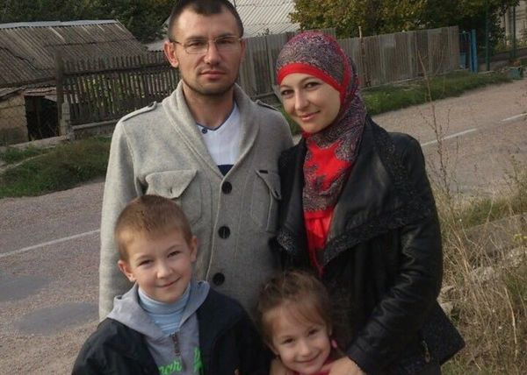

The final hearing in the trial of Emir-Usein Kuku and his co-defendants is expected soon. Emir-Usein Kuku is a Crimean Tatar who peacefully denounced the human rights violations taking place since the occupation of Ukraine’s Crimean Peninsula by the Russian Federation. He has been in pre-trial detention, separated from his wife and children since February 2016. He is facing trumped-up charges, which carry up to 25 years in prison. Emir-Usein Kuku and his co-defendants are prisoners of conscience and should be released immediately and unconditionally.
Action request - Send the attached letter to The Embassy in London before 11th November.

FINANCES
We currently have £275.76 in the account.
WRITE FOR RIGHTS
We have planned the following events which you may be interested in supporting
Saturday 30 November
Stall at Culcheth Christmas Market 10am to 4 pm in the Methodist Hall (Ellesmere Street)
Tuesday 10th December
Open morning at the Quakers Academy Way from 9am to 12 noon
Weekend 13th to 15th December
Christmas Tree Festival @ Newchurch Parish Church,
November (Date to be decided)
In addition St Monica’s church congregation will once again be supporting Write for Rights at their church
Thursday 5th December
Chester University (Padgate Campus) – a group of students are supporting Write for Rights in their lunch time with our help!
FILM OFFICIAL SECRETS
For cinema lovers, local cinemas are screening ‘Official Secrets’ this week, a biopic of Iraq war whistle-blower Katharine Gun (Keira Knightley)
TAKE ACTION FOR DOMESTIC ABUSE SURVIVORS
Help protect survivors of domestic abuse who are migrants by calling on the UK government to offer them support, free from discrimination,https://www.amnesty.org.uk/actions/domestic-violence-bill-migrant-women-surviors.
NIGERIA
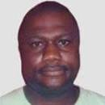
Amnesty International mourns Nigerian human rights activist Patrick Naagbanton was a fearless and inspirational human rights champion, who dedicated his life to helping others, Amnesty International said today, mourning the death of the 49-year-old activist and writer in Port Harcourt, Nigeria on 21 September 2019. “Patrick’s life work was to campaign for justice and defend the rights of ordinary Nigerians. He leaves behind an enormous legacy - not only in terms of all those people he helped, but also the countless activists he mentored and inspired,” said Kumi Naidoo, Amnesty International’s Secretary General. Patrick worked across the country, but his primary focus was on the situation in his home region, the Niger Delta. This has suffered from devastating pollution caused by the oil industry, as well as years of militancy, high crime levels, and politics-related violence. “Patrick was a highly skilled and effective human rights investigator in one of the riskiest parts of the world. He had an incredible contact book, and liked to travel by public transport to know what ordinary people were talking about. He was charming, charismatic, selfless and courageous. Amnesty International has lost a close friend,” said Kumi Naidoo. Patrick Naagbanton started out as an activist during the ultimately successful pro-democracy campaign.
The Islamic Movement in Nigeria (IMN)—
Members sent letters appealing on behalf of injured members of The Islamic Movement in Nigeria currently in police custody and in need of urgent medical attention.
At least 15 members of the Islamic Movement in Nigeria (IMN)—including two children—are suffering from gunshot wounds and need urgent medical attention. The IMN members were injured when police used tear gas and live ammunition to disperse a peaceful protest they were participating in. They have been denied access to medical care and to their lawyers or family members since their arrest on 22 July
BURMA - Aung Marm Oo

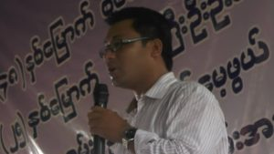
More than 150 days (5 months) have passed since Aung Marm Oo, Chief Editor of Development Media Group went into hiding following charges under the Unlawful Association Act and receiving death threats. Burma Campaign UK calls on the government of Burma to immediately drop all charges against Aung Marm Oo and Development Media Group.

Journalists at the Development Media Group have been interrogated by Special Branch police and Aung Marm Oo’s family members have also been questioned. The Unlawful Associations Act is frequently used by the military to arrest and jail journalists and activists. It effectively allows the military and police to use any contact with a member of an ethnic armed organisation to be considered as providing assistance or promotion or being a member of that organisation.

As the military has stepped up its operations against the Arakan Army in Rakhine State, it has been deliberately targeting civilians, with civilians being killed, tortured, arrested and displaced. Human rights violations by the military against the local ethnic Rakhine population and others fit the legal criteria of crimes against humanity and war crimes.

The military and government of Burma have made it increasingly difficult for media to report on what is taking place in the State.

