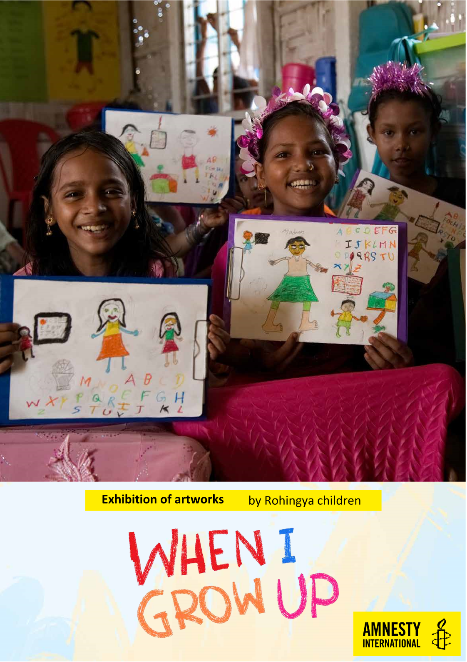

**Kutupalong Refugee Camp in Bangladesh is “home” to 600,000 Rohingya who have fled persecution in Myanmar.**

**Denied the right to a formal education,the children of the camp still have dreams for their future just like children all over the world.**

**Come and see their artwork in The Minster, Sunderland, SR1 3ET FROM 13th October TO 15th November, 2019!**