DATES
GROUP MEETING
Thurs. Sept 19th Sept. 7.30 pm to 9.30 pm
@ Nora Street Community House, HOWLEY
ADVANCE NOTICES
Sat. 30th November
2019 Write for Rights - Stall in the Methodist Hall / Culcheth Community day
Weekend 13th – 15th December
Christmas-Tree Festival at Newchurch Culcheth
Friday 24th January 2020
Provisional date for a TESCO collection

México

Murder of journalists continues unabated
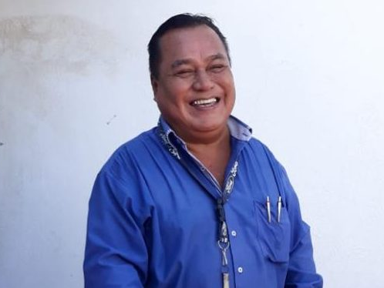
Jorge Ruiz Vazquez (pictured) became the third reporter in a week to be murdered in México. He was shot on 2 August days before he was scheduled to testify before state authorities about previous death threats. He alleged that the mayor was behind the threats. Edgar Alberto Nava, who also served as a municipal official in Guerrero state, was killed the same day. Three days before, Rogelio Barragán, who covered the police in Morelos, was found dead in the trunk of a vehicle with signs he had been shot and tortured. And on 24 August the body of Nevith Condes Jaramillo, a reporter who posted stories on his website, was found with stab wounds.
Tesco Collection Jan. 2020

Thanks to Gill’s persistence we have been offered the provisional date of Friday 24th January for an indoor collection at Tesco WINWICK Road store - to be confirmed in October.

CONVENTION ON THE RIGHTS OF THE CHILD

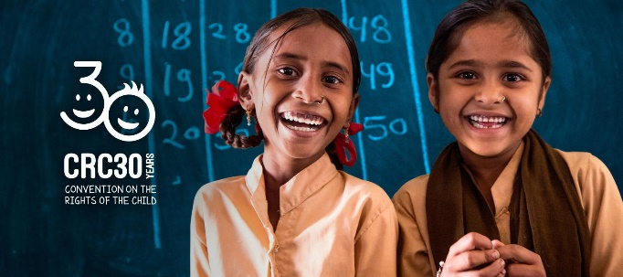

30 years of children’s rights
The Convention on the Rights of the Child was agreed 30 years ago in November 1989. Almost every country in the world has signed up to it – except for the USA.

The treaty lists important rights that every child & young person under the age of 18 should have.
These include:
- The right to food, water, and healthcare
- The right to be protected from harm
- The right to education
- The right to play
- The right for children’s voices to be heard in decisions that affect them

Make their voices heard
In 2011 the UN added Optional Protocol 3 which means that children can make complaints directly to the UN Committee on the Rights of the Child, if they believe their rights have been breached. This was a huge step forward because governments can often play a huge role in violating those rights. However, the UK government has not made this legally binding. Children shouldn’t have to wait to grow up before they’re heard. It's time to make those rights real, and to strengthen the voices of young people who are fighting for their futures.

Sign the on line petition.
EVELYN HERNÁNDEZ ACQUITTED
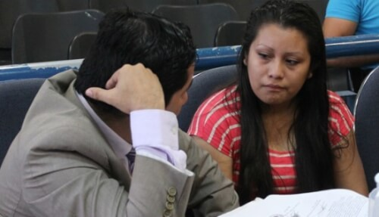

The acquittal of Evelyn Hernández is being hailed a victory for human rights. Erika Guevara-Rosas, Amnesty International's Americas director, said: “This is a resounding victory for the rights of women in El Salvador. It reaffirms that no woman should be wrongly accused of homicide for the simple fact of suffering an obstetric emergency.” Now that Evelyn has been acquitted, Amnesty International calls on El Salvador to end the shameful and discriminatory practice of criminalising women once and for all by immediately revoking the nation’s draconian anti-abortion laws.”

CHARGES AGAINST MAURITANIAN BLOGGERS DROPPED
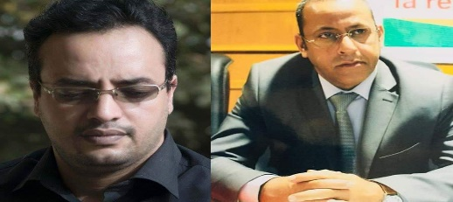
All the charges against bloggers Cheikh Jiddou and Abderrahmane Weddady were dropped by a judge, who also dismissed the case against them, on 29 July. Their travel and identification documents were also returned to them. Both had been conditionally released on bail on 3 June. The two bloggers were arrested on 22 March by the economic crimes police in Nouakchott after they posted comments on Facebook condemning corruption. Their comments came after media articles were published alleging that some Mauritanian officials had acquired wealth illegally and stashed it abroad. Afterwards they were transferred to the Central prison of Nouakchott but in early June they were released on bail. Cheikh Jiddou said ‘‘I would like to thank all the Amnesty International members who have been mobilized since the beginning. I will not give up my fight to defend human rights in particular the right to freedom of expression’’.
BREAKING THE SILENCE
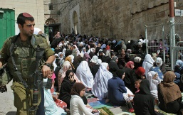
Founded in 2004 by a group of soldiers who served in Hebron, and to this date has collected more than 700 testimonies from soldiers who represent all strata of Israeli society and cover nearly all units that operate in the Territories. The organization publishes these testimonies, holds lectures, house meetings, and other public events to bring to light the reality in the Territories through the voice of former combatants, and also conducts tours in Hebron and the South Hebron Hills region with the aim of giving the Israeli public access to the reality that exists in the Occupied Territories.
https://www.breakingthesilence.org.il/
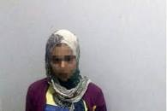
EGYPT: HIGH SCHOOL STUDENT WHO KILLED RAPIST RELEASED
South Giza Court released 15 year-old
Amira Ahmed Rizk on bail. She was detained in July after stabbing a microbus driver when he attempted to rape her. Despite her age, she had been detained and prosecuted as an adult.

