|  |  |
| --- | --- |
| LOGO | **MANCHESTER AMNESTY GROUP NEWSLETTER**  **June 2019**  <http://manchester.amnesty.org.uk/>  Facebook page: Manchester Amnesty International  Facebook group: Manchester Amnesty  Twitter: @amnestymanc |

**Next Group Meeting**

N.B. Now on 2nd Monday of the month: 7.30 – 9.30pm.

**Monday 10th June**

**Cross Street Chapel**

**Cross Street M2 1NL - Look for the Amnesty Candle.**

**Campaign Planning**

Find out what the UAE, Refugee and Crisis and Tactical campaigns are all about

and get involved in planning our activities.

**Sexual and Reproductive Rights in the Dominican Republic**

AIUK are planning a campaign on sexual and reproductive rights in the Dominican Republic where police are routinely raping, beating and humiliating women who engage in sex work – often at gunpoint. This is a new area of work for Amnesty and Emily Butler, the campaign lead, is coming to find out how we feel about campaigning on this topic.

*A few of us will meet up at Sandinista on Old Bank Street for a bite to eat about 6pm before the meeting. All welcome to join us.*

**Campaigning**

**UAE (Mohammed al-Roken & Ahmed Mansoor)**

**Ahmed Mansoor**

After many weeks of hunger strike in March-April, Ahmed has finished his strike due to marked health concerns. Currently the UAE is describing 2019 as the “Year of Tolerance” . We feel the lack of due process for prisoners in the country undermines the principles of “Peace, humanity, coexistence, respect” which they outline in the marketing for the Year of Tolerance (<https://www.theyearoftolerance.ae/en/>)

We are planning a number of events to raise the profile of Ahmed’s case and keep the pressure on the authorities in UAE:

* Petition at Didsbury festival regarding Ahmed to the Emirati authorities and the Manchester city council.
* October/December - Peterloo year of protest Poetry event with Young Identity and workshops in weeks before with school amnesty groups
* October – Birthday vigil for Ahmed
* All Year: We run a monthly letter writing rota to keep a regular stream of letters going to significant authorities

If you would like to be involved in working on the UAE, please contact Lil – [lil.ratcliffe@yahoo.co.uk](mailto:lil.ratcliffe@yahoo.co.uk) .

Further to the above events we are connecting with AI groups around the country to form larger events in the coming months which we will update as news comes in.

**Other news from UAE**

15/05/19 – Lack of due process and reports of torture in the imprisonment of Lebanese men.

Three Lebanese men have been charged with terrorism offences but the trial is marred by concerns regarding due process. Eight Lebanese Shi’a muslims were detained from Dec 2017 to Feb 2018, they lived and worked in UAE for more than 15 years, seven of them worked with Emirates Airline. They have been held in solitary confinement and denied legal representation. They have reported being tortured and having no access to lawyers during pre-trial interrogation. Though five were released one has been sentenced to life imprisonment and two to 10 years.

Lynn Maalouf, Amnesty International’s Middle East Research Director, said:

*“The absence of basic requirements of a fair trial – such as having access to a lawyer – strips today’s verdict of any reliability or credibility”*

*“It is welcome news that five men were acquitted; however, the authorities must now effectively investigate allegations of torture and quash the unreliable convictions of the remaining three. If there is not sufficient evidence against them and they cannot be prosecuted fairly, they too should be acquitted and released. The flagrant disregard for human rights in this case is incongruous with the global image of a state-of-the-art, open and inclusive state that the authorities in the UAE seek to project”*

Action:

Visit the AI website and tweet and share this story. <https://www.amnesty.org/en/latest/news/2019/05/uae-three-lebanese-men-receive-heavy-sentences-including-life-despite-grave-fair-trial-concerns/>

**People’s History Museum event**

As well as being a prolific blogger before his imprisonment, Ahmed Mansoor also wrote poetry. Hazel is in active discussion with the People’s History Museum and Young Identity about a poetry event linked to the Peterloo commemorations– the date seems to be drifting backwards. December 12th is currently being discussed which would tie in well with Human Rights Day.

If you want to get involved in planning this event, email [hazelerrey@yahoo.com](mailto:hazelerrey@yahoo.com).

**Refugee I Welcome**

**Refugee Week**

With Refugee Week taking place next month, we see lots of events happening around the city, recognising and celebrating the contributions that refugees have made to our communities. The theme this year is ‘you, me and those that came before’ - an invitation to explore the lives of refugees – and those who have welcomed them – throughout the generations.

The events that Amnesty are involved in and looking for support to staff the stalls, are:

Didsbury Festival – 8th June (see later)

Horizon’s Festival – 15th – 23rd June (Exact event TBC)

<https://homemcr.org/event/horizons-festival-2019/>

Refugee World Cup – 22nd June ALBERT PARK, GRECIAN STREET, MANCHESTER, M7 1JF

It would be great to see members of our group attending these events and showing their support.

**Amnesty Petitions**

You can also show your support by signing these two Amnesty petitions:

* **Reunite refugee families**

**‘Everyday family life is full of wonderful moments we all take for granted’.**

But many refugee families are being forced apart. After fleeing conflict and persecution, unfair and restrictive rules are forcing people to make an impossible decision.  
  
The stroke of a pen could reunite these families. Tell the new Home Secretary, Sajid Javid to change these rules - sign our petition.

<https://www.amnesty.org.uk/actions/home-secretary-reunite-refugee-families>

* **Lift the Ban**

People seeking safety in our country are banned from working. Unable to provide for themselves and their families, they’re often left to live in poverty.

Adding your voice means we can fight harder for change and win over those with the power to make it.

<https://www.refugee-action.org.uk/lift-the-ban/>

**Individuals at risk**

**Letter Writing Drop-In**

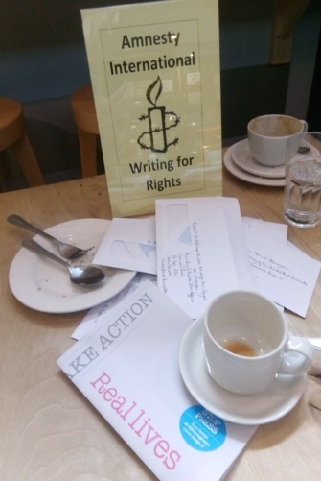This month we had our regular bi-monthly letter writing drop in session at the Eighth Day Café. Only three people turned up, but they wrote 18 letters between them.

Our next session will be on:

**Saturday 27th July**

**2 – 4 pm**

**Eighth Day Café**

**Oxford road**

**Come along and make a difference!**

**Whalley Range stall**

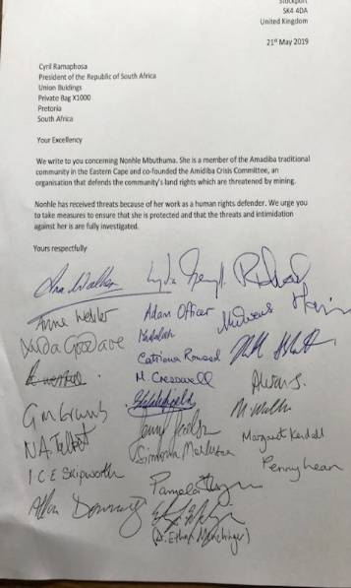We had a stall at the Land Rights event organised by the Whalley Range for Peace and Justice group. We had a letter for the audience to sign to the South African authorities on behelf of Nonhle Mbuthuma who is a member of the Amadiba tradional community in the Eastern Cape whose land rights are currently under threat due to mining.

Thanks to Talia and Toni for running the stall.

**Crisis and Tactical**

**PALESTINE**

**Nakba – 71 years**

The 15th May 2019 marked the 71st anniversary of Nakba Day (Nakba is Arabic for catastrophe). This is the day when, in 1948, more than 700,000 Palestinians were forced out of their homes and land following the creation of the State of Israel. Since then Israel, while allowing any Jewish to settle in the newly created State, has refused to recognize Palestinians the right to return and has not offered any compensation for their loss. This is a violation of international law.

To mark this anniversary, Amnesty International teamed up with Tanya Habjouqa, an award-winning photographer*,* and created a website called ‘[70+ Years of Suffocation](https://eur02.safelinks.protection.outlook.com/?url=https%3A%2F%2Fnakba.amnesty.org%2Fen%2F&data=02%7C01%7Csara.hashash%40amnesty.org%7C1ee4cbb625a4460d813f08d6d7a6975a%7Cc2dbf829378d44c1b47a1c043924ddf3%7C0%7C0%7C636933507846234006&sdata=vW7WhosC%2FiCUpFqkxVM0CRpj6Aoh7cbuVyKuYPlOe0Y%3D&reserved=0)’. The website contains images and testimonies of Palestinian refugees living in the Occupied Palestinian Territories (OPT), Jordan and Lebanon.

<https://nakba.amnesty.org/en/chapters/west-bank-gaza/>

Currently there are more than 5.2 million registered Palestinian refugees. Many have been forced to live their entire lives in overcrowded camps in dire conditions and are denied access to essential services.

Philip Luther, Amnesty International’s Research and Advocacy Director for the Middle East and North Africa said: “There can be no lasting solution to the Palestinian refugee crisis until Israel respects Palestinian refugees’ right to return.’’… “Palestinian refugees in Lebanon, Jordan and the Occupied Palestinian Territories are trapped in a cycle of deprivation and systematic discrimination with no end in sight. For many of them life is full of suffocating restrictions and has become a living hell.”

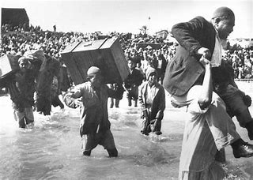

An image from Nakba -15th May 1948

Challenges for Palestinian refugees in Lebanon

Although the majority of Palestinian refugees in Lebanon were born in the country and have lived there all their lives, they cannot acquire Lebanese nationality, and many remain stateless and deprived of access to public services including medical care and education.

Palestinians are banned from practising over 30 professions including medicine, dentistry, law, architecture and engineering. Such restrictions have trapped many Palestinian refugees in deprivation and poverty.

Challenges for Palestinian refugees in Jordan

Around 2.1 million Palestinian refugees live in Jordan. Around three quarters of them have been granted Jordanian citizenship, giving them access to health care and education. However, over 600,000, including some 150,000 who fled to Jordan from the Gaza Strip following the 1967 Israeli-Arab conflict, were not naturalized and do not have sufficient access to public services.

Some 370,000 of Palestinian refugees live in camps where conditions are generally sub-standard.

A decision by the US authorities in 2018 to cut funding to the UN Relief and Works Agency for Palestine Refugees (UNRWA), which provides essential services, including health care, education, emergency assistance and jobs, to millions of Palestinian refugees has put further strain on their lives.

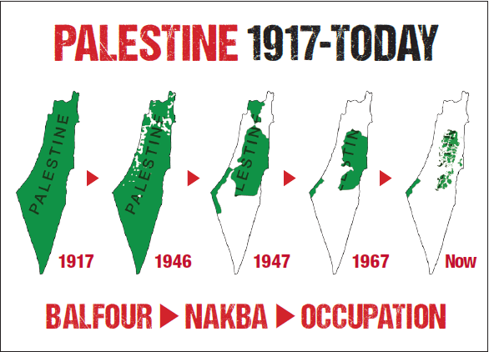

**Take Action!**

Amnesty’s current campaign is targeting businesses that are profiting from Israeli’s occupation of Palestine. Among those, TripAdvisor and Airbnb are advertising properties and amenities in the Occupied Palestinian Territories (OPT).

* Sign the petition to ask TripAdvisor to check out from the OPT. <https://www.amnesty.org.uk/actions/checkout>
* Write to Airbnb CEO Brian Chesky asking him to keep his promise, made in November 2018, to pull Airbnb’s 200 listings from the OPT. (Address: Airbnb UK, Compton Courtyard, 40 Compton St, London EC1V 0BD)

**SYRIA**

**Deliberate attacks on hospitals**

The Syrian government, aided and abetted by Russia, is carrying out deliberate and systematic assaults on hospitals and medical facilities in Idlib and Hama, Amnesty International stated.

This statement comes after Amnesty interviewed 13 people about recent attacks on four hospitals (Kafranbel Surgical Hospital, Pulse of Life Hospital, Kaferzita Cave Hospital and Al-Sham Hospital) and verified videos that corroborate their testimonies. All hospitals are now out of service.

Staff at these hospitals told Amnesty they were targeted despite sharing their coordinates with the Syrian and Russian governments. According to the UN and Syrian medical organisations, at least 15 hospitals have reportedly been damaged or destroyed in Idlib and Hama since the beginning of May. Recent attacks in the region have led to the displacement of 180,000 people, exacerbating an already dire situation where some 1.5 million people need urgent humanitarian assistance.

Amnesty called for Russia to be pressured over its part in these attacks at May’s UN Security Council discussion on the crisis situation in northwest Syria.

Attacks on hospitals and medical facilities in opposition-controlled areas have become a familiar feature of the Syrian war. Hospitals in Aleppo, Daraa and the Damascus countryside were also targeted during Syrian government operations to reclaim these areas. In numerous cases, hospitals and humanitarian organisations said they had shared their coordinates with the Syrian government to try to prevent attacks - all to no avail

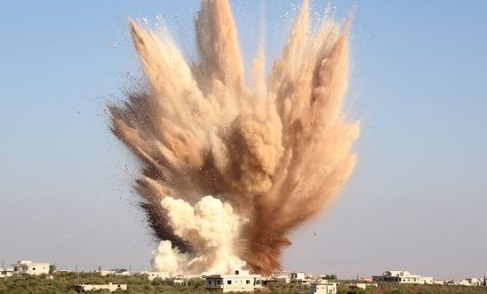

**Take Action!**

According to evidence gathered by Amnesty, the US-led coalition has also been responsible for the death of civilians (at least 1,600) as a consequence of their air strikes targeting Isis and terrorist groups. The US, the UK and France, part of this coalition, deny their responsibility. In cooperation with Airwars, Amnesty has created a website called: Rhetoric versus Reality: How the ‘most precise air campaign in history’ left Raqqa the most destroyed city in modern times, which contains all the evidence collected.

You can ask for justice and tell the UK to recognise its responsibilities into the death of Syrian civilians:

<https://www.amnesty.org.uk/actions/demand-justice-syrians-killed-us-led-coalition>

**Assad’s prisoners**

At our meeting in May, Dr. Haytham Alhamwi, Director of Rethink Rebuild Society, talked to us about the arbitrary detentions and ill treatment that the government of Assad have imposed on Syrians since the conflict started in 2011. On the waves of the Arab Spring, Syrians started a peaceful revolution, sometimes asking for simple things like cleaner streets, an end to the corruption widely spread among public authorities and a ban on smoking. For this thousands of Syrians have been summarily detained, confined in isolation in appalling conditions, tortured and killed.

Dr. Alhamwi has experienced detention in isolation himself, after being subjected to a trial in front of a Martial Court, without a lawyer. Amnesty International contributed to his release.

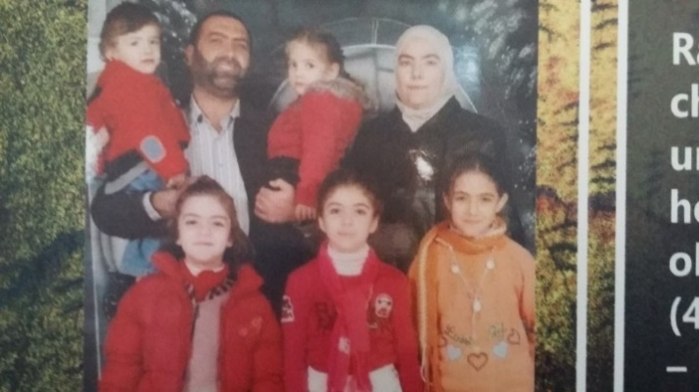

Rania al-Abbasi, a dentist, and her family were taken from

their home in Damascus in 2013. There has been no news

about their whereabouts since then.

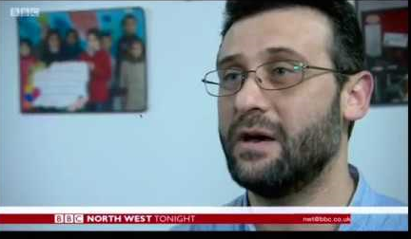

Dr. Alhamwi in a BBC interview

We thank Dr. Alhamwi for having shared his personal experience with us and for having shared the stories of friends and family who have also endured such injustice. Some of them have died because of the harsh condition and torture in prison. Our solidarity goes to all Syrians who are suffering under Assad’s regime.

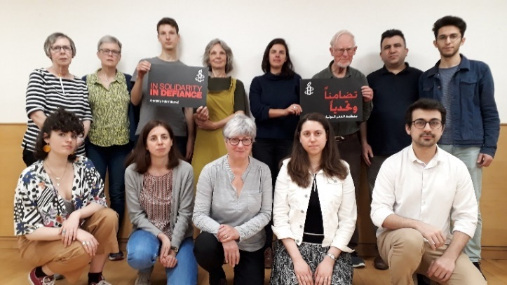

**YEMEN**

**Court Appeal against UK Government for selling arms to Saudi Arabia**

In early April 19, Amnesty International, Human Rights Watch and Rights Watch UK have intervened at the Court of Appeal in London seeking to challenge the legality of licences issued by the UK Government for arms exports to Saudi Arabia for use in Yemen, despite the risk of the weapons being used for serious violations of international humanitarian law in the conflict.

The case was originally brought forward by Campaign Against the Arms Trade (CAAT) in February 2017. At that time the court dismissed CAAT’s case.

Extensive and credible reports, including Amnesty’s [own research in Yemen](https://www.amnesty.org/en/search/?country=38563), have demonstrated that British-made weapons have been used repeatedly - and continue to be used - to commit serious violations of international humanitarian law, including possible war crimes. According to publicly-available information, Saudi Arabia has failed to adequately investigate these violations, nor has it held those responsible to account. As such, there is a clear risk that authorising further arms exports would lead to further serious violations in Yemen, and would be counter to the UK’s obligations under domestic and international law.

Other countries have already responded to public pressure and have reacted.

Countries that partly or totally suspended arms sales to Saudi Arabia and the United Arab Emirates (part of the Saudi Arabia-led coalition):

-The Netherlands

-Belgium (Flemish region)

-Greece.

Countries that have put in place restrictive measures on Saudi exports:

-Austria

-Ireland

-Sweden

-Switzerland

Countries that announced they would be suspending arms transfers to Saudi Arabia:

-Germany

-Norway

-Finland

-Denmark

Amnesty has repeatedly called on the UK Government to suspend all arms sales to Saudi Arabia. Since the conflict began in 2015, the UK has sold £5bn of arms to Saudi Arabia, including more than two dozen Eurofighter Typhoon war planes. In March, Amnesty activists took a [replica Typhoon plane](https://www.amnesty.org.uk/press-releases/typhoon-plane-taken-parliament-protest-uks-arming-saudi-arabia) to Parliament in protest and handed in a 56,000-signature petition to the Secretary of State for International Trade Liam Fox.

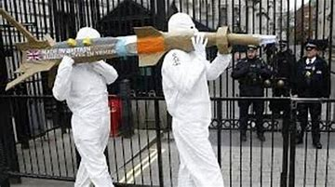

Pictures from the stunt

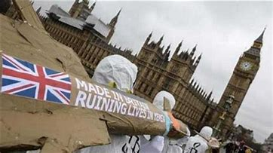

**Leaked French military documents prove use of French weapons in Yemen**

On 15th April leaked French military documents were [published](https://made-in-france.disclose.ngo/en/chapter/yemen-papers/) by an investigative news site and confirmed the widespread use of French weapons in the conflict in Yemen.

Lynn Maalouf, Amnesty International’s Middle East Research Director, stated:

*“The information made public today should spur the French government to immediately suspend all arms transfers that could be used by any of the warring parties in Yemen. Amnesty International’s repeated calls on the French Ministry of Defence to be transparent about French arms transfers since the conflict began have fallen on deaf ears.”*

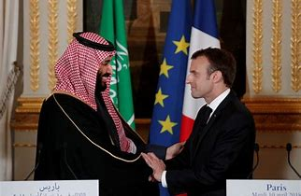

**Hodeidah investigation -French involvement**

A [recent investigation](https://www.amnesty.org.uk/press-releases/uae-arming-militias-yemen-weapons-western-countries-new-investigation) by Amnesty analysing open-source information around the battle for Hodeidah identified how French-manufactured Leclerc tanks that had been transferred to the UAE were among the military equipment being used. According to open-source information, the UAE has diverted similar military equipment to unaccountable UAE-backed militias. Meanwhile, Amnesty has previously verified the use of French- supplied CAESAR truck-mounted Howitzers on the border between Saudi Arabia and Yemen.

According to the [UN](https://www.ohchr.org/en/NewsEvents/Pages/DisplayNews.aspx?NewsID=24373&LangID=E), in the past three months there has been a surge in hostilities in governorates bordering Saudi Arabia leading to an increase in civilian casualties and an influx of internally-displaced people.

**Turkey**

We have just received an Urgent Action on behalf of 47 people recently detained by the anti-terrorism branch of the police in Urfa province, south eastern Turkey.

There are credible allegations of torture being used and although 22 people have now been released the 25 people still in detention remain at risk of torture or other ill-treatment.

Please send protest letters to the Turkish government (full details are attached with this newsletter)

**Group News**

[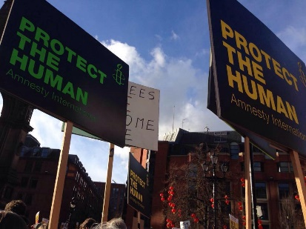](https://www.facebook.com/109895619228/photos/10210709189059)**Trump visit**

We’re sure that you are all aware that President Trump will be making a state visit at the beginning of June. Given Trump’s disdain for human rights issues, we hope to join in with the anti-Trump demo in Manchester, bringing our own messages to the protest.

Monday 3rd June, 6pm in CATHEDRAL GARDENS

See <https://www.facebook.com/events/367038847238924/?ti=icl>

**Didsbury Festival**

We have a stall at the Didsbury Festival on Saturday 8th June and will be featuring in the Reunite Families petition (see I Welcome campaign) with some craft opportunities to draw the families in and a petition on the UAE.

This takes place in Didsbury Park (South end of Didsbury village) and is always a very busy affair (even if it pours with rain!).

Volunteers needed

We need help to staff the stall from 11am to 1.30 pm, and from 1.30-3.30pm, 3.30 – 4.30 inc packing up.

If you can help, please email [hazelerrey@gmail.com](mailto:hazelerrey@gmail.com).

**Subscriptions please!**

Annual donations from members are vital to keep the Group going. The suggested sum is £20 if you have a wage, £5 otherwise, or whatever you can afford to give. Please bring your cash or cheque to the next meeting or contact Treasurer Sean Dunne ([Sean.a.dunne@btinternet.com](mailto:Sean.a.dunne@btinternet.com)) and he will tell you how to get the money to him.

**Thanks!**

**Other News**

**War School**

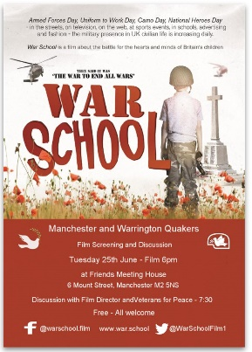Free film screening and discussion of a film about the battle for the hearts and minds of Britain’s children organised by the Quakers of Manchester and Warrington. Tuesday 25th June at 6 pm Friends Meeting House,6 Mount Street, Manchester M2 5NS

**Join Stone Flowers and Manchester Camerata for**  
  
**Conflict & Compassion**  
  
**Gorton Monastery, Manchester @ 3pm, Sunday 23 June    
Refugee Week 2019**

See <https://www.eventbrite.co.uk/e/stone-flowers-and-manchester-camerata-gorton-monastery-23-june-tickets-61227753860>

N.B. If you wish to subscribe to, or unsubscribe from, this newsletter and other general group emails

from the Manchester Group of Amnesty International, please email manchestergroup@amnesty.org.uk