

**Amnesty Letter Writing afternoon**

**Thursday 18 July, 2.00-3.30 p.m.**

**Quaker Meeting House**

**Bancks Street, Minehead**

**Join us and support**



**human rights defenders across the world**

Pens, paper and stamps supplied, with information about people unjustly in prison or at risk for standing up for the rights of others. Your cards and letters to relevant authorities can really help.

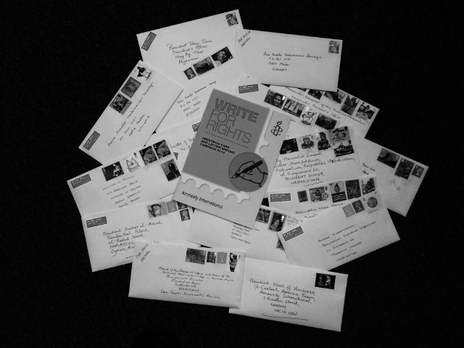

Refreshments provided.

**Organised by Amnesty International Minehead**

**For more information contact 01643 821209**