23rd March 2019
East Anglia Amnesty International Conference

Our Rights in Today’s Climate
Universal Human Rights in the age of Climate Change and Populism
Jesus Lane Friends’ Meeting House,12 Jesus Lane Cambridge UK CB5 8BA

10am Registration opens. Coffee & Tea

10:30am Welcome

10:35 Keynote speech: “Environmental (in)justice: reflections on the ecological crisis and human rights”
Dr Damien Short Director: Human Rights Consortium, University of London
This talk will explore the ecological crisis from a human rights perspective, discussing a range of issues from human consumption patterns, to the rise of extreme energy and resource scarcity and the growing threats to environmental human rights defenders

11:35 Workshops
- Brazil
David Palmer, Country Co-ordinator Brazil, Amnesty International
- Amnesty’s policy on Climate Change
David Ford & Liesbeth ten Ham
- Women’s rights and the environment
Eva Rehse, Executive Director, Global Greengrants Fund UK
- India & Bangladesh
Jerry Allen, AIUK South Asia Country Coordinators Team leader

12:45 Lunch (in three groups) A. 12:45 B 13:10 C. 13:30
Action & information tables, tea/coffee in the upstairs rooms (Please do not take any food or drink into the main meeting room)
Exhibition (tbc)

14:00 Workshops
- Writing as a form of activism
Aude Konan, novelist, journalist and filmmaker.
- Creative activism: Zines for Justice
Lucie JF
- Self-care for activists [Note: this workshop will start at 14:15]
Beatriz Serrano
- Fundraising
Yvonne Heaton, Community & Events Fundraising Manager, Amnesty UK

15:00 Human Rights under threat: Do we need a new playbook?
Panel: Manali Desai, Political Sociologist, University of Cambridge (Chair)
Eva Rehse, Executive Director, Global Greengrants Fund UK
Melanie Strickland, Stansted 15
Tim Gee, UK Priority Campaign Manager, Amnesty UK

16:00 Close

You are welcome to stay until 16:30 to informally discuss the issues raised.
Speaker Biographies & Workshop Details

Keynote speech: “Environmental (in)justice: reflections on the ecological crisis and human rights”
This talk will explore the ecological crisis from a human rights perspective, discussing a range of issues from human consumption patterns, to the rise of extreme energy and resource scarcity and the growing threats to environmental human rights defenders

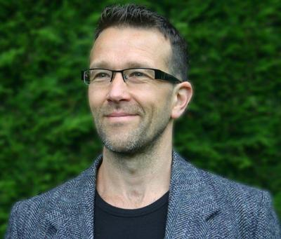
Dr Damien Short
Dr Damien Short is Director of the Human Rights Consortium (HRC) and a Reader in Human Rights at the School of Advanced Study. He has spent his entire professional career working in the field of human rights, both as a scholar and human rights advocate. He has researched and published extensively in the areas of indigenous peoples’ rights, genocide studies, reconciliation projects and environmental human rights. He is currently researching the human rights impacts of extreme energy processes (e.g Tar Sands and Fracking - see our designated HRC website http://extremeenergy.org) .
Dr Short is a regular academic contributor to the United Nation’s ‘Expert Mechanism on the Rights of Indigenous Peoples’ and an academic consultant for the ‘Ethical Trade Task Force’ of the Soil Association. He is also Editor-in-Chief of the International Journal of Human Rights (Taylor and Francis). He currently advises local anti-fracking groups in the UK and county councils on the human rights implications of unconventional (extreme) energy extraction processes such as fracking.

Morning Workshops
- Brazil
The Effect of Industrial and Agricultural Changes in Brazil and its impact on the human rights of civil society, including rural communities, indigenous peoples and those acting in defence of their rights.

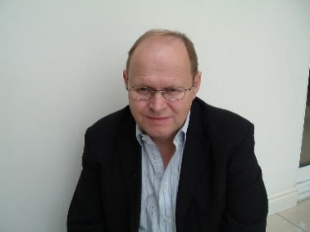
David Palmer
David Palmer has been an Amnesty International member since the 1990’s and appointed as the Brazil Country Coordinator for AI UK since July. He has worked with a variety of other NGOs on human rights issues. As a member of the Colombian Caravana, he assists with advocacy in relation to particular cases and has participated in three delegations to Colombia. He has also been involved in a mission to Mexico with BHRC. He conducted research leading to a PhD in 2004, on the investigation of police-related deaths in South Africa.

- Amnesty’s policy on Climate Change
AI’s draft policy on human rights aspects of climate change, and the recent discussions within the international movement about how it might develop.

David Ford
David Ford has been an active member of the Norwich Amnesty Group since 1977 and has been Chair for about fifteen years. He is now Treasurer and hold the casework file on the group’s long term case in Uzbekistan. In the 1980’s he was regional representative for East Anglia and an AIUK Board member for six years including one year on the Board’s Executive Committee. He has also served on the Board’s Active Members Sub Committee for four years.

Liesbeth ten Ham
Liesbeth ten Ham has a history degree from Utrecht University in The Netherlands and has lived in Cambridge for nearly twenty years, working in marketing, for a BME charity for which she led on refugee and migrant worker projects and currently setting up her garden design and mosaics company. She has been an activist for Amnesty International since she came to Cambridge and has held various local, regional and national volunteer roles. She has been regional representative for East Anglia since 2010 and as such has organised several other regional conferences. Her third and final term as regional rep will finish this spring.

- Women’s rights and the environment
The impacts of climate change and environmental degradation are not gender neutral. Our solutions cannot be either. Women around the globe are at the forefront of addressing the human rights impacts of climate change and environmental degradation. Socially defined gender roles in many societies place the responsibility for natural resource management and use squarely on women and girls. As a result, they are disproportionately impacted by damage to water, land, air and by natural disasters. Moreover, women environmental defenders experience very specific threats that are different to how male human rights defenders are affected. As research by Global Greengrants Fund has found, women environmental defenders are critically overlooked and underfunded in their work.

This workshop will explore the connection between gender justice and environmental justice, and how we can improve how we protect women’s rights and our planet at the same time.

Eva Rehse
Eva has been Executive Director of Global Greengrants Fund UK, an activist-led grantmaking organisation supporting grassroots environmental justice initiatives, since 2015. Previously, Evaworked for Amnesty International as project advisor and with CIVICUS/Scottish Council for Voluntary Organisations as project manager. Eva has an M.A. from Bonn University in Political Science and Sociology. She is a member of the European Steering Group of the EDGE Funders Alliance, and sits on the Alliance Magazine Editorial Advisory Board, as well as being an alumni of the Oak Foundation and Resource Alliance’s Future Leaders Programme.

- India & Bangladesh
The impact of climate change on Bangladesh and India and the plight of indigenous people (like Pavitri) battling against mining companies.

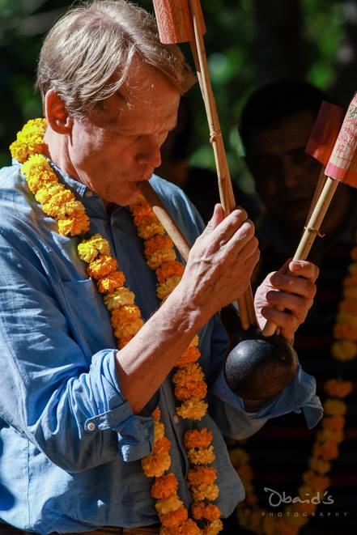
Jerry Allen
Jerry Allen is a Country Coordinator in the UK South Asia team. He has lived and worked in eastern Sri Lanka, Thailand, Tajikistan and Bangladesh and travelled extensively in India. He considers himself an ’accidental activist’, as he found himself in areas where human rights atrocities are occurring with very little outside awareness. It made him realise that these issues are ubiquitous.
He is particularly interested in Bangladesh and in the issues of the Indigenous people of South Asia (land-grabbing, violence against women, accessibility to education and health, the need to preserve languages and culture, etc.).

Afternoon Workshops

- Writing as a form of activism
How participants can use writing as a form of activism to either put a light on issues they are working to resolve or dealing with on their personal lives. They can use various forms, such as blog posts, article, open letter, rants, etc. They will also learn how to center their writings to a specific audience: either the people impacted by these societal issues, or the ones who created it, or anyone, really. Eventually, the workshop will help them design an end goal: who are they writing these texts for and what is their goal?

Aude Konan
Aude Konan wrote My little sister (Ma petite soeur), her first novel, at only 12 years old. It got published by the publishing company Dagan. As a playwright, she is an alumni of Talawa TYPT 1, Soho Writers Group and the Royal Court’s Introduction to Playwriting. Aude is an award-winning writer, and writes scripts as well as working as a journalist for British, French and American magazines such as Complex UK, Okay Africa, and The Guardian covering a broad range of issues such as politics, culture,
environmental racism, sexism, queer phobia, etc.

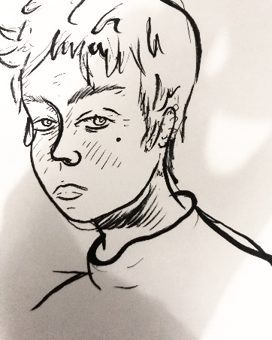
- Creative activism: Zines for Justice
A "zine" is term for a short, home-made magazine, a trend which emerged in the late 70’s from the punk movement. While they have usually been about music there has always been a political element to zines, from the riot grrrl scene in the 90’s up into the present day young people have been making zines to share their political opinions and have their voice heard.

Lucie JF
“I always believed that if you want to see something in the world then you should be the one to make it happen. That’s why I’m proud to be able to give people a space to create their own zines, encourage a focus on human rights to help raise awareness, and get people feeling more hands and creative in activism.”

- Self-care for activists
Mindfulness- based self care for activism : join in a group discussion of the many challenges of activism and the use of mindfulness to notice and manage the pressure, expectations and the strong emotions that arise during campaigning.

Beatriz Serrano
Beatriz Serrano is a Psychologist and trainee psychotherapist offering Mindfulness Based Psychotherapy.

- Fundraising
How do you fundraise and how do you fundraise in a responsible way? What is the role of community fundraising in a big organisation such as Amnesty?
Yvonne Heaton
Yvonne Heaton, Community & Events Fundraising Manager, has worked for Amnesty since 2001 and set up the Community Fundraising Team at Amnesty International UK. The Community Fundraising Team manage all fundraising with Amnesty Activist groups, schools, universities, RAGs, faith organisations and other community groups and individuals. They also manage a Sponsored Events programme, in Memory Giving, Commercial Participator agreements with individuals and small companies and In Celebration Giving which covers life events such as weddings, anniversaries and other significant celebrations.

Panel
Human Rights under threat: Do we need a new playbook?

Dr Manali Desai
Dr Manali Desai received her PhD in Sociology from the University of California, Los Angeles where she trained as a comparative and historical sociologist. Her work encompasses the areas of state formation, political parties, social movements, development, ethnic violence, gender and post-colonial studies. Manali's first book State Formation and Radical Democracy in India, 1860-1990 (2007) was a historical analysis of the emergence of two different welfare regimes in India where social democratic parties have ruled consistently since independence. Manali has co-edited two books titled States of Trauma: Gender and Violence in South Asia (2009) and Building Blocs: How Parties Organize Society (2015).

Eva Rehse
Eva Rehse has been Executive Director of Global Greengrants Fund UK, an activist-led grantmaking organisation supporting grassroots environmental justice initiatives, since 2015. Previously, Evaworked for Amnesty International as project advisor and with CIVICUS/Scottish Council for Voluntary Organisations as project manager. Eva has an M.A. from Bonn University in Political Science and Sociology. She is a member of the European Steering Group of the EDGE Funders Alliance, and sits on the Alliance Magazine Editorial Advisory Board, as well as being an alumni of the Oak Foundation and Resource Alliance’s Future Leaders Programme.

Melanie Strickland
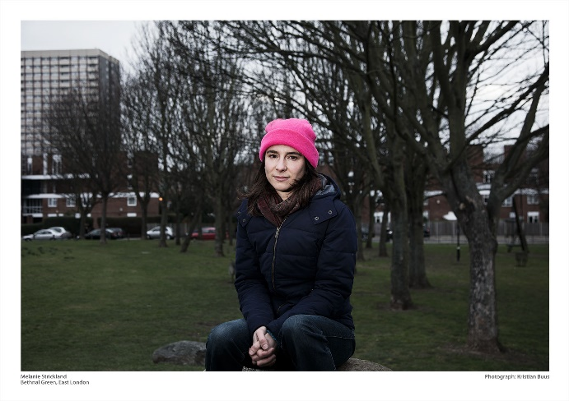
Melanie Strickland is a community activist. For years she has been organising with Plane Stupid, an environmental direct action group committed to preventing further airport expansion on social and climate justice grounds. She is a member of the 'Heathrow 13' and 'Stansted 15'. In March 2017 the 'Stansted 15' staged a peaceful direct action at Stansted airport to successfully prevent a deportation flight due to unlawfully deport people from the UK. 11 of the 60 people due to be deported that night remain in the country including trafficking survivors, parents of dependent children and those who have claimed asylum here.

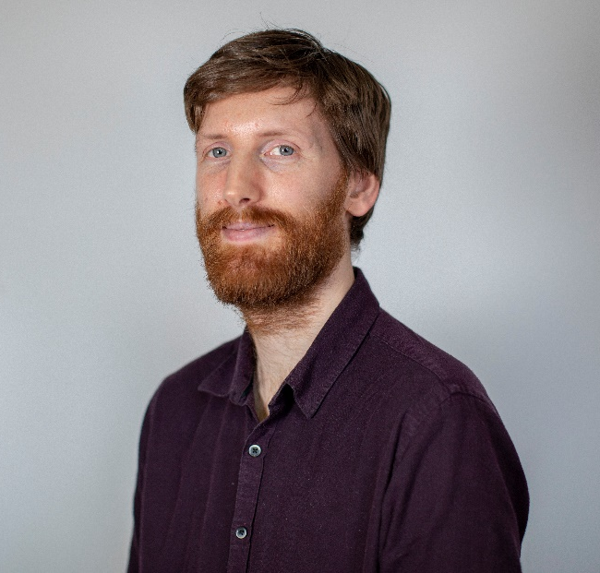
Tim Gee
Tim Gee is Amnesty International’s (maternity cover) Campaigns Manager for Human Rights in the UK. He has worked to protect the Human Rights Act, challenge racially biased policing and stand with Human Rights Defenders. He has previously campaigned with Friends of the Earth, Christian Aid and Quaker Peace and Social Witness. He has written three books about campaigning and social change. His first book entitled “Counterpower: Making Change Happen” was published in 2011 and shortlisted for the Bread and Rose prize for nonfiction. In the book he argues that no major movement has ever been successful without counterpower, or the power that the "have-nots" can use to remove the power of the "haves."

