Amnesty Campaigns / Strategy
‘OCCUPATION 50’ – This campaign continues following the statement from AirBnB that they will remove their bookings listed in the illegal colonies in the West Bank. (Firm action is, however, still awaited from that statement and East Jerusalem listings may be seen as outside of it.).
Amnesty International will continue to pursue the case that companies cannot operate in or with settlements in a way that respects international human rights. For this reason, the organisation calls on online companies named in the next stage of the campaign to stop listing or in any other way promoting properties, activities and attractions located in illegal Israeli settlements, or run by settlers in the OPT
The campaign will move on to other companies involved in the colonial economy in January and there will be further notice of possible actions and available materials associated with the campaign at the time.

NAKBA @ 70 Campaign (with active web-site, below !) – This Nakba campaign was launched on 11 December. The project focuses on 3 chapters of Nakba stories revolving around the theme of 70 years of suffocation. (Image from web site).
Amnesty International hired Tanya Habjouqa, an award winning photographer, to take photos for this microsite. The project is an immersive digital media project that allows the viewer to look at photos, videos, and audio while exploring the testimonies from refugees in the OPT, Lebanon, and Jordan.
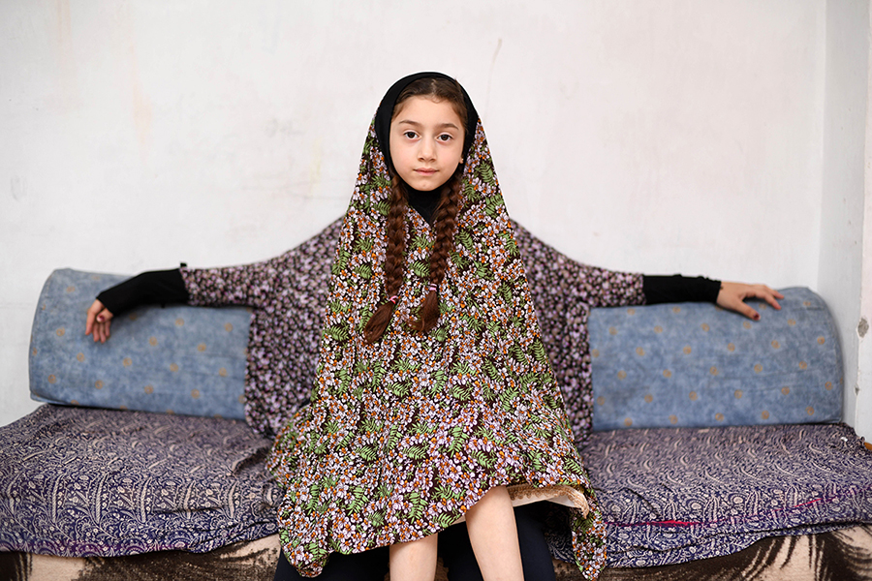
The main purpose of the project is to showcase the enduring issues facing Palestinian refugees in Lebanon, Jordan and the OPT, and to push out our longstanding calls for durable solutions. We will be releasing this photo-story on a microsite, as three distinct chapters, each focusing on a different set of rights violations that Palestinian refugees currently face. Both the Lebanon and Jordan chapters will focus on ongoing ESC rights by the Lebanese and Jordanian authorities, while the OPT chapter will focus on the Israeli army’s frequent use of tear gas during protests and raids in refugee camps in the West Bank and the Gaza Strip.
This campaign will run from December 2018 to June 2019, starting with the 70th anniversary of UN General Assembly Resolution 194 resolution on 11 December and ending soon after the 71st anniversary of the Nakba on 15 May 2019. Therefore, the microsite will also be shared and promoted periodically throughout the year to react to relevant issues related to Palestinian refugees.
The microsite can be found at :
https://nakba.amnesty.org/en/chapters/west-bank-gaza/#
Actions / Individuals at Risk
Suha Jabra (Social justice activist detained by PA) - The Palestinian authorities have transferred social justice activist Suha Jbara to a hospital in Jericho following a deterioration in her health condition. She has been on hunger strike since 22 November to protest her arbitrary detention. Her next court hearing is scheduled for 20 December. (Image – A poster supporting Suha Jabra).
Suha Jbara, 31, who is primary carer for three children, is a Palestinian, US, and Panamanian citizen. She is a social justice activist and is involved with Islamic charities. She also works to support the families of Palestinian prisoners in Israel. On 3 November 2018, she was arrested from her home in Turmusaya near Ramallah in the West Bank.
She is thought to have been held on the grounds of assisting the transfer of financial aid to the Gaza Strip for families of Palestinians killed or imprisoned by Israeli occupation forces after the PA suspended their salaries.
Amnesty International met with Suha Jbara in prison on 4 December and gained first-hand testimony detailing her brutal treatment from interrogators. Suha Jbara told Amnesty International that she was interrogated for three consecutive days during which she alleges she was tortured by several male interrogators.
Go to full Urgent Action.

Issa Amro (Human Rights Defender) - There were no major developments in Issa Amro’s trial that was held 17.12. at the Ofer military court, near the West Bank city of Ramallah. An Israeli military judge heard the testimony of two Israeli police officers testifying against Issa Amro regarding allegations of obstructing the work of Israeli soldiers.
Issa Amro’s next court hearing will be held at the Ofer military court on 17 February 2019.
We will keep you posted with any updates. (Background in Newsletter of September 2017).

Country News
12.12.18 - Gaza boy, 4, dies from Israeli fire - Gaza’s health ministry has announced the death of the youngest person yet to be killed during Great March of Return protests.
Ahmad Yasir Sabri Abid (pictured), 4 years and 8 months old, died on Tuesday from injuries sustained the previous Friday during protests in Khan Younis, southern Gaza.
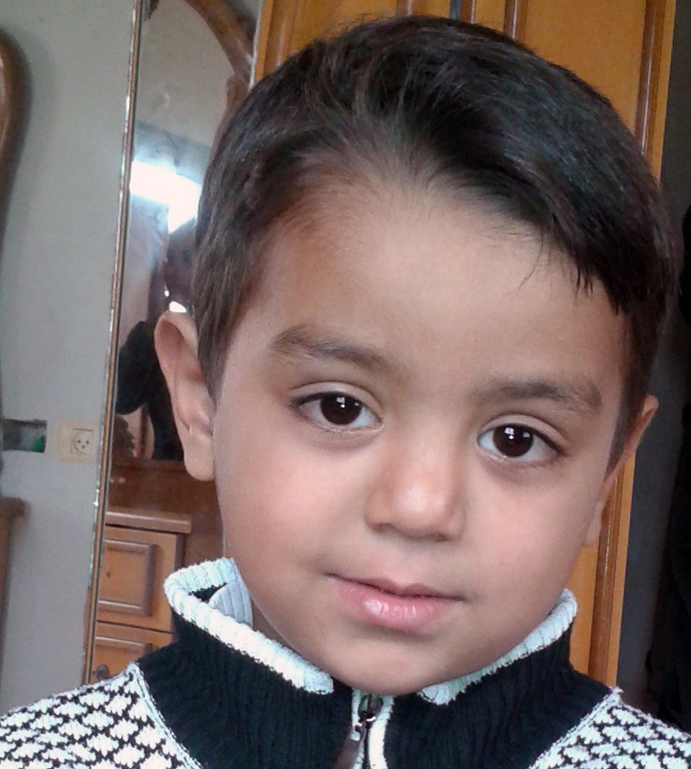
A senior health ministry official told The Times of Israel that the boy “was hit by bullet shrapnel in the face, chest and stomach at a protest” as a result of Israeli fire.
Some 180 Palestinians have been shot dead and nearly 6,000 others injured by live fire during Great March of Return protests along Gaza’s eastern and northern perimeter since 30 March. Nearly three dozen of those killed were children.
Palestinian child fatalities due to Israeli fire have spiked in 2018, with more than 50 killed in the West Bank and Gaza Strip – one death per week on average.
Ahmad Abid’s is the first Great March of Return death in a month, as protest fatalities in Gaza decrease and deadly encounters between Israelis and Palestinians rise in the West Bank.

16.12.18 - Israeli army razes home of prominent Palestinian activist - The Israeli army has demolished a residential building owned by a prominent Palestinian activist, whose six sons have been imprisoned by Israel.
The building, owned by Latifa Abu Hmeid, is located in the Amari refugee camp near the occupied West Bank city of Ramallah.
According to an Anadolu news agency reporter based in the area, Israeli soldiers raided the camp early Saturday, surrounding the building before bringing it down in a controlled demolition.
Before razing the four-storey structure, the army evicted dozens of journalists and solidarity activists who had been inside the building in a bid to prevent its destruction.
Israel accused one of Abu Hmeid's sons of killing an Israeli soldier in May.
Protesters called the destruction a form of collective punishment.

(Full story at : https://www.aljazeera.com/news/middleeast/2018/12/israeli-army-razes-home-jailed-palestinian-brothers-181215102622438.html )

N.B. – Links, usually in blue, can be accessed using Control and clicking.

Feed-back !
This is a standing request to please feed-back on any activity, action or events that take place as a result of information you receive from me or other AI channels. This is a vital means of assessing the productivity of this information and the likely impact of AI campaigns.
Thank you for all your activity. Be assured that none of it is inconsequential.

Keeping in touch
You have received this email as the IOPT / ‘Middle East and Gulf’ contact for a local group which has expressed an interest in the Middle East – please do let me know if you don’t want to receive updates on Israel and the Occupied Palestinian Territories, or if there is an alternative contact for your group.

You can contact me via the details below (preferably evenings or weekends by phone, as I am a volunteer).

Please do let me know if you have any questions on IOPT that I can help with and especially if you have feed-back on any of the items in this ‘Review’ and note that I remain available for talks to your Group or local community.

Garry Ettle,
Country Coordinator (AIUK),
Israel & Occupied Palestinian Territories / Middle East & Gulf
(Tel. 01932 224707 / 077487 34199)
Visit the AIUK Middle East and Gulf Facebook page at -
https://www.facebook.com/AmnestyMEG.org.uk
You are receiving these emails because you have opted in to updates from the Middle East/Gulf country coordinator team. You can unsubscribe at any time by replying to this email, or by contacting the Amnesty UK supporter communications team on 020 7033 1777 and letting them know you would like to stop receiving country specific emails.
