MAYFAIR AND SOHO AMNESTY GROUP
All human beings are born free and equal in dignity and rights
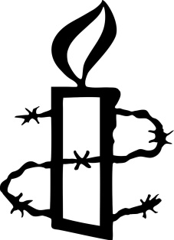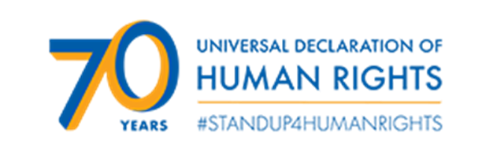
Thursday 13 December 2018
At 7.00 pm in the Conference Room, Human Rights Action Centre, London EC2A 3EA
An event to commemorate the 70th anniversary of the Universal Declaration of Human Rights
With original writing by members of the Human Rights Creative Writers’ Group
Ambassadors have been invited to send messages of support for the Universal Declaration and for those who defend human rights around the world
We will remember by name hundreds of people whose rights under the Declaration have been violated and for whom Amnesty has worked
Refreshments
Everyone has the right to life, liberty and security of person
No-one shall be subjected to torture
No-one shall be subjected to arbitrary arrest, detention or exile
Everyone has the right to freedom of thought, conscience and religion
Everyone has the right to freedom of opinion and expression

The right to life – Karol Sendrei, Slovakia; Freedom from torture – Adrian Vasquez, Mexico; Freedom from arbitrary detention – Asma Ahmed, Sudan; The right to freedom of expression - Akbar Ganji, Iran; The right to a fair trial – Ogulsapan Muradova, Turkmenistan
On 13 December the Mayfair and Soho Group will be remembering by name these and hundreds of other people whose rights under the Universal Declaration have been violated. Please sponsor us generously for the number of names we read, so that Amnesty can continue its vital campaigns for the victims of human rights breaches throughout the world.

NAME AMOUNT

We have a justgiving page - http://www.justgiving.com/fundraising/Amnesty-Mayfair-and-Soho-Group1/

Names provided on this sponsorship form will be used only by the Mayfair and Soho Group for the purposes of Amnesty International

