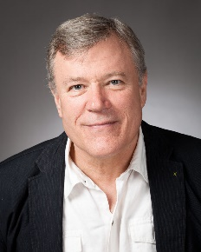
From Prejudice to Pride
Our LGBT heritage in Fitzrovia and Bloomsbury
FUNDRAISER FOR
AMNESTY
INTERNATIONAL
Meet outside Goodge Street Station at 6:30 pm
Wednesday 26 September

This walk led by Richard Cohen, a Camden Guide and Amnesty member, takes in places in Fitzrovia, Bloomsbury and King's Cross which are part of Camden's rich heritage of sexual diversity. We will visit pubs which were notorious watering holes for the Bohemian demimonde of the 1920s and 1930s. We will pass the vanguard of lesbian and gay theatre and a bookshop which has been at the heart of the LGBT community since 1979. We will visit the homes of the writers and artists of the Bloomsbury Set who challenged Victorian codes of behaviour and see the house where the great genius of polari Kenneth Williams was brought up. We will hear about how the LGBT community rallied together to respond to the HIV/AIDS crisis of the 1980s and end our walk at Camden Town Hall where the first Same Sex weddings were joyously celebrated.
Pay on the day (suggested contribution £10) but let Richard know by text on 07852 14 1425 or book through Eventbrite.
Eventbrite:
https://www.eventbrite.com/e/from-prejudice-to-pride-our-lgbt-heritage-in-fitzrovia-and-bloomsbury-tickets-48449971168
