Summer 2018

Dear Supporter

Our NEW Amnesty Shop range is here!

We are pleased to again be able to offer you 20% off everything at www.amnestyshop.org.uk. We have loads of exciting gifts including clothing, books and a wonderful range of jewellery. We know that Local Groups and Student activists do amazing work for Amnesty. Buying and sending out cards and gifts from the Amnesty Shop is another way in which you can get involved and help spread our message.As always, we really appreciate your on-going support.

To thank you for all your brilliant work, all Amnesty Groups receive a 20% discount off the retail price of everything on our entire online shop (for orders over £75) and free postage. It couldn’t be easier, just fill out the attached form – or order online.

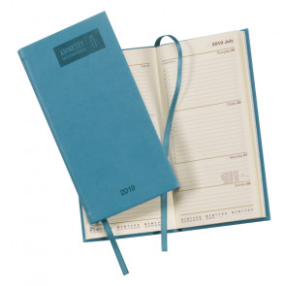

Many groups also buy cards and gifts at the discounted rate, to sell at local fayres or fetes. It’s a great way to entice people to your stall when collecting signatures for campaigns or running Write for Rights events. All the money you make goes straight to your group fundraising efforts. Christmas cards are always very popular, so make sure to stock up on those for your stalls!

We would also encourage you to order extra catalogues for your stalls – this can be done via the attached order form, online at https://amnestyshop.org.uk/free-2018-catalogue-ai.html or via Amnesty’s activist mailing house MDA – just call 01788 545553 and quote the code MDA is PR220/9.

Please find the Groups Order Form enclosed within this pack. Instructions (on how to place your order) can be found at the top of the order form. Due to the volume of orders we are unable to accept returns on discounted purchases.

To order online please visit www.amnestyshop.org.uk and set yourself up with an account and log-on. Enter the code AGP20 into the discount box when checking out to receive your 20% off and free P&P. For questions relating to how to shop, to order more catalogues email support-general@amnesty.org.uk visit www.amnestyshop.org.uk/how-to-shop.html or phone 01865 403272.

I look forward to receiving your order,

Emma

Emma Blunt
emma.blunt@newint.org
+44 (0)1865 403272
UK Amnesty Trading

UK Amnesty Trading is run by New Internationalist Publications Ltd (newint.org) on behalf of Amnesty International UK Section, Reg No.01735872.

New Internationalist Publications Ltd. is incorporated in England Reg No 1005239. Registered Office: Old Music Hall, 106-108 Cowley Road, Oxford, OX4 1JE, UK.

ORDER ENQUIRIES — 01420 525540
For enquiries about your order please phone between 9am and 5pm Mon-Fri and 9am and 4pm Sat (Oct-Dec).

MEMBERSHIP ENQUIRIES — 020 7033 1500
For Amnesty membership enquiries or to make changes to your Group’s name/address details, please phone between 9.00 am and 5.00 pm Monday to Friday.

