This guide is for Amnesty trainers and activists in their roles as facilitators of difficult conversations on our Ban Israeli Settlement Goods Campaign.
We encourage groups and activists to:
- Hold open and honest conversations on Israel and Occupied Palestinian Territories.

- Base discussions and conversations within Amnesty International’s remit, i.e. international human rights law & International humanitarian law.

- Work towards the elimination of all forms of racism, discrimination and xenophobia in addressing issues on Israel and Palestine.

- Call out language and behaviour that is not rights respecting and in keeping with Amnesty’s values and attitudes, including but not limited to racism, Anti-Semitism and Islamophobia.
Your goal as the facilitator or activist should be to create a space where individuals can express their concerns honestly, where the feelings of the group are valued and protected and where challenges can be made respectfully.
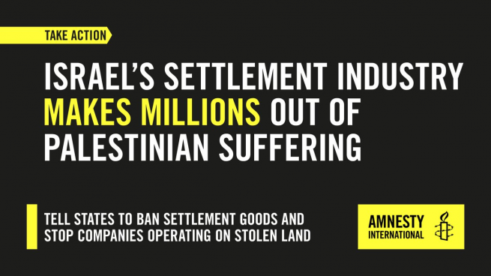
This guide intends to help you have important discussions in a safe, open and judgement free space. We want to allow respectful conversations to take place on an often misunderstood and divisive topic.
Here are some suggestions about how to create that space and talk about difficult questions and issues.
- Establish ground rules: This can be pre-set or done together. These rules may include encouraging rights respecting language and behaviour, confidentiality, setting a safe space.

- Be intentional about your language: think carefully about the language you are using, considering both intent and impact of your words. This means being context specific when using language such as Zionist, Islamist, militant, or Nazi. Be factual and sensitive in how you use language, e.g. such as pointing to Nazi atrocities or the Zionist Federations’ work promoting settlements or armed groups which have Islamist ideologies.

- Use fact and evidence-based arguments – humbly: human rights are not about who can win the argument but about facts on the ground that impact people in their daily lives and what can be done to make this world more rights respecting. Conversations we have on Israel and Palestine should focus on human rights abuses. Going into history or comparisons are not helpful and not our approach. Focusing on messaging and our evidence/law-based approach helps ground our message. This makes it harder to challenge and critique our position because ultimately, we want to see the human rights of all Palestinians and Israelis respected and protected.

- Listen to lived experiences: Listen to the lived experiences of those who have lived through the issues we are discussing, whether they are rights holders with first-hand experience living under occupation, a person’s account of facing racism, Anti-Semitism, Islamophobia, etc. However, also be mindful not to tokenise people and expect them to speak on behalf of their faith group, nationality or race.

