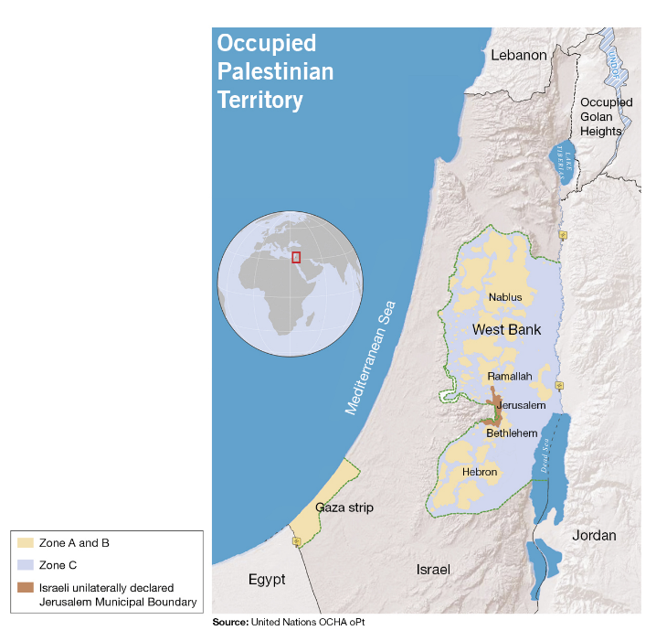
Why States must ban Israeli settlement goods
To mark the 50th anniversary of Israel’s occupation of the West Bank, including East Jerusalem, and the Gaza Strip, we launched a campaign calling on states across the world to prohibit settlement goods from entering their markets and to prevent their companies from operating in settlements or trading in settlement goods.
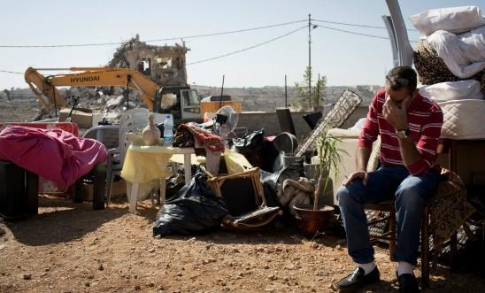
Decade after decade, states have stood by as Israel has destroyed Palestinians’ homes and stolen their land and natural resources for profit. While the Palestinian economy has been stunted by 50 years of abusive & discriminatory policies, a thriving multimillion-dollar settlement enterprise has been built out of the systematic oppression of the Palestinian population.
Merely condemning Israel’s settlement expansion is clearly not enough. States must be pressured to take concrete international action to stop the financing of settlements which themselves flagrantly violate international law and constitute war crimes.
Hundreds of millions of dollars worth of goods produced in Israeli settlements built on occupied Palestinian land are exported internationally each year, despite the fact that the vast majority of states have officially condemned the settlements as illegal under international law. Over the years, Israeli and international businesses have also enabled and facilitated settlement construction and expansion.
Israel’s policy of settling Israeli civilians on occupied Palestinian land has led to numerous human rights violations. Tens of thousands of Palestinian homes and properties have been demolished by Israel and hundreds of thousands of Palestinians have been forcibly displaced; many families were pushed out of their homes or land to clear areas for settlement construction. At least 100,000 hectares of Palestinian land have been taken for exclusive settlement use.
Israel has also unlawfully seized control of Palestinian natural resources, such as water, fertile land, stone quarries and minerals, and diverted these to benefit settlement industries to produce agricultural products, construction materials and manufactured goods that are often exported abroad. At the same time, Israel has imposed arbitrary restrictions depriving Palestinians of access to and use of their own water, land and other resources, restricting their economic development and violating their economic and social rights.
All states have a clear obligation to ensure respect for international humanitarian law. They must also not recognize or assist in any manner the illegal situation that Israel’s settlement policy has created and, in fact, they should use their influence to stop such violations.
By banning settlement goods and putting in place laws and regulations that stop companies from operating in Israeli settlements, governments worldwide have an opportunity to make a real difference to the lives of millions of Palestinians who have endured decades of injustice, indignity and discrimination.
Of course, the Israeli government has made it clear that maintaining and expanding settlements takes priority over respect for international law. That’s why we want to see states send a clear message that it will no longer tolerate the Israeli authorities’ blatant disregard for international law.
But to make this happen we must all come together and put pressure on our government and our politicians to take action on this issue and push for a ban on settlement goods. The government and politicians must see that there is strong support amongst the public and amongst the business community for a ban on settlement goods. We must change the narrative in parliament from one of strongly worded condemnation to action, and we need your help to do this. Visit 50yearstoomany.uk for more information on our campaign and to take action.

