DATES

Thurs. 21st June 7.30 – 9.30 pm
GROUP MEETING
Nora Street Community House, Howley. WA1 2JG
Sat 16th June 10 am
Refugees Welcome Photo Shoot
Market Gate by the skittles - meet 9.55
Week 15th to 23rd July
Magnum Poster Exhibition - The Gateway

STREET STALL 26TH MAY

We collected £91.02 in donations and sent a small number of cards supporting the Brave campaign. Harold, Gill, Jane & Evelyn agreed that the cards for the campaign which featured Egypt Finland, Cambodia and Chile needed more promotion than we had provided. Petitions have always proved more popular to engage passing support.

PLANT SALE ON BANK HOLIDAY MONDAY

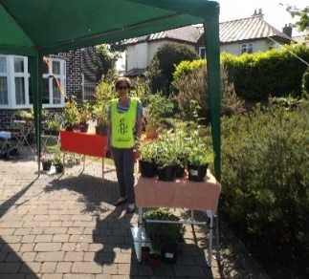

The plant sale held on Bank Holiday Monday raised an amazing £192.12 in just 2 hours – the weather was beautiful making the event doubly enjoyable. Gill, Bryan and Evelyn and Harold provided the plants. Gill organised the event and advertised it locally helping to ensure that it was well supported. We thank Gill and Bryan for using their driveway and for all their preparation for the sale. Thank you again Gill & Bryan!

REFUGEE WEEK ACTIONS

NORTH WEST REGION PHOTO SHOOT
Sat. 16th June @ 10 am
REFUGEES WELCOME
13 North West groups including Warrington group are taking part in this refugee week action. The aim is to co-ordinate the photo shoot, in front of an iconic landmark in our area, at 10 am on Saturday 16th June.

We have chosen to meet in Market Gate at the skittles to photograph members holding a poster: WARRINGTON WELCOMES REFUGEES
This should only take about 15 minutes and we are hoping that some of the wider membership will come and join us.
Join us to help support this AIUK action.
EMAIL benkin64@talktalk.net ASAP.

MAGNUM DISPLAY
The Gateway has agreed to host the MAGNUM poster exhibition during Refugee Week from Friday 15th June until Saturday 23rd June. Magnum Photos produced the posters under the title: Global Refugee Crisis. The photos span 70 years from the 2nd World War to the current crisis giving us a glimpse of the individual stories that lie behind any refugee crisis.
If you missed the poster display last Sept. at the Friends Meeting House you have a 2nd chance to see it during Refugee Week.
CROFT CARNIVAL 7TH JULY.
For our stall at the croft carnival we hope to collect names on a petition, promote the BRAVE campaign and publicise Good News stories. We will again be having a hoopla game for children.
Individual @ risk in the Occupied Palestinian Territories
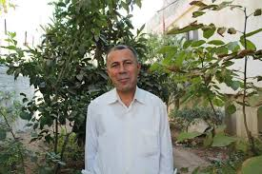

Abdul Razeq – Occupied Palestinian Territories
On 10th April, Abdul Razeq Farraj’s detention order was renewed for the third time for another three months and is now expected to end on 17 July.
Arrested on 21 May 2017 Abdul was given a four-month administrative detention order without being questioned. Due to end on 20th September his detention order has been renewed another three times. He is currently in prison, near the city of Ramallah.
Under administrative detention a person is held without trial without having committed an offence, on the grounds that he or she plans to break the law in the future. This measure is supposed to be preventive so has no time limit. The person is detained without legal proceedings on classified evidence that is not revealed to them. This leaves the detainees helpless – facing unknown allegations with no way to disprove them. Abdul has spent a total of 16 years in Israeli prisons.

An optional letter to the Israeli Embassy in London is attached.

INDIVIDUAL MEMBERS’ NEWS
Members reported on some interesting news during the week
- Jane watched the ‘Dispatches’ TV programme which revealed the horrifying violence against Rohingya people in Myanmar.
- Gill saw the TV programme, ‘Nigeria’s stolen daughters’, about the kidnapping of the ‘Chibok’ girls by Boko Haram in Nigeria.
- Evelyn read in the Observer newspaper about the situation of the children of first generation Chagossians born in exile. The Chagos Islands are a UK Overseas Territory. The largest island, Diego Garcia, was leased to the US military, and Chagossians were forced into exile in the 1960s and 70s. The first generation Chagossians born in exile were given British nationality in 2002 but those living in the UK are being separated from their children by the costs of immigration and visas.
- Jo reported on a photo exhibition, ‘The secret life of Liverpool’, being held at the Unity Theatre, which includes photos of Liverpool life since the Toxteth riots.
Good News

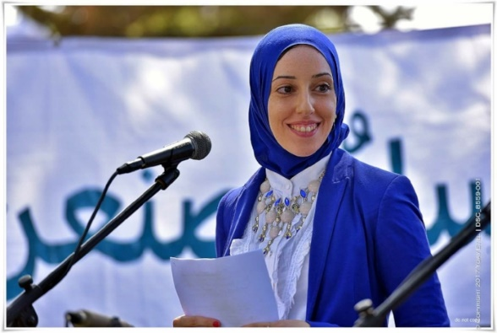
Israel & the Occupied Palestinian territories.

Women Wage Peace is the largest grassroots movement in the country. It was founded in the summer of 2014 following Operation Protective Edge. The movement has tens of thousands of members from the right, the centre and the left of the political spectrum, Jews and Arabs, religious and secular, from the centre of the country and the periphery, women from kibbutzim and from settlements, all of whom are united in a demand for a mutually binding non-violent accord, agreeable to both sides. For more information go to: http://womenwagepeace.org.il/en/

SENTENCED TO DEATH FOR KILLING HER RAPIST

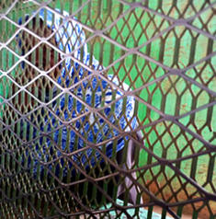

Having already endured rape by the man she was forced to marry at just 16, Noura Hussein used a kitchen knife to protect herself when he tried to rape her again. Sudanese law doesn’t recognise marital rape and now she faces execution for an act of self-defence.
SIGN THE ONLINE PETITION
https://www.amnesty.org.uk/actions/sentenced-death-killing-her-rapist

