FITZROVIA
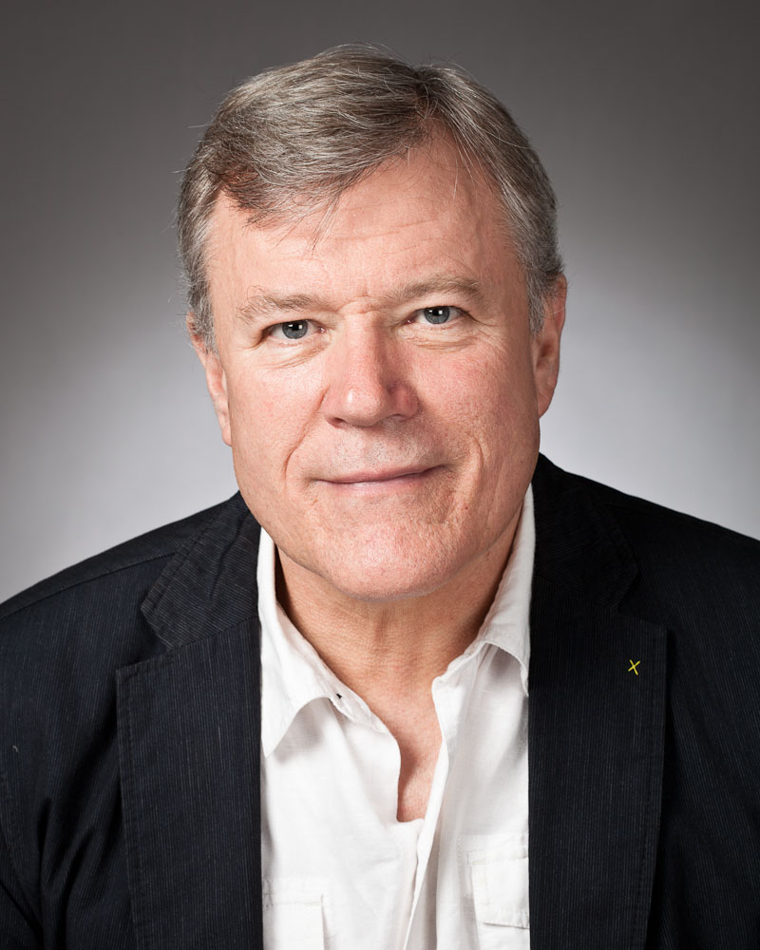
LONDON'S MEDICAL POWERHOUSE
Wednesday 25 July at 6:30 pm
Meet at the Euston Square (Gower Street exit) Finish at Charlotte Street by 8:00 pm where those who wish can take refreshments in the famous Fitzroy Tavern

Fitzrovia has long been London's medical powerhouse. It is the site of University College Hospital and we will see many of the world-class medical treatment and research centres based here. It also boasts one of the most beautiful squares in London. We will also visit one of London's earliest Family Planning clinics. We will discover the site of the wild and riotous Gooseberry Fair of Tottenham Court Road. We will hear about the artists, writers and lowlifes who inhabited the Fitzroy Tavern and see the Telecom Tower from a new angle. We will visit London's oldest Workhouse Buildings where the poor and infirm had sanctuary in Georgian and Victorian times and see the site of a notorious gay scandal in Victorian London. We will also pass the homes of some of our greatest writers.
THIS EVENT IS A FUND RAISER BY MAYFAIR & SOHO AMNESTY
This is a fund-raiser by Mayfair & Soho Amnesty. Pay on the day (suggested contribution £10.00) but let Richard Cohen by texting 07852 14 1425 or book a place via Eventbrite using this link: -
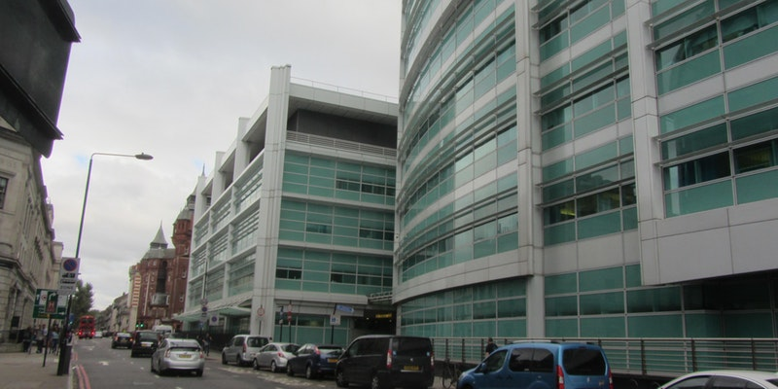
https://www.eventbrite.com/e/fitzrovia-londons-medical-powerhouse-amnesty-fundraiser-walk-tickets-47344197770

