DATES FOR YOUR DIARY:

Sat 03/03/2018: South-East Regional Conference
Thu 15/03/2018: Group AGM, School of Music, Bognor
Sat 24/03/2018: Chichester Street Collection
BOGNOR CHICHESTER AND DISTRICT AMNESTY GROUP
LOCAL AMNESTY NEWSLETTER, January 2018.

Dear Writers,
Happy New Year! Thanks to all who took part in the GREETINGS CARD CAMPAIGN, by sending cards, letter-writing, and asking others to sign at the cathedral green table. Our sympathies go to our ex-Chair, Colin Crouch, whose wife Pamela died on 07/01/2018.
LOCAL AMNESTY EVENTS
THURSDAY 15/03: Formal notification of our AGM; full details in the next newsletter.
SATURDAY 24/03. We want VOLUNTEERS for our STREET COLLECTION in Chichester. Full details in the next newsletter, but we are hoping for as many people as possible to rattle a tin, if only for an hour or so that day. Please contact Jilli Webber on (01243) 371463.
OTHER EVENTS
UK Amnesty AGM at Swansea 7/8 April. Booking closes 1 March. There are four roles up for election, including the Chair – contact me (deadline 16/02)
POLITICAL CAMPAIGN TRAINING – there is a first one-day course in London on Saturday 03/03 for our region (second day later in the year) to train (especially younger) supporters how to lead political actions. Contact me (01243 823016) for details.
The new Chichester MP Gillian Keegan has agreed to talk to the Quakers at the Friends Meeting House, Chichester on THURSDAY 22/02 at 7pm (on the New Economy and the arms trade). Contact me for details.

Carry on Writing!!!!!!!!

Bob Dewick

Amnesty action: campaigns & letter-writing
This month’s action
Syria: 529 PATIENTS ARE STILL AWAITING MEDICAL EVACUATION
Background to this action  29 of the 558 patients awaiting medical evacuation in besieged Eastern Ghouta have been evacuated and transferred to hospitals in Damascus for treatment. 529 more patients still require urgent medical treatment.  On 27 December 2017, the Syrian government approved the medical evacuation of 29 critical cases from Eastern Ghouta.This evacuation was completed on Friday 29 December 2017 with 17 children, six women, and six men transferred to hospitals in Damascus, where they are being treated for serious injuries or medical conditions such as heart disease, cancer, and kidney failure. Eastern Ghouta is an area near Damascus which is besieged by government forces, the area is home to around 400,000 civilians  According to medical personnel in Eastern Ghouta, 14 people have died while awaiting medical evacuation. The medical evacuation of 572 people with severe injuries and chronic diseases has been pending approval from the Syrian government since July 2017. Medical personnel corroborated news about the evacuation being agreed after negotiations that led to the release of individuals held by the armed opposition. These 29 cases were at the top of the list of patients awaiting medical evacuations due to the urgency of the cases.  529 more patients still require urgent medical treatment for their injuries and diseases. Furthermore, under international humanitarian law the sick or injured must not be treated as bargaining chips; they must receive necessary medical treatment without conditions. Doctors and medical workers in Eastern Ghouta are unable to provide adequate medical care due to lack of adequate surgical supplies, medical equipment and medicine, particularly for treatment of chronic diseases such as cancer, heart disease, and diabetes. | What you can do  Write or email:  - Calling on the Syrian government to unconditionally allow medical evacuations to Damascus  - Urging the government to immediately lift the siege on Eastern Ghouta;  - Calling on it to provide access to UN humanitarian agencies and their implementing partners  PLEASE SEND APPEALS BEFORE 19 FEBRUARY 2018 TO  Permanent Representative to the UN Bashar Ja’afari  Ambassador Extraordinary and Plenipotentiary  820 Second Avenue, 15th Floor  New York, NY 10017, USA  Fax: +1 212 983 4439  Email: syria.pr@outlook.com  Salutation: Your Excellency  President  Bashar al-Assad  Fax: +963 11 332 3410 (keep trying, if it does not go through, include your message to the president in an e-mail to the Ambassador, asking for it to be forwarded)  Email: syria.pr@outlook.com  Salutation: Your Excellency  And copies to:  Permanent Representative to the Mission of the Russian Federation to the UN  Nebenzia Vassily Alekseevich  136 East 67 Street,  New York, N.Y. 10065  Fax: +1 212 628-0252  Email: press@russiaun.ru  There is currently no Syrian Embassy in the UK.  If you would prefer to take action online, go to:  https://www.amnesty.org.uk/actions/syria-evacuate-patients-urgently-needing-care?from=issue
Write for Rights at Chichester Cathedral, 2017

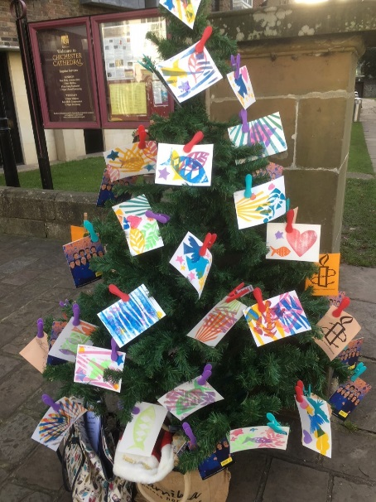
The group welcomed donations of cards from the Chichester Cathedral print making workshop.

The donations were produced by local young people, using block prints to make beautiful cards inspired by the colour and symbolism of the Reconciliation tapestry in the Cathedral. The group’s visual creativity resulted in some visually stunning cards for the Individuals at Risk highlighted in this year’s Write for Rights campaign.

The cards were used at our annual Write for Rights event on the Cathedral Green, where Christmas shoppers were invited to sign cards and decorate our Amnesty Christmas tree.

The tree was a great way to attract people and the hand-printed cards provided a impact: they looked really effective, and it was great to be able to tell people that they had been made by young people in the Cathedral.

In total, passers-by signed around 70 cards for Individuals at Risk as part of the annual Amnesty Write for Rights campaign. Our thanks to the artists and the Cathedral for helping make this a successful event.
See https://www.amnesty.org.uk/groups/bognor-chichesterand-district/about-0 for further group information

