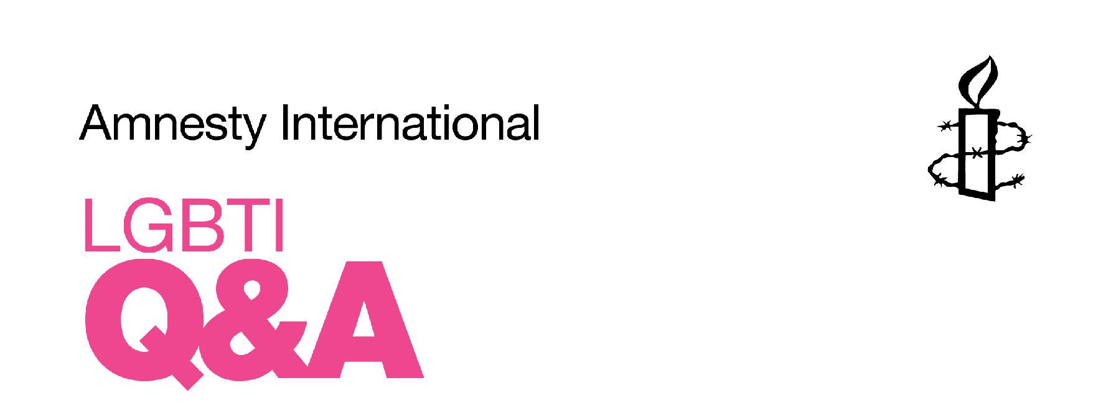

Around the world people suffer discrimination, persecution and violence because of their sexual orientation and gender identity. This Q&A explains how and why Amnesty International campaigns on lesbian, gay, bisexual, transgender and intersex (LGBTI) rights. It also highlights some key issues and current Amnesty cases.

1. What does LGBTI stand for?

LGBTI stands for lesbian, gay, bisexual, transgender and intersex.

- A lesbian woman is attracted to and forms relationships with other women.

- A gay man is attracted to and forms relationships with other men.

- A bisexual person is attracted to and forms relationships with men and women.

- A transgender, or trans, person’s gender expression and/or gender identity differs from conventional expectations based on the sex they were assigned at birth.

- An intersex person possesses genital, chromosomal or hormonal characteristics which do not correspond to the given standard for ‘male’ or ‘female’.

2. What's the difference between T and I?

In most, if not all, countries children are assigned a sex – male or female – at birth. This sex appears on official documents, such as passports and identity cards.

Transgender people’s innate sense of their own gender differs from the sex they were assigned at birth. Some transgender people – but not all – wish to change their name and gender markers on official documents, and/or seek surgical, hormonal or other medical treatments to modify their body in line with their gender identity.

Intersex people – approximately 1.7 per cent of the population¹ – have genital, chromosomal or hormonal characteristics that do not correspond to the given standards for ‘male’ or ‘female’.

There are many forms of intersex. Some variations are diagnosed at birth, others later on, for example at puberty or when attempting to conceive a child. Intersexuality is not always diagnosed as such – doctors may simply say that a child has abnormally large, small or ‘ambiguous’ genitalia. Infants and children with genitalia that are not easily classifiable as ‘male’ or ‘female’ often undergo genital surgery or pharmaceutical procedures to ‘correct’ their genital presentation and are then ‘assigned’ a corresponding male or female sex. Intersex is not a gender identity: intersex people have a broad range of gender identities – including but not limited to male and female – just like non-intersex people.

Transgender and intersex are not mutually exclusive categories, nor are transgender or intersex people necessarily LBG or straight.

‘We should all speak out when someone is arrested or imprisoned because of who they love or how they look. This is one of the great neglected human rights challenges of our time.’

UN Secretary-General Ban Ki-moon

- Figure from OII Australia, see http://oii.org.au/wp-content/uploads/key/OII-Australia-Intersex-Ally.pdf

- Why does Amnesty campaign for LGBTI rights?

As a human rights organisation, Amnesty International works on behalf of all individuals who experience violations of their human rights, regardless of their sexual orientation or gender identity.

Human rights apply to everyone. Yet all over the world, individuals face discrimination, harassment and violence because of their real or perceived sexual orientation or gender identity. Human rights violations include – but are not limited to – killings, rape and physical attacks, torture, arbitrary detention, the denial of rights to assembly, expression and information, and discrimination in employment, health, housing and education. The right to equality is at the forefront of human rights: Article 1 of the Universal Declaration of Human Rights (UDHR), says ‘all human beings are born free and equal in dignity and rights.’ Amnesty International campaigns on behalf of individuals subjected – to human rights violations – for example, discrimination, harassment, and even violence – because of their real or perceived gender identity or sexual orientation.

- Are same sex relationships ever criminalised?

Yes, around the world there are 78 countries where same-sex sexual activity is illegal.² In 10 countries, the death penalty for such acts is possible, although Amnesty International is not aware of any person currently on death row under these laws.³

5. Are LGBTI rights progressing?

Around the world, the situation for LGBTI people varies enormously. At international level, support for and positive statements in favour of LGBTI rights are increasing.⁴ In some countries, legal equality and protection are advancing –

- ILGA 2014:

http://old.ilga.org/Statehomophobia/ILGA_SSHR_2014_E ng.pdf

- Amnesty International 2014: http://www.amnesty.org/en/library/asset/ACT50/001/2014 /en/652ac5b3-3979-43e2-b1a1-6c4919e7a518/act500012014en.pdf n.91

- See for example statements made by Ban Ki-Moon, and Navi Pillay, UN High Commissioner for Human Rights in particular at.http://www.ohchr.org/EN/Issues/Discrimination/Pages/ LGBTSpeechesandstatements.aspx

increasing numbers of countries have marriage equality, some countries have improved their laws on legal gender recognition for transgender people⁵ – while in others, new laws are being introduced that have a negative effect on LGBTI people.⁶ Even in countries where the criminal sanctions are not enforced, the presence of these laws reinforces a climate of hostility towards LGBTI people and legitimises the denial of other rights.

- What other problems do LGBTI people face?

Amnesty International has documented cases of individuals being harassed, threatened or killed because of their sexual orientation or gender identity (see below). Around the world, LGBTI individuals also experience violations of other rights: for example, discrimination in family laws (including marriage and adoption of children), or denial of access to housing, healthcare, education and employment.

7. Where does Amnesty stand?

Amnesty opposes laws that criminalise same-sex sexual acts. These laws violate international human rights law, even if they are not enforced.⁷ Moreover, rights including the rights to life, to security of person and privacy, to freedom from torture, arbitrary arrest and detention, to freedom from discrimination and to freedom of expression, association and assembly are protected in international human rights law, and apply to all people, regardless of their sexual orientation or gender identity. LGBTI rights are not ‘special rights’; they are the extension of human rights to everyone regardless of sexual orientation or gender identity. Discrimination or denial of these rights based on a person’s real or perceived sexual orientation or gender identity is a violation of international human rights law.

8. What is Amnesty doing?

Amnesty UK LGBTI pursues justice for individuals whose rights were abused because

- See for example the landmark decision in Denmark in June 2014 http://www.amnesty.org/en/en/news/denmark-transgender-law-2014-06-12

- See for example the Anti-Homosexuality Act in Uganda, and the overturning of the repeal of Section 377 in India
- For more information, see the 1994 UN Human Rights Committee decision in Toonen v Australi
of their sexual orientation or gender identity.

Amnesty also campaigns on broader issues, such as repressive legislation that restricts or violates the rights of LGBTI people. Examples include our campaigns against Russian legislation that limits freedom of expression for LGBTI people, and against the Anti-Homosexuality Act in Uganda. We also conduct advocacy and lobbying in many countries as well as internationally at the UN.

- What are some examples of Amnesty’s campaigns being successful?

Amnesty has run successful LGTBI campaigns on many occasions. An example is that of Elena Klimova who ran a website supporting LGBTI teenagers in Russia. Elena was charged with ‘promoting’ homosexuality. After 15,000 Amnesty supporters joined the campaign, the charges against her were dropped.

We support LGBTI asylum seekers and make sure that the UK government is aware of the dangers that they face if they are sent back to their country of origin.

We also work in schools. This includes training for teachers to ensure a ‘whole school response’ to homophobic bullying. Working alongside the organization Inclusion For All, Amnesty helped to educate both teachers and pupils on how to deal with homophobic bullying. Schools work can also include teaching children about LGBTI rights around the world.

10. Are LGBTI rights harmful to children?

No. There is no evidence that suggests campaigning for LGBT rights has any influence over determining people’s sexuality.

11. How can I get involved?

Join the LGBTI network here: https://www.amnesty.org.uk/join-lgbti-activist-network to stay informed about campaigns, urgent actions, and individuals at risk.

You can also find out more and follow our work on Facebook (@amnestyuklgbti), Twitter (@AmnestyUK_LGBTI), and Instagram (@AmnestyUK_LGBTI)

