SCARBOROUGH AMNESTY GROUP
presents

Music in Scarborough Market

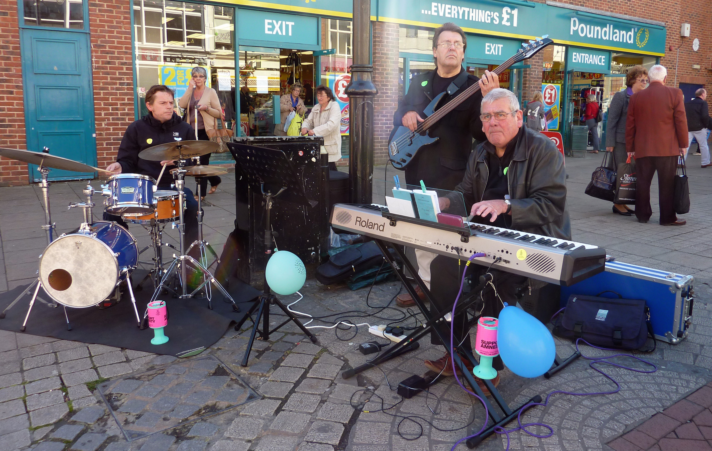

Find out about Amnesty International
and listen to live music from
Mike Gordon and friends

Saturday 16 December, 12 noon to 3pm,
in Scarborough Market Hall

www.amnesty.org.uk/groups/group/2129

