BOGNOR CHICHESTER AND DISTRICT AMNESTY GROUP

LOCAL AMNESTY NEWSLETTER, OCTOBER 2017.
DATES FOR YOUR DIARY:
Nov-Dec: Write for Rights greetings card campaign
Wed 15/11: Letter-writing evening, Barnham
Sat 09/12: 10-12 Write for Rights: Greetings Card Campaign publicity table, Cathedral Green, Chichester

Dear Writers,

Many thanks to the hostess and supporters who made a success of the Barnham AmnesTEA on 23/9, netting £75.70 which, together with more money from Jamnesty sales, is being donated to Amnesty’s “I welcome” refugee campaign.

LOCAL AMNESTY EVENTS

Margaret Robertson has kindly offered to host a LETTER-WRITING EVENING in Barnham on WEDNESDAY 15/11 – 30 Stempswood Way PO22 0LA. Please contact her to book a place on (01243) 552113.

Bognorians! Have you seen the two Amnesty plaques near the seafront, dedicated to Prisoners of Conscience? We hope to re-dedicate them during the Greetings Card Campaign – see next newsletter.

OTHER EVENTS

There will be a talk on North Korean prisoners at New Park Road Centre, Chichester, on THURSDAY 30/11 at 6pm, as part of the “Talks At Six” programme. Free admission, collection afterwards. I shall be following up with a brief plug for Amnesty’s work, so contact me for details - (01243) 823016.

Chichester Quakers annual peace lecture at Priory Road PO19 1NX on SATURDAY 11/11 at 6pm (refreshments 5.15pm) will be by Symon Hill on “Rethinking Remembrance; why this is the right time of year to challenge militarism.” On a related theme, the book “Kill Chain; drones and the rise of high-tech assassins” by Andrew Cockburn is available from Bognor library.

Carry on Writing!!!!!!!!!!!!

Bob Dewick

Amnesty action: campaigns & letter-writing
This month’s action
Update: PALESTINIAN CIRCUS PERFOMER RELEASED
Palestinian circus performer and teacher Mohamed Faisal Abu Sakha was released on 30 August from Ketziot Prison in Israel. He spent nearly two years in administrative detention without being charged or tried. He has now returned home to his family in Jenin in the occupied West Bank.
Thank you to those of you who wrote on his behalf: his case was covered in previous newsletters and events run by the group.
New campaign: BRAVE
Background to this action  On 16 May 2017, Amnesty launched a new global campaign, BRAVE, to strengthen the recognition and protection of human rights defenders around the world. This campaign is in response to the increased attacks and targeting of Human Rights Defenders, Activists and civil society organisations around the world and will run until the end of 2019.  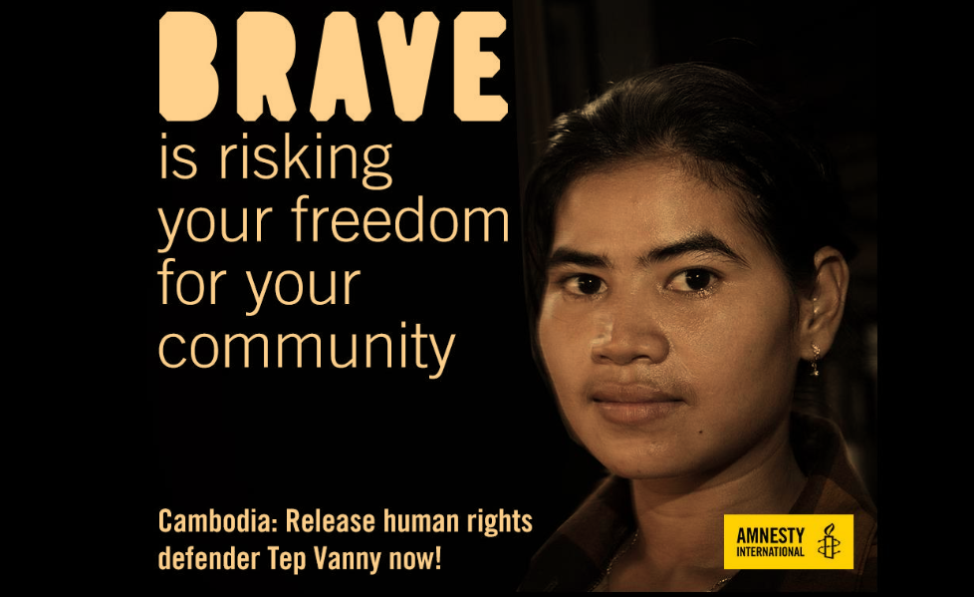  This month, we are taking action on behalf of Cambodian housing rights defender Tep Vanny. | What you can do  Tep Vanny is a housing rights activist, human rights defender and a community representative. She was arrested on 16 August 2016 for defending her community’s land following their forced eviction from their homes in Phnom Penh.  Write to the Prime Minister, Samdech Hun Sen:  - Stating that Tep Vanny is a human rights defender and prisoner of conscience, detained on baseless charges for her peaceful activism defending the right to housing and freedom of expression  - Calling for her immediate and unconditional release, the dropping of all charges and the end of all criminal investigations against her  - Calling on the authorities to publicly condemn and order an end to harassment and violence against human rights defenders, including unwarranted legal action and imprisonment.  Send your letter to:  Prime Minister Samdech Hun Sen,  Office of the Prime Minister,  Jok Dimitrov Boulevard,  Phnom Penh, Cambodia

STOP 14 MEN BEING EXECUTED IN SAUDI ARABIA
Background to this action
On 1 June 2016, the Specialized Criminal Court (SCC) in Riyadh sentenced 14 men to death by beheading. The men were accused of spying for Iran. They endured a grossly unfair mass trial based on 'confessions' they told the court were obtained under torture. They were eventually charged with a series of offences including 'high treason' with some facing several other charges which are not recognised criminal offences under international law, such as 'supporting protests' and 'spreading the Shi’a faith'.
Crushing dissent
Put simply, they are victims of the Saudi commitment to use the death penalty as a weapon to crush dissent and neutralise political opponents.
The families of the 14 men have been kept largely in the dark, but on 23 July they learned that the sentences of their relatives have been upheld by the Supreme Court. This means they have exhausted their appeals and could be executed as soon as King Salman ratifies their sentences.
The men told the court they were subjected to prolonged pre-trial detention and were tortured during their interrogation to extract 'confessions', however the judge failed to order investigations into their allegations. Subsequently, the SCC appears to have based its decision on these forced 'confessions'.
Impending execution spree
At least 66 people have been executed in Saudi Arabia since the start of 2017, and this looming execution spree will significantly add to the toll.
All that stands between these 14 men and their death is King Salman’s signature; he must immediately quash these death sentences, a result of sham court proceedings which fail to meet international fair trial standards.
Please act now to halt the executions. They are due to happen any minute, but together we can stop them.

What you can do
This is an email action on the Amnesty website:
https://www.amnesty.org.uk/actions/stop-14-men-being-executed-saudi-arabia#tab1

See www.amnesty.org.uk/bognor-chichesterand-district/about-0 for further information about the group

