Amnesty International


JOIN AMNESTY’S YOUTH ADVISORY GROUP!

Youth Advisory Group 2016-17
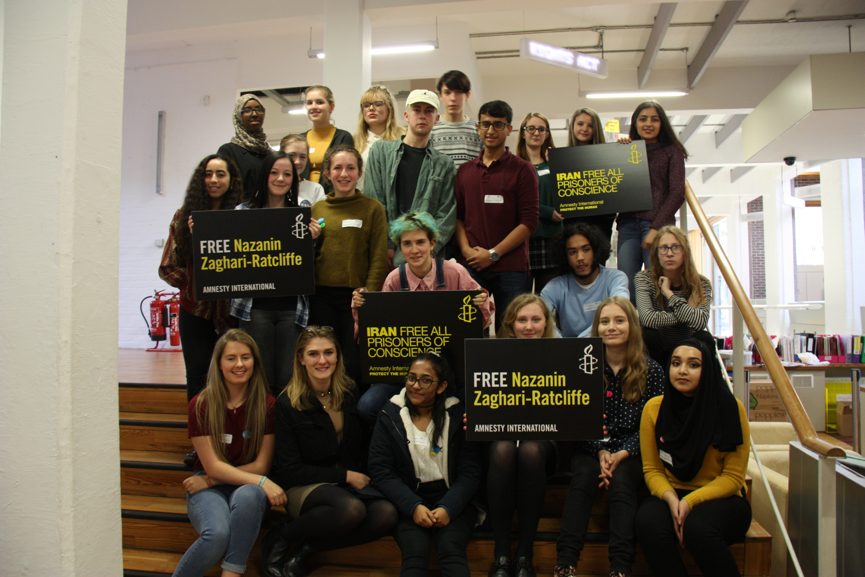

Deadline: Sunday 22nd October

Produced by the Community Organiser (Youth), Amnesty International UK, The Human Rights Action Centre,17-25 New Inn Yard, London EC2A 3EA, 020 7033 1590, anne.montague@amnesty.org.uk
Want to help Amnesty develop its work?
Want to meet other youth members?
Free to come to London on the 18th November 2017?
Apply to be on AIUK’s Youth Advisory Group!
Recruitment has now started for Amnesty’s Youth Advisory Group. Each year we recruit a small group of youth group members to give us their views on our campaigns, our mailings, our website and how we can get more young people involved in Amnesty.

Who can apply?
Up to 2 members from each youth group can apply. We like to get a good spread of people from across the UK. This great opportunity is for enthusiastic and committed members of youth groups aged 14 and over.

Do I have to know lots about Amnesty International?
You don’t need to be an expert on Amnesty. Nor do you have had to be a member of a youth group for long. But we do need you to be committed, passionate about Amnesty and ready to contribute positively.

How much time will I have to give?
It is a one-year commitment and you are expected to attend 5 meetings over the course of the year. We cover all transport costs and pay for accommodation if you need it. The meetings are always on Saturdays and the first one will be on the 18th November 2017. Other meetings will be in January, March, July and September 2018. Meetings are at our offices, the Human Rights Action Centre, in London. In addition, you will be asked to give feedback by email, text or social media in between meetings.

What happens at meetings?
For those of you who have to come down the night before, we pick you up from the station if you want us to. We take you to your accommodation and we take you out for dinner too - we pay! At least two staff members also stay at the accommodation and we provide 24-hour contact phone numbers.

Meetings run from about 10am to 4pm and are really informal. We basically just ask you for your opinions and ideas on all kinds of things such as our materials, website and campaigns. Sometimes we split you up into smaller groups to discuss things or sometimes we all stay as one group. There are usually about 20 of you in total. We try to make sure the day is fun and active. At the end of the meeting we can take people back to the station if needed. We cover all your food and travel expenses.

How do I apply?

Fill out the form overleaf and post or email it to us by the end of the day on Sunday 22nd October 2017. Our contact details are on the first page. Successful applicants will need to organise their travel arrangements soon after this date so be prepared! We will, of course, help with this.

We asked this year’s group what they gained from being part of YAG. Here’s what they said:

‘met new people, gained ideas for youth group, independence’
‘A support network of fellow Amnesty youth members’
‘You feel like you make a difference and are important’
‘Confidence, independence, motivation for running your group, part of a valuable movement’
‘People have commented on how I’ve matured’
‘Friends and knowledge about how Amnesty works’
‘an understanding of what happens ‘behind the scenes’
‘a better appreciation of how widespread Amnesty’s work is’
YOUTH ADVISORY GROUP: APPLICATION FORM
ABOUT YOU

Name: Date of Birth:

Gender:

Home address:

Mobile: Landline:

Email:

Name of school/college:

How long have you been a member of your youth group?

Have your parents seen the enclosed information about the Youth Advisory Group and the meeting on the 18th November and have given you permission to apply? Yes / No

Contact email of parent/guardian: ……………………………………………………….

Contact phone number of parent/guardian: ……………………………………………
(Note: We provide parents with more detailed information about the meeting if your application is successful)

(Feel free to attach additional sheets).

Why do you want to join Amnesty’s youth advisory group and why would you be suitable?

How would you ensure that you effectively balanced your school/home commitments with being part of the Youth Advisory Group?

Tell us about some of the activities you’ve been involved in with your Amnesty youth group.
- What went well?
- What would you do differently next time?

How could we get more young people involved in Amnesty? Give us 1-2 ideas.

Prefer to answer these questions over the phone?
Just fill in the About You section and post it to us - we will arrange a time to have a chat over the phone. You will be asked the same questions as on this form.

Please ask a school staff member to fill in this section:
Please write a few lines about why this student should be given a place on Amnesty’s Youth Advisory Group:

Feel free to continue overleaf
Staff member name: ………………………………………………………………

Staff member signature: …………………………………………………………

Staff member email: ……………………………………………………………….

Please return by 22nd October 2017 to: Anne Montague. Community Organiser (Youth). Human Rights Action Centre, 17-25 New Inn Yard, London EC2A 3EA. Contact Anne Montague: anne.montague@amnesty.org.uk

Equality and diversity monitoring

Amnesty International UK (AIUK) exists to protect individuals wherever justice, fairness, freedom and truth are denied. Promoting equality and valuing diversity are fundamental to our mission. We welcome you to complete this form but this is entirely optional.

To which of these groups do you consider you belong? (Tick/mark one box only)

A. White

White British English ■ Scottish Welsh Irish

Any other White background, please write: …………………………………………

B. Mixed
White & Black Caribbean White & Black African White & Asian
Any other Mixed background, please write in……………………………………

C. Asian
Asian British Asian English Asian Scottish Asian Welsh Indian Pakistani Bangladeshi
Any other Asian background, please write………………………………………

D. Black
Black British Black English Black Scottish Black Welsh
Caribbean African ■
Any other Black background, please write……………………………………..

E. Chinese
Chinese British Chinese English Chinese Scottish
Chinese Welsh Any other background, please write…………………………..

F. Other, please write…………………………………… ■ Prefer not to say

How would you describe your religion or belief?

Buddhist Christian (all denominations) Hindu
Jewish Muslim Sikh No religion Prefer not to say Other

What is your gender identity?

Male (including trans male) Female (including trans female)
Other gender identity Prefer not to say

Do you consider yourself to have a disability?
The Equality Act (2010) covers any individual who has a physical or mental impairment, which has substantial long-term adverse affect on his or her ability to carry out normal day to day activities. You do not need to be registered disabled to be covered by the Act.
Yes No

