BOGNOR CHICHESTER AND DISTRICT AMNESTY GROUP
DATES FOR YOUR DIARY

Sat 17/06 Aria and Song for Amnesty, Christ Church, Chichester, 7.30 pm
Sat 08/07 Pumble (10 am from Boxgrove)
Sat 23/09 AmnesTEA, Barnham
LOCAL AMNESTY NEWSLETTER: JUNE 2017.

LOCAL EVENTS

Many thanks to ANN STEWART and to all who helped in the Plant and Book Sale – it made £121.66 profit.

As usual, there is an exciting and varied programme for the Chichester Festival 2017 (www.festivalofchichester.co.uk) including our very own Aria and Song for Amnesty on 17 June at 7.30 pm at CHRIST CHURCH, Chichester. Join Rebecca Grove (soprano), Stephanie Peat (mezzo-soprano) and Charlie Wood (tenor), accompanied by Chris Coote, for an evening of beautiful music. Light refreshments will be available in the interval, and an action for REFUGEE WEEK (June 19-25th).

Horsham Group are having a HUMAN RIGHTS WALK around their town on SATURDAY, JULY 1st – Contact Jackie on Horsham.amnesty@btinternet.com

Peter James has organised our PUmBLE (=Pub ramBLE) on SATURDAY JULY 8th, starting at BOXGROVE PRIORY at 10 am to stroll up to the “George” at Eartham and back. Bring your own sandwiches if you wish, though the “George” does food. Bus 55 from Chichester bus station at 0940 should get you to Boxgrove just after 1000, and there is a bus back every half-hour until 1740. If wet, ring (01243) 533745.

23/9 AmnesTEA, Barnham. As last year it will be morning coffee-and-nibbles rather than afternoon tea, with a small raffle.

OTHER EVENTS

REFUGEE WEEK –This has been rather overshadowed by political events, but see what Amnesty is doing at www.amnesty.org.uk/refugees

As the new or re-elected MPs prepare to go to Westminster, Amnesty UK would like us to write to them to keep up the pressure for human rights. We will let you know the details soon. Thanks to all of you who raised human rights matters at the local hustings.

Carry on Writing!!!!!!!!!!!!

Bob Dewick

Amnesty action: campaigns & letter-writing
This month’s action
Free Nazanin and Kamal Campaign / May 2017

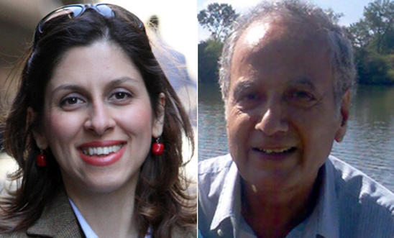  Background to this action  Nazanin  It’s just over a year since British-Iranian charity worker Nazanin Zaghari-Ratcliffe was arrested at a Tehran airport as she was about to board a flight home to the UK with her young daughter, after visiting family in Iran. She has been imprisoned ever since.  Prison is taking its toll on Nazanin. She suffers from severe arm, neck and back pain and needs urgent specialised medical care in hospital. She has very limited movement in her arms, and there is a risk that her right arm and hand will be permanently damaged if she doesn’t get the medical care she needs.  Nazanin was arrested on vague charges, held in solitary confinement for months, and, following an unfair trial, was sentenced to five years in prison for “membership of an illegal group” in connection to her work at the BBC’s Media Action and Thompson Reuters Foundation (TRF), a charity organization promoting socio-economic progress, independent journalism and the rule of law. Amnesty International therefore consider Nazanin a prisoner of conscience, held solely for peacefully exercising her right to freedom of expression and association: she must be immediately and unconditionally released.  Kamal  77-year-old British-Iranian grandfather Kamal Foroughi was arrested on 5 May 2011 by men in plain clothes who apparently did not show an arrest warrant or explain the reasons for his arrest. He was held in solitary confinement for 18 months and he was only allowed to meet his lawyer once before the start of his trial. In 2013, following an unfair trial, he was convicted of ‘espionage’ and given a 7- year sentence. Kamal has not seen his daughter, son and two granddaughters in six long years, and has not had any visitors in prison for over 2,000 days, apart from his lawyer.  Kamal has developed cataracts in both eyes and could go blind in prison if he’s not given the specialised medical care he needs. He was told by a doctor that he needs surgery on his eyes – back in September last year. The Iranian authorities have still not granted him this surgery.  Iran’s own early release laws - Article 58 of the Islamic Penal Code allows for the conditional release of prisoners after serving one third of their sentence – meaning he could have been released every day since January 2014. And yet Kamal remains in prison, separated from his family and in need of medical attention, with no one understanding what is going on. | What you can do  While Nazanin and Kamal remain in prison, they continue to miss out on the moments with their families that many of us could take for granted. Nazanin is missing out on her daughter Gabriella growing up and time with her husband, Kamal is missing out on time with his children and grandchildren. The moments we share with our families are precious and beyond value, and the injustice of Nazanin and Kamal’s ongoing imprisonment robs them and their families of those memories.  We need your help to show how important these simple memories shared with family truly are, and to demand the release of Nazanin and Kamal so they can be reunited with their loved ones.  The action:  Make your tulips  This is a simple but creative action that you can do at home. We could also do this at events we are arranging over the summer.  - Write a fond or cherished memory of a time spent with family or loved ones on a square piece of coloured paper  - Fold your memory into an origami tulip  - Send it to Amnesty International UK (Amnesty will share these with the Nazanin and Kamal’s families and use them in public actions with politicians to call for Nazanin and Kamal’s release).  What you need:  - A memory!  - Some coloured paper, scissors, ruler and a pen/pencil  - Amnesty’s how to make a tulip guide (see enclosed)  Please send your tulip to Amnesty at:  FAO: Kieran Aldred  Amnesty International UK, The Human Rights Action Centre, 17-25 New Inn Yard, London, EC2A 3EA  Further information about the action can be found here:  https://www.amnesty.org.uk/parliament2017
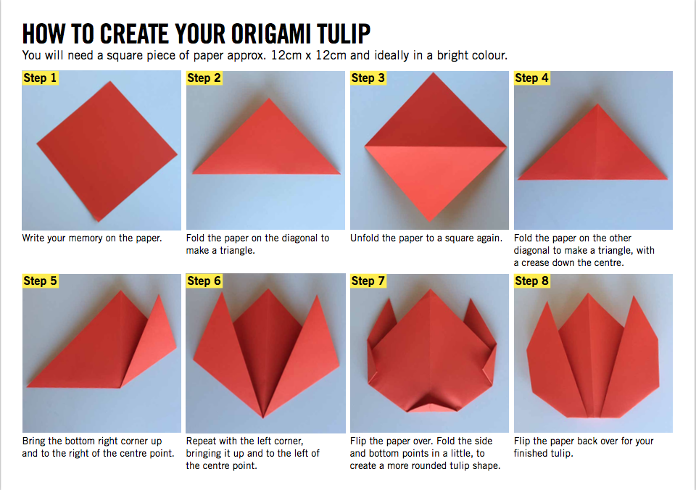
Human Rights Defenders Campaign – BRAVE
On 16 May 2017, Amnesty International launched a new global campaign, BRAVE, to strengthen the recognition and protection of human rights defenders around the world. The campaign is in response to the increased attacks and targeting of Human Rights Defenders (HRD), Activists and civil society organisations around the world. The campaign will run until the end of 2019 and will also be a priority campaign at Amnesty UK (AIUK).
We should have cases for action from the end of July: https://www.amnesty.org.uk/resources/human-rights-defenders-campaign-brave

After the General Election
To have a Parliament that promotes and defends human rights, we need Amnesty activists across the country to tell their MPs to raise their voice for human rights.
Amnesty will upload resources and template letters for writing to your newly-elected MP. This was planned for Friday 9 June, the day after the General Election, but at the time of the creation of this newsletter, it looks as if the materials are undergoing some revisions! Please do keep an eye on https://www.amnesty.org.uk/parliament2017 for updated actions.

See www.amnesty.org.uk/bognor-chichesterand-district/about-0 for further information about the group

