DATES
GROUP MEETING
Thursday 18th MAY 2017 – 7.30 to 9.30
Nora Street Community House, 15-17 Nora Street, Howley, WA1 2JG
Sat 3rd June 10.30am to 2.30 pm
Town Centre Stall to celebrate Amnesty’s Birthday
Sat. 1st July Croft Carnival
We will be having a stall at this event.
Friday 4thAug Collection at TESCO Altrincham
Friday 15th Sept. 7.00pm Quaker meeting House - Journeymen Theatre ‘The Bundle’.

GROUP FINANCES
Balance at the beginning of April - £167.95

Collection Saturday 22nd April

Many thanks to members who collected in Stockton Heath on 22nd April. In spite of seeming quite quiet at times we raised the excellent amount of £200 for funds. Well done everyone!
4th August
Our Next Collection at TESCO in Altrincham
We have been very fortunate to have been included in the list of charities able to fundraise in TESCO Stores. Previously whenever we have applied to various stores we have been turned down due to what the management consider to be the political nature of Amnesty’s work.
We have been offered 4th August at Altrincham and although we consider this to be further than we would normally want to travel to do a collection we don’t like to turn down an opportunity to fundraise in case we are not offered any future dates with Tesco.
If you are able to support this collection would you let me know asap.

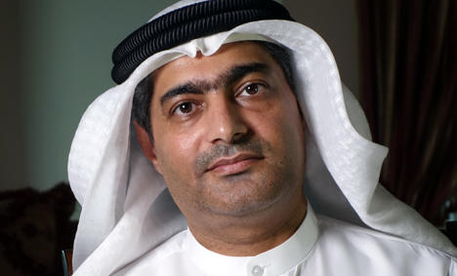
Individuals at Risk - Ahmed Mansoor
United Arab Emirates

In March, Ahmed Mansoor’s home in the United Arab Emirates (UAE) was searched and he was taken away.
A week later his family were informed that he was in prison in Abu Dhabi detained for ‘promoting false and misleading information through the Internet and spreading hatred and sectarianism'.
As a human rights defender Ahmed is in danger of being tortured. He is a prisoner of conscience being punished for using social media to exercise his right to free speech.
In the past Ahmed has been assaulted and faced death threats from government supporters, he’s been prevented from working and had his passport confiscated for calling for political reform.
His travel ban and the confiscation of his passport are punishment for his peaceful human rights activism and under international law they violate Ahmed’s right to freedom of movement.

If possible please send the enclosed letter to The Embassy of the United Arab Emirates in London.
Nazanin Zaghar-Ratcliffe
Supporters are invited to write comments on her husband’s change.org FREE NAZANIN RATCLIFFE petition. Anyone can add comments on this.
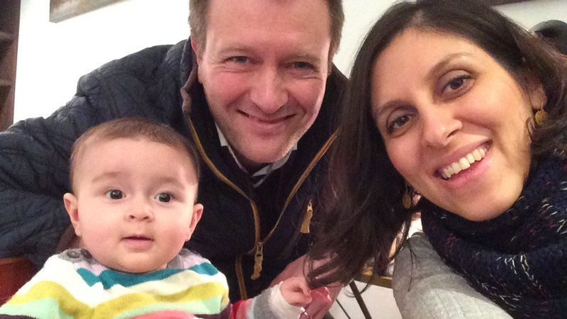

Nazanin Zaghari-Ratcliffe, 37 year old charity worker, was on holiday visiting her family in Iran. She was at the airport returning to the UK on the 3rd April when she was detained by the Iranian Revolutionary Guard. She has been transferred to an unknown location in Kerman Province, 1,000 kilometres south of Tehran, and is being held in solitary confinement.

Nazanin has not been allowed to access a lawyer or her daughter. She has not been able to call out of the country to speak to her British husband, and the Red Cross have not been able to make contact. There have been no charges.

Nazanin has informed her family that she has been required to sign a confession under duress, its content unknown. Her family have been informed that the investigation relates to an issue of ‘national security’.
Nazanin has now been in solitary confinement for over 30 days.

UK-wide Great-Get-Together

This will take place on the weekend of 17th and 18th June. We hope to join in local celebrations and the mayor’s office have promised to keep us informed of any official events when plans have been drawn up.

Mordechai Vanunu
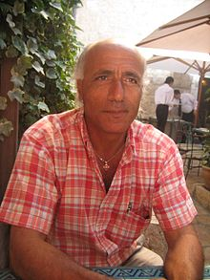
Members signed a letter on behalf of Mordechai Vanunu marking the 13th anniversary of his release from prison appealing for travel restrictions to be lifted.
Other letters sent
Central America.
Appealing against a law on torture in Mexico which will virtually give impunity to those carrying out torture.
West Africa.
On behalf of Paulin Makaya in Democratic Republic of Congo.
Child Refugees in the UK
Members signed a letter on behalf of child refugees who aren’t allowed to be joined in the UK by their families.

Burma’s Political Prisoners

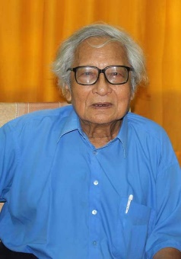
21st April was the third anniversary of the death of U Win Tin. AI supporters spent years campaigning for his release from prison. In his memory people were asked to wear a blue shirt or blue clothing to publicise the plight of political prisoners in Burma and post photos with the hashtag #blueshirt4burma on social media.

Prison addresses are available for anyone wishing to send a message of support to individual political prisoners in Burma.

