Amnesty International  Frome Group Newsletter  WE ARE ORDINARY PEOPLE FROM ACROSS THE WORLD STANDING UP FOR HUMANITY AND HUMAN RIGHTS  Website: www.amnesty.org.uk/groups/frome  Facebook: www.facebook.com/fromeamnesty  Support our April group action  On Saturday 22nd April join us in our fight to defend human rights! We will be holding a letter signing stand and a book stall in the Market place, just opposite Frome library from 9.15 -12.  We are focussing on cases from the Real lives campaign; the ‘Ayotzinapa 43’ (43 missing students in Mexico) 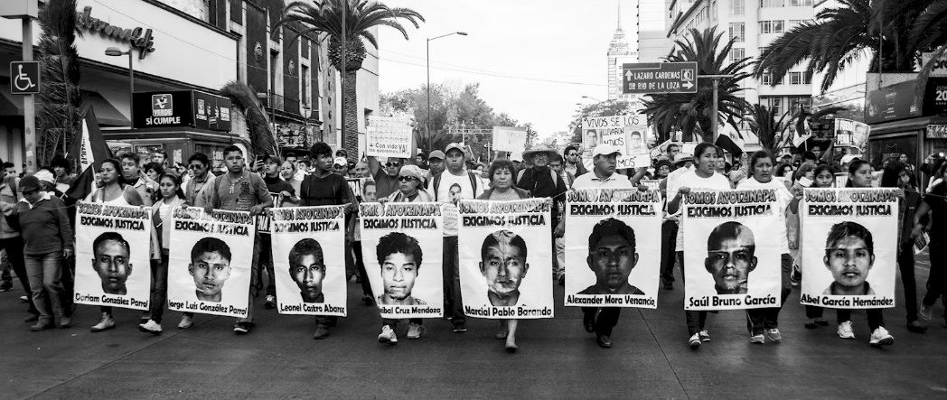  Trần Huỳnh Duy Thức who is a Vietnamese entrepreneur, author, blogger and human rights defender has been jailed for championing political reform.  For more information please copy and paste this link into your browser (the real lives brochure) : https://www.amnesty.org.uk/files/2017-02/JNL%20192%20Real%20lives%20supplement%20single%20pages%20LORES%20NEW_0.pdf?ndMNpu8onSRJ1QHxm2LlmeFsu6cB0Zdn |  | April 2017  Issue 13  Issue 2  IN THIS ISSUE: *Our April group action * Frome group march meeting *Library exhibition
Amnesty is also joining forces with the Library and Information association to call for the release librarian Natalya Sharina who is currently being held under house arrest in Moscow. https://www.cilip.org.uk/news/join-call-release-librarian-natalya-sharina-house-arrest
Natalya will feature on our stall and also on our library display (see below).

If you are not able to pop along to the stall then please email me at njwardman@yahoo.co.uk and I will send you the letters to sign and post, or alternatively check our facebook page at www.facebook.com/fromeamnesty they will be uploaded in due course.

Frome Amnesty group March meeting

We met on Thursday 16th March. It was an interesting meeting and lots of ideas were discussed. The main focus of the conversation was how we could get more people more involved with group events (if they’d like to be!). We now have a whopping 68 members on our email list! Our book stalls and letter writing events are generally pretty well attended but we could do with a bit of a hand on the stall. So if you are reading this and fancy doing a stint volunteering on our next letter signing stall on Saturday 22nd April then please contact Judy at judy.hosegood@btinternet.com , any time no matter how short greatly helps.

There are also plans afoot for an Amnesty library display from 29th April – 3rd May and we may also be involved in a Pride event. Please come along to our next meeting if you’d like to get involved with these events and others…! (or contact Nadine or Judy).

Library display
From April 29th until May 6th, which includes Word Press Freedom Day on May 3rd. We will have a display in the library focussing on journalists who have been imprisoned for exercising their right to freedom of expression. Look out for the large display boards near the Mendip Council Information Point desk. Watch this space for further details…

Are you a musician, do you organise musical events?
To raise awareness of our group in the town, to raise awareness about what Amnesty International is about and perhaps to raise a few quid for Amnesty to boot if you are already organising an event why not put the event on in aid of Amnesty…?
Please come along to our next meeting or get in touch with Judy or Nadine.

Your ideas for the newsletter…
If you have any feedback on this newsletter or would like anything included in the next issue then please feel free to contact me – Nadine Crook njwardman@yahoo.co.uk

Our group meets on the third Thursday of each month at the Bridge Café, Selwood Road, Frome, BA11 3BS at 8pm.
Our next meeting is: Thursday 20th April 2017
If you’ve never been to a meeting before why not come along! It’s very informal and it would be great to hear your ideas.

