COLWYN BAY GROUP
GRWP LLEOL BAE COLWYN

Secretary’s Report and Review of 2016.
2016 was a busy year for the Colwyn Bay Group when we continued to follow the trend of recent years by embarking on some new ventures in addition to our more regular activities of Group Meetings and Street Collections.

Attendance at meetings has remained high, with an average of 17 (15 in 2015) for our meetings, and it is great to see the Group thriving and indeed growing.
Sadly, one of our most long-standing members, Pat Jones, died at the end of the year and 2 members represented the group at her funeral.

Many thanks to everyone:
Every contribution is valued and valuable no matter how small.
Every attendance, every letter signed, every penny collected all make crucial contributions to our human rights work.

Our new departures and events included:
the continuation of our work in Junior schools, and Group members also had a taster session of the workshop that we had taken to school children; increased social media presence with the use of Twitter as well as a Facebook page; collaboration with the Conwy County Peace Group and Quakers during a weekend of dramas on social and human rights issues. One of these was on torture and we used this to spread the word about Amnesty’s work and our Resolution on the need for a judge-led enquiry; a gig in Conwy during the Food Festival weekend which introduced Amnesty to a new and different audience; a Write for Rights event at the Winter Fair in St Asaph Cathedral in November followed shortly afterwards by our annual carol singing in Llandudno.

January: The year began with a visit to the Group by Tom Davies and Rachel Logan from AIUK who talked with us about the background to, and progress of, our Resolution to the AGM in 2015. This was a fascinating discussion and a good way to start our year of campaigning.

February: We held our AGM this month and elected new officers to the Committee, Noni Roberts and Duncan Rieder who took on Press and Social Media responsibilities. Maggie Towse stepped down as Chair and this post was filled by Viv Smith-Franks. Maggie took on the tasks of Secretary for the Group. All Committee members were thanked for their work during the past year. Following this we held our monthly meeting when we signed letters to the authorities in Israel (Mohammad al – Hashlamoun) and the UK (arms sales)
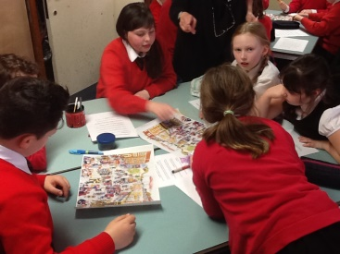
March: Group meeting when we discussed the Resolutions for the National AGM and discussed future events for the year. Junior School children in several schools in the area learned about human rights in assemblies and workshops from our teams of school speakers. Feedback was universally good. We made bunting for women and girls in Burkina Faso and sent letters to authorities in Angola and collected signatures to campaign to keep the Human Rights Act in the UK.

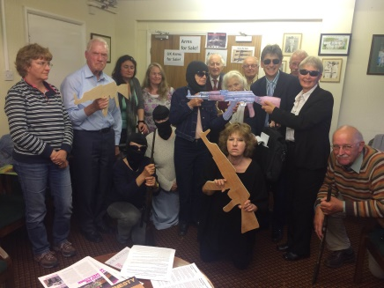
April: Four Group members attended the National Conference and AGM in Nottingham. As usual they returned feeling inspired, and re-energised by the event which they summarised for the Group at the May monthly meeting. During the April meeting we heard Dr Charles Dotou from Senegal talk of his experience of persecution and eventual escape from his country due to his work on HIV/AIDS with the LGBTI community. He also talked about the British Immigration system and the difficulties he has experienced in making a new life for himself. An inspiring man! We also sent a card to congratulate the Burmese authorities for releasing many prisoners of conscience and other political prisoners.

May: This was a busy month too! In addition to our monthly meeting we held a street collection in Llandudno, when we raised £367.We got some press coverage for our photo shoot action on the UK arms sales to Saudi, and signed letters for people in Azerbaijan, and Palestine

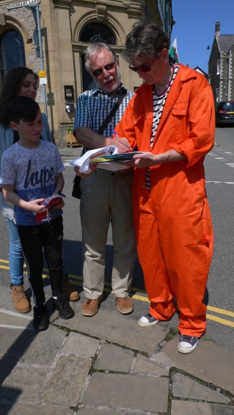
June: During our monthly meeting in June we held a Members’ Evening and were privileged to hear Anne Williams talk about her work on Turkey and the complex human rights situation there. Kevin Gill then asked us all to join in a fun workshop based on the ‘Right Up Your Street’ poster. This has formed the basis of much of our work in primary schools and group members clearly enjoyed the task they had been set! This month we also collaborated with local Quakers and the Peace Group in their weekend of human rights dramas. The Saturday prior to their event we helped promote it in Conwy when we handed out fliers and also asked for support for our petition for a judge –led enquiry. Pat Barry with help from group members and local embroiders made 100 stop torture flags which were hidden around the town for people to find. Each carried a message about the campaign. We ended the day with 350 names and these were supplemented at the drama weekend when audience members visited our stall. ‘Feeding the Darkness’ was a very powerful drama on torture that we have actively promoted to other Amnesty groups around the UK.
We held our annual street collection in Llandudno and raised £284+

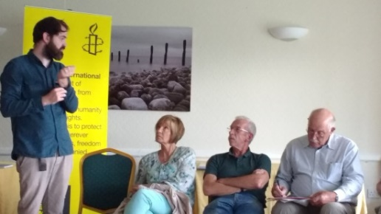
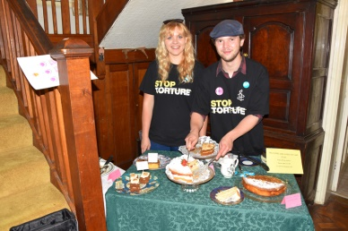
July: This month saw us once again in the beautiful gardens at Gilfach in Rowen where we baked cakes and sold refreshments to the garden’s visitors. This raised nearly £300 – a very enjoyable way to raise funds for Amnesty! Later in the month we held a collection at Tesco in Llandudno Junction and raised another £190 for Amnesty. Unfortunately our scheduled speaker, Yvonne McDermott-Rees was unable to attend so we improvised but we were very fortunate to welcome Martin Gallagher to speak in her stead. Martin talked passionately about hate crime particularly in relation to the Roma community to which he belongs. There was a very lively discussion after his talk. We invited Martin to sign Amnesty’s petition about the rise in hate crime in the UK since the European Referendum.

August: We held a collection and had a stall at Abergele Tesco where we raised £115 and gained 85 signatures from Conwy Residents on the Hate Crime petition. This was then sent to the leader of Conwy Council.

September: During our meeting this month we watched the moving film ‘Nostalgia for the Night’ by Patricio Guzman, a film shot in and about Chile during the Pinochet regime. Actions were signed for our new long-term case, Jorge Lazaro Nunes from Brazil and for Matsumoto Kenji on death row in Japan.
Gareth attended the national rally in London on refugees and reported back to the meeting about the experience.
Gill and Maggie represented the Group at the Third Sector meeting held by Conwy Council and CVSC on Syrian refugees coming to the area. 40 people were in attendance and several other organisations were represented. We await news of further progress on this and how we may be able to help.

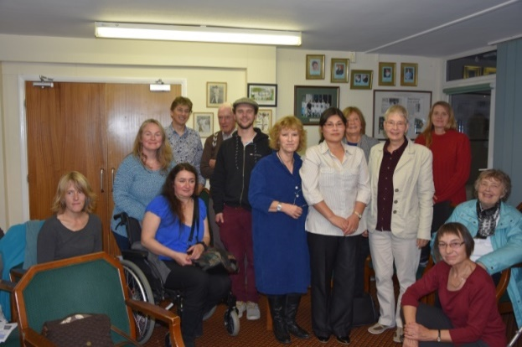
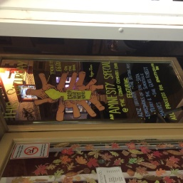
October: During the meeting we watched a very moving animation ‘The other Interview’ and then heard directly from Jihyun Park, the film’s protagonist, about her life in N Korea and how she managed to escape and make a new life herself and family in the UK. A truly inspirational woman! Earlier in the month we ventured into ‘heavy rock’ with a gig in Conwy during the Food Festival weekend. The bands were appreciated by the audience and we made the princely sum of £985, including a very generous donation from Gary who organised the event with Duncan. Gary waived all his expenses of £340.
Maggie and Gill attended the NW Regional Conference in Liverpool where the theme was Modern Trafficking and Slavery. This was a well organised and very interesting conference.

November: We held our usual Group Write for Rights evening when we sent 69 cards and 3 appeal letters. Judith distributed Amnesty catalogue orders.
The following evening we went to St Asaph Cathedral for the Winter Fair where we held a Write for Rights stall. We engaged members of the public on 5 cases from the Write for Rights campaign: Eren Keskin (Turkey), Johan Teterissa (Indonesia), Fomusoh Ivo Feh (Cameroon), Nazanin Zaghari –Ratcliffe (Iran) and Syrian refugees coming to the UK. 80 cards were signed including one by Colin Hardie, Mayor of St Asaph. Debs took 2 beautiful dolls that she had made and held a ‘name the doll’ game for children, and we also sold Amnesty Christmas cards.
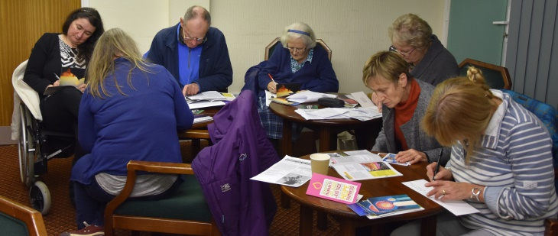
Maggie spoke to 180 students at Hawarden High School and 130 at Eirias Park School who learned about human rights and Amnesty’s work. They were all invited to sign cards for Nazanin Zaghari-Ratcliffe and Fomusoh Ivo Feh.
Gill and Maggie visited Llanddulas School where they gave an assembly for the Junior school and a workshop for years 5 and 6

December: A further 120 6th formers at Eirias Park learned about refugees and Amnesty’s campaign and signed cards for Nazanin
We returned to the Victoria Centre, Llandudno for our annual carol singing event. The choristers were ‘better than ever’ and were certainly appreciated by the public who donated just over £500! Coastal Voices once again joined us at midday and entertained the public with their lovely voices and mix of world music. Thanks to friends from other choirs who swelled our numbers and created such a good sound.
.

An active year indeed!

Maggie Towse
7 January 2017

