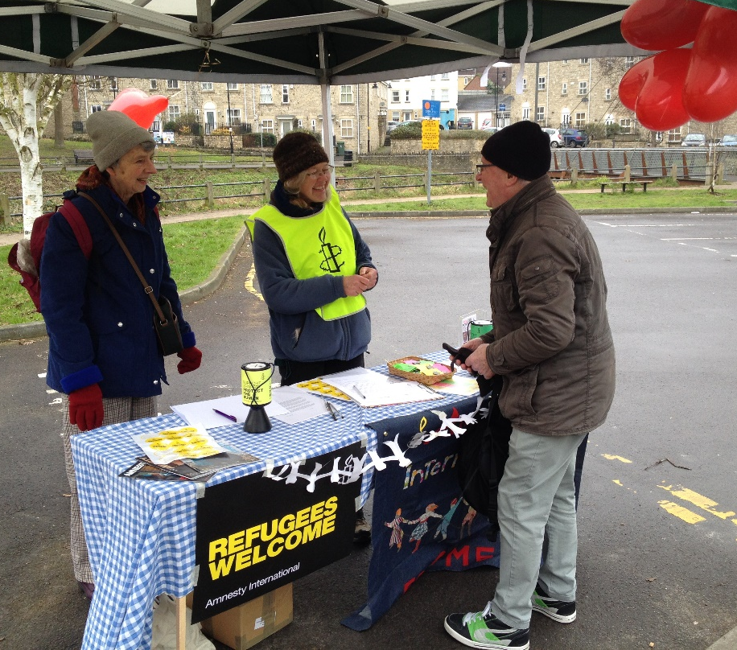  Amnesty International  Frome Group Newsletter  WE ARE ORDINARY PEOPLE FROM ACROSS THE WORLD STANDING UP FOR HUMANITY AND HUMAN RIGHTS  Website: www.amnesty.org.uk/groups/frome  Facebook: www.facebook.com/fromeamnesty  Thank you for supporting our group action –  Reuniting child refugees with their families  Thank you to everyone who braved the snow to support our February group action on Saturday 11th February. We ran a stall just opposite the library and despite the very cold weather we raised £62.17 and sent 39 letters! The letters have been sent to the Home Office and the Department for Education, and call on these departments to allow children recognised as refugees in the UK the right to be reunited with their families.  The Home Office and the Department for Education are currently running a consultation on safeguarding unaccompanied children in the UK. So this was a well-timed for our group action.  For more information on the consultation see :  https://www.gov.uk/government/speeches/safeguarding-unaccompanied-asylum-seeking-and-refugee-children |  | March 2017  Issue 12  Issue 2  IN THIS ISSUE: * *Our February group action * Frome group AGM *National Conference/ AGM *South West regional conference

Frome Amnesty International group AGM

Frome group’s Annual General Meeting was held at the February group meeting on Thursday 16th February.

Judy Hosegood will continue as group co-ordinator, Claire Stott will continue as treasurer and I (Nadine Crook) will continue as the group’s newsletter editor/ communications person.

Judy presented a summary of the group’s activities and events from the past year. Please find this attached to the email along with this newsletter. The financial incomings/ outgoings were reviewed and it was agreed to send a donation of £300 to Amnesty International UK.

National Conference and AGM for AIUK

The national conference and AGM will be held on 8-9th April at the East Midlands conference centre in Nottingham.
It is free to attend for Amnesty International UK members. There promises to be plenty to whet your appetite for human rights campaigning including hands-on workshops and actions, compelling speakers and powerful debates. There will be sessions on the I Welcome campaign, Against Hate campaign and the new Human Rights Defenders campaign.
For more information and to book your place click on this link:
www.amnesty.org.uk/AGM

South West Regional Conference
The South West Regional conference was held on Saturday 25th February in Exeter.
70 members from across the South West attended and heard from Ethiopian Human Rights defender Getachew Simie Obse about the important role of community radio in educating to improve children's rights, gender equality and environmental protection, and how this is being curtailed by government legislation. There is now no internet connection in Ethiopia.There was also an action outside Exeter cathedral to highlight the disappearance of 43 Mexican students.
If you attended the conference then please let me know your highlights from the day and I’ll include an update in our next newsletter.
Our group meets on the third Thursday of each month at the Bridge Café, Selwood Road, Frome, BA11 3BS at 8pm.

Our next meeting is: Thursday 16th March 2017

If you’ve never been to a meeting before why not come along! It’s very informal and it would be great to hear your ideas.

Your ideas for the newsletter…
If you have any feedback on this newsletter or would like anything included in the next issue then please feel free to contact me – Nadine Crook njwardman@yahoo.co.uk

