HORSHAM AMNESTY
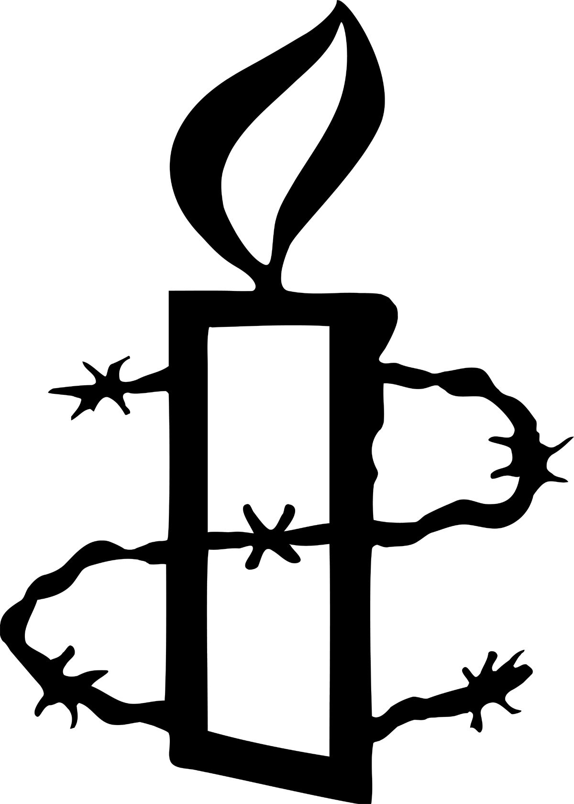
February 2015

Horsham Amnesty Open Evening:
Next meeting is at 8pm on Tuesday 3rd March at the Friends Meeting House Worthing Rd. (Free parking opposite in Sainsbury’s car park after 7pm).
This will be our OPEN EVENING: a chance to find out more about our group and Amnesty’s work. Invite your family and friends so that they can see why you support Amnesty. If you are not a member of a local group come and find out what we do, chat to members informally, hear about campaigns we have worked on and what we are doing now. There will be a warm welcome (and refreshments).
Hope to see many of you there – some of you for the first time!
Horsham Group AGM
We had a very interesting and useful AGM in our new venue at the Friends Meeting House.
Looking back over 2014 we noted that group members had attended the Guantanamo demonstration in Trafalgar Square, the SE regional conference in Dorking, the National AGM in Edinburgh, the Stop Torture campaign launch outside the Mexican embassy and the Embassy crawl in London.
As part of our campaigning for the North Africa region we had talks from Vilyana Tsekova, Morocco Country Coordinator and Hugh Sandeman Country Coordinator for Libya and Algeria. During the course of the year we took part in monthly actions and held a Writeathon and Write for Rights event as well as responding to requests from actions from the North Africa team.
In May we organized a production of “Even if we Lose our Lives” at the Hawth theatre in Crawley. There was a large audience including the MP for Crawley, Henry Smith and the Mayor and Mayoress all of whom were moved by the words of these Afghan women. We raised both awareness and funds for the campaign plus the audience took part in a photo shoot which was used to accompany petitions asking governments continue to protect the rights of Afghan women during the period of transitional government.
We continued during the year to raise funds by holding an AmnesTea, a boot sale and street collection. The new website also was up and running with news and updates about the group.
We finished the year by choosing a new case to work on and campaigning for the release of Ethiopian journalist Eskinder Nega has begun in earnest.

Eskinder Nega
You will be hearing a lot more of Eskinder our adopted Prisoner of Conscience in coming months as we begin our campaigning in earnest. Here is a brief summary of his case:
COMMUNITY LEADER IN DANGER
In June 2012 Eskinder Nega, a journalist, was sentenced to 18 years in prison for terrorism offences, after he criticised the Ethiopian government and called for freedom of expression in speeches and articles. The Ethiopian authorities routinely use criminal charges and accusations of terrorism to silence dissenters. Eskinder has long been a thorn in the side of the Ethiopian authorities. This is the eighth time he has been arrested and prosecuted for his journalism. His journalist wife, Serkalem Fasil, was also jailed on treason and other charges. Their son Nafkot was born in prison. Amnesty International considers Eskinder to be a prisoner of conscience.

South East Region AGM
Three group members attended the SE regional conference in Chichester. It was an inspiring event. The opening speaker was Celia Ouellette from Reprieve. She is a Staff Attorney on Reprieve’s Death Penalty Team working on cases of British and EU nationals facing the death penalty in the US. There are about 40 of these people and she looks after about seven of them. Her talk was entitled “Who is a Client on Death Row in the US?” The case she described is of a man she called Tyler, who had an appalling childhood. Celia described her examination of the development of this man from the age of four by comparison using words and pictures with her normal but privileged life. He was badly abused and then rejected by both parents. Since the case is in a pre-trial state she could not go into great detail, but extremely interesting and worrying information came out from the discussion afterwards.
There was also a presentation by Lesley Burgess, on torture in the Philippines and a choice of three workshops: Lobbying & the general election, Social Media and Refugees and Asylum Seekers: Rights and Responsibilities.
All this information and general networking with other local group members was very useful.

Stop Torture Conference
Five of us travelled up to London on a sunny St Valentine’s Day to go to AIUK’s conference:
“Stop Torture:-How Activists Can Campaign for Safeguards”. It opened with a talk by Craig Murray, former UK ambassador to Uzbekistan. He described his experiences of human rights abuses in the country and his attempts to bring these to the attention of the UK government with no success. Eventually he was fired by the foreign office. He said the reason for his removal was his criticism of the use of intelligence allegedly obtained under torture by the Uzbekistan Government.
During the morning there were workshops on each of the five cases selected for the Stop Torture campaign. In the afternoon there was a panel discussion of safeguards and strategies that may or may not be working in the countries concerned. The most memorable quote from the conference came from Rhian Beynon from Freedom from Torture who gave us one torture survivor’s definitions of torture: “the act of killing a man without him dying”.

National Conference and AGM
A reminder this is still just time to book a place at the national AGM.
As a member of Amnesty, you can influence the issues we focus on, the human rights campaigns we run, and the way we work as an organisation by taking part in our National Conference and Annual General Meeting (AGM).
Make your vote count – join us at Warwick University, Coventry, on 18-19 April 2015, for a weekend of inspiration, activism and debate.
Horsham Amnesty Facebook Page:
This is now active so if you have a Facebook account search for Horsham Amnesty then “like” it. We have news of the cases we are working on and what is happening in the group. Often there are actions where you can click through to a petition or letter. Within a few minutes your can add your name and make a positive difference by joining in an action to free a prisoner, protect someone in danger or persuade a government to change the law. You can also share posts making them more effective by reaching a bigger audience.
If you don’t have a Facebook account maybe someone in your family does so encourage them to sign up. That way Horsham group’s campaigning actions get the widest coverage possible.
Keep an eye on our website, too: http://www.amnesty.org.uk/groups/horsham

Looking Forward:
8pm 3 March OPEN EVENING Friends Meeting House, Horsham
7.30pm18 March Shoreham AI -Iraq &Islamic State Methodist Church
Brunswick Rd, Shoreham
8pm 7 April Lobbying & the General Election Friends Meeting House, Horsham
18-19 April National Conference & AGM Warwick
22 April Election hustings Capitol Theatre, Horsham
8pm 5 May Group meeting Friends Meeting House, Horsham
9 May (tbc) AmnesTea in the Carfax Horsham town centre
8pm 2 June Group meeting Friends Meeting House, Horsham
20 June AmnesTea Ifield Quakers, Crawley
8pm 4 July Writeathon Friends Meeting House
8pm 7 July Group Meeting Friends Meeting House

For more information about group venues and events please contact:
horsham.amnesty@btinternet.com
Don’t forget to look at our website for news about the group, up to date information and actions:
http://www.amnesty.org.uk/groups/horsham

