HORSHAM AMNESTY
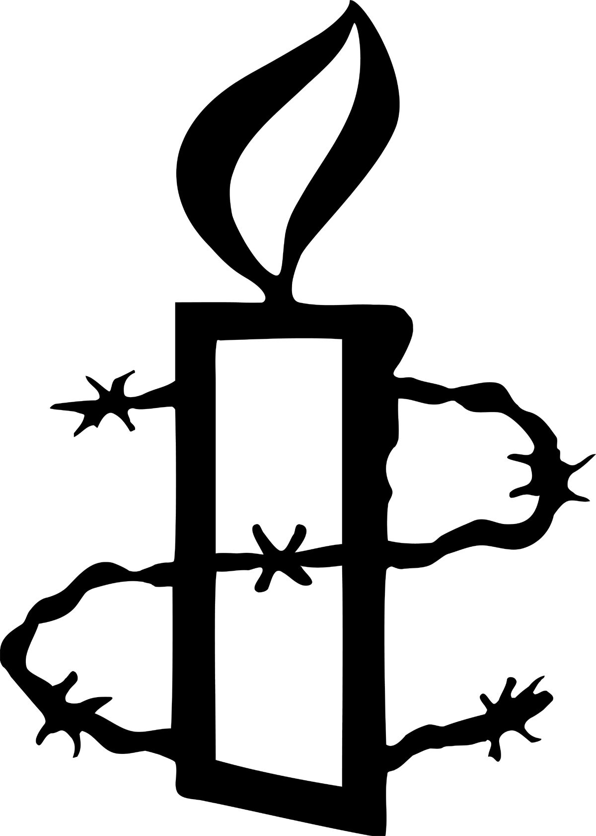
March 2014

National AGM and next group meeting
We have two group members attending the National AGM in Edinburgh 12- 13 April. They will be taking our 10 group votes and casting them on our behalf. All the resolutions are posted on our Horsham Group website: http://www.amnesty.org.uk/groups/horsham . We will be discussing them at our meeting on 1 April at Daphne’s house. Please note the earlier time of 7.30pm.
If you are coming to the meeting please have a look at the resolutions beforehand. If you can’t come to the meeting and would like to comment on the resolutions please send these by email to horsham.amnesty@btinternet.com.
Rusper Boot Sale
We have a stall at the boot sale in May and need contributions to sell. Last year we made a good start but think we can do better. We need books, bric a brac, good quality jumble. We were surprised at what will sell! You can email Jacinta who is happy to collect items or can tell you where to drop them off: jacinta.white@hotmail.co.uk or phone her on 01798 813545
Before 11 May – please help!

March Action: Women’s Rights n Afghanistan

At the March meeting we took part in the action taking photos of ourselves holding pictures of Afghan women who had lost their lives because of their work. The photos will be used to express solidarity with Afghan women human rights defenders and as a way to pressure the UK government to improve support and protection.

We are now working on holding a reading event to tell the moving stories of Afghan women on the front line. More news on this event shortly. Meanwhile here is some background on the campaign.

2014 is set to be a critical year for Afghanistan, and particularly for women’s rights. International troops will withdraw from the country by the end of the year and Presidential elections are scheduled for April. International pressure to reach a political solution to the conflict and negotiate with the Taliban and other insurgent groups is growing. Afghan women, who have already been sidelined from the peace process, have well-founded fears that should the Afghan government and international community strike a peace deal, their rights will be negotiated away.
More worryingly there are several indications that the fragile progress for women’s rights might already be backsliding. Last year the conservative Afghan parliament heavily criticised the progressive Elimination of Violence against Women law and almost succeeded in removing the 25% quotas for women sitting on provincial councils. Additionally there have been attacks on no less than nine high-profile Afghan women in the last six months, including the murder of four policewomen, a pregnant teacher, an author and a local government worker. Almost exclusively these attacks have happened with impunity, sending an incredibly dangerous message that, in the words of Suraya Pakzad, who runs women's shelters in several provinces: "Killing women in Afghanistan is an easy thing. There's no punishment".
Fragile human rights gains made in recent years need to be supported and consolidated throughout the transition and beyond. The role of human rights defenders will be fundamental in protecting human rights and ensuring the Afghan government meets its commitments but their ability to do this will be severely compromised if their security becomes ever more fragile. It is absolutely essential that women’s rights in Afghanistan are kept firmly on the UK government’s agenda and that every possible effort is made to protect those on the frontline – teachers, doctors, civil society activists and parliamentarians – who are instrumental in defending women’s rights, pushing for peace and supporting their communities.

Looking Forward
1 April Group Meeting 7.30pm Daphne’s house
AGM resolutions

12-13 April National AGM Heriot-Watt University in Edinburgh

13 May Group Meeting 8pm Chris’ house
Report back from AGM/planning

11 May Boot Sale Rusper (25 May if wet)

8 June AmnesTea 2pm 4 Patchings

5 July Writeathon 10-12 Friends Meeting House

For more information about group venues and events please contact:
Horsham.amnesty@btinternet.com

President Moncef Marzouki
Palais Présidentiel
Tunis
Tunisia
Your Excellency
RE: Jabeur Mejri
I am writing to you regarding Jabeur Mejri and his friend Ghazi Beji who were sentenced on 28th March 2012 to seven and a half years in prison and a fine of 1200 Tunisian Dinars after the first instance court in Mahdia deemed posts that they had made online to be insulting to Islam and Muslims under the Tunisian Penal code and the Telecommunications Code.
Jabeur Mejri’s posts included articles and images of the Prophet Mohamed on his Facebook page and Ghazi Beji’s posts included a manuscript he had written called “The Illusion of Islam” in which he expressed his atheistic views, satirised Islam and depicted the Prophet Mohamed in cartoons.
International human rights law protects the expression of ideas that are perceived as being offensive. Criticism of religions and other beliefs and ideas is a vital component of the right to freedom of expression, and laws that criminalise criticism of (or insult to) religious beliefs violate freedom of expression.
Jabeur Mejri is currently in Mahdia prison whilst Ghazi Bejri fled the country before being arrested and was tried in absentia.
I ask you to do all that you can to ensure Jabeur Mejri’s immediate and unconditional release. Jabeur Mejri is a prisoner of conscience held solely for peacefully exercising his right to freedom of expression.
I also ask you to call on the Tunisian authorities to quash the conviction and prison sentence against Jabeur Mejri and Ghazi Beji and to do all that you can to ensure that the Tunisian authorities respect the right to freedom of expression and that they meet their international human rights obligations.
Thank you for taking the time to read this letter and I look forward to hearing from you further.
Yours faithfully

