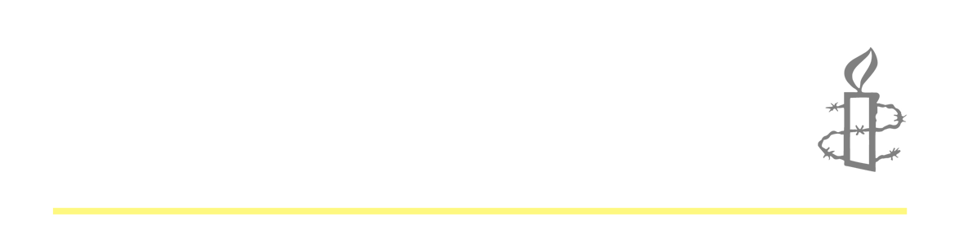
GENERAL ELECTION AND LOBBYING SKILLS PACK

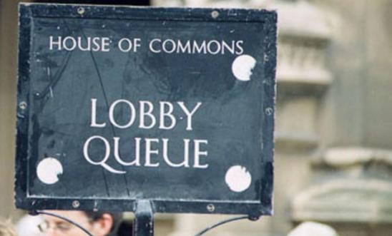
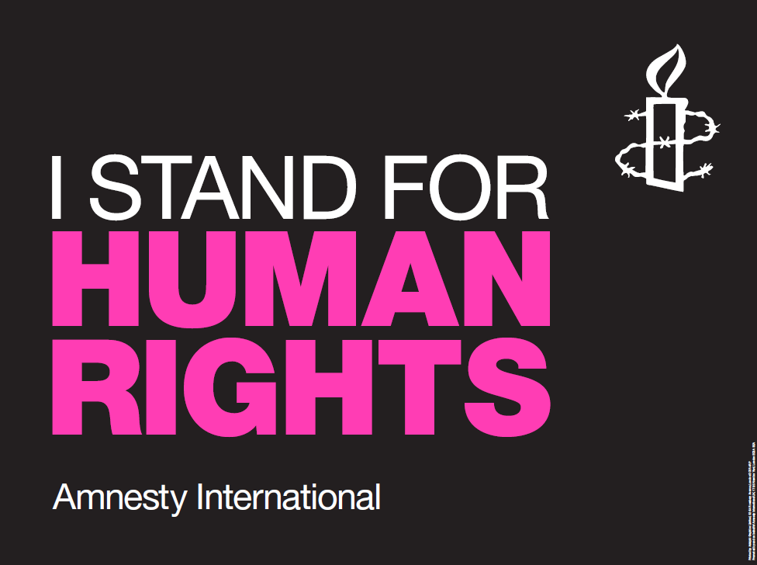

About this presentation
This training pack is part of Amnesty’s General Election 2015 strategy. This presentation is a guide for Trainers to use when engaging with Local Groups, Student Groups or external organisations.
The script is intended for delivery in a training or facilitation setting. Trainers may add or delete slides as they find appropriate and adapt the script to suit the style and length of your session. Also included are additional materials which can be used in selected activities.
Training Objectives:

- Provide an introduction to Amnesty’s General Election strategy.
- Understand how to operate under the Lobbying Act.
- Build the skills and understanding needed to lobby effectively.

Suggested Resources

- Post-it notes
- Flip-chart, paper and pens
- Laptop and projector

Training Pack Contents
This General Election and Lobbying Training Pack contains the following materials to support training:
- Facilitation Notes
- PowerPoint Presentation
- The Lobbying Act: a guide for Amnesty groups
- Stop Torture - General Election Briefing 2015
- Human Rights Act - General Election Briefing 2015
- Case Sheet - Human Rights Act
- 5 Top Lobbying Tips
- Prospective Parliamentary Candidates Bios
- Links to Resources
- FAQs

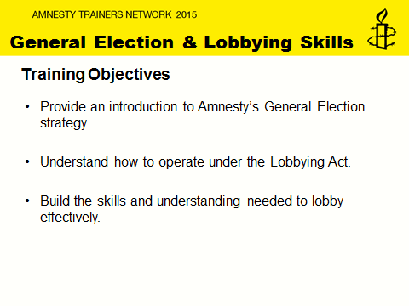
Slide 2: General Election and Lobbying Skills
This slide explains the training objectives to local, student and other groups.
You may include the following:
- Today’s training will cover Amnesty International UK’s focus during the 2015 general election.
- This training will provide an introduction to Amnesty’s general election strategy and where our key focuses will be.
- In addition, you will be provided with some clarity and guidance about how to operate under the Lobbying Act, including where you can get further information.
- Last but not least, this training will look at ways to develop your lobbying skills and how to lobby more effectively.
NOTES:
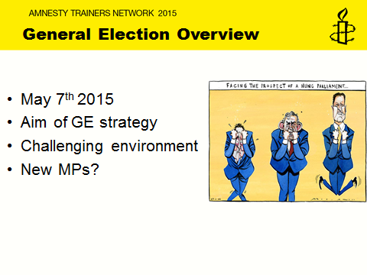

Slide 3: General Election Overview
This slide gives and overview of the general election and looks and the aims and challenges activists will face going forward.
You may include the following:
- The next General Election is on May 7th 2015 and it is gearing up to be one of the most uncertain election outcomes for a long time with predictions for another coalition or power sharing agreement.
- Our aim for this General Election is for post-May 2015 Members of Parliament to be more aware and supportive of Amnesty International. We are looking to build relationships and further understanding about human rights through AIUK activist campaigning during and after the 2015 General Election.
- To date 88 MPs have announced that they are standing down and an unknown number of seats are changing hands, bringing new MPs to Westminster. This means Amnesty activists will have the opportunity to engage with a significant number of new MPs. This opportunity allows our activists to mobilise support in Parliamentary constituencies to protect human rights and to ensure that AIUK’s issues and our membership’s work is visible.
- It is important for activists to engage with as many PPC’s as possible. Amnesty is not aligned to any political party and is completely impartial. The credibility and success of our work is because of our wide engagement across party lines.
NOTES:
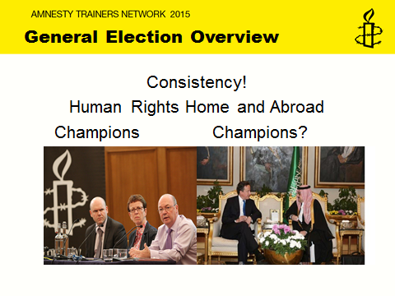
Slide 4: General Election Overview: Consistency
This slide illustrates the importance of drawing attention to human rights during the general election, emphasising the need for consistency in Britain's approach to human rights both home and abroad. (For example, Picture one (left) shows the UK government Minister Alistair Burt championing the Arms Trade Treaty whilst Picture two (right) shows a meeting between the Prime Minster and Saudi Arabia. We have recently been critical of the UK government’s failure to criticise the Saudi authorities publically on their human rights record.

You may include the following:
- Successive UK governments have approached human rights and, it is fair to say, undermined them in different ways. No government has applied human rights standards consistently – in fact probably the only constant has been the seemingly haphazard application.
- At Amnesty we have seen human rights be applied inconsistently at all levels of government; between parties, within parties, between departments, within departments; and even between successive Ministers at the same department. It has often been the case that progress on one issue is met with deterioration on another.
- For example, Picture one (left) shows the UK government Minister Alistair Burt championing the Arms Trade Treaty whilst Picture two (right) shows a meeting between the Prime Minster and Saudi Arabia. We have recently been critical of the UK government’s failure to criticise the Saudi authorities publically on their human rights record.
- The UK presents itself as a leading voice on human rights internationally, on issues such as the death penalty, LGBTI rights, women’s rights etc. However, we know through experience that successive governments continue to avoid difficult conversations about human rights in the pursuit of commercial and 'strategic' relationships. Unfortunately, human rights are largely absent in UK government visits overseas where trade focused delegations to countries like China, Saudi Arabia and India take precedence over human rights.
- In addition, UK diplomacy on human rights needs to be reflective of its activities at home. However, efforts are arguably undermined by continued attacks on human rights at home; from calls to scrap the Human Rights Act and attacks on the ECHR to a negative narrative on asylum & immigration.
NOTES:
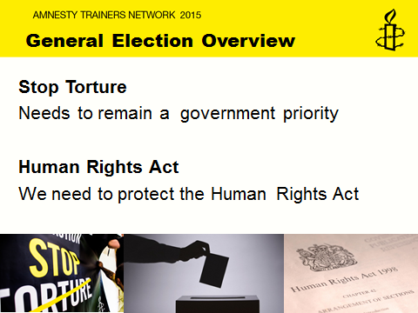
Slide 5: General Election Overview: Stop Torture and HRA
This slide briefly shows how Amnesty will focus on human rights at home and abroad. These are the two key issues we think the next UK government need to prioritise. More details will be covered in later slides.
You may wish to say the following:
1. During the lead up to the general election, Amnesty will be focusing on human rights at home and abroad.
2. As it currently stands the prevention of torture is currently a priority for the Foreign and Commonwealth Office. Amnesty wants to stress that the next government continues to prioritise the prevention of torture.
3. In addition, Amnesty wants to see human rights in the UK safeguarded by protecting the Human Rights Act.
NOTES:
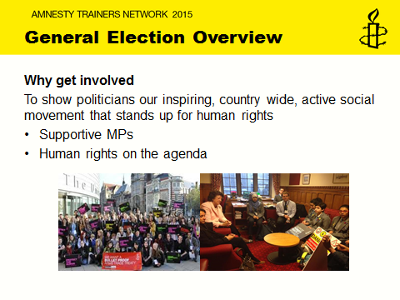
Slide 6: General Election Overview: Why get involved?
This slide explains why activists should get involved with the general election and how important it is to use this opportunity to build the profile of the contribution groups make in their communities and to the international movement.
You may include the following:
- In the run up to the General Election when politicians are perhaps more focused on their constituencies it presents an opportunity to demonstrate that AIUK is a vibrant social movement made up of passionate activists working in communities across the UK.
- In addition, having good relationships with MPs from all parties following the 2010 election allowed Amnesty to secure UK government support for the Arms Trade Treaty, get more support for survivors of domestic violence and secure resettlement for some Syrian refugees.
- If we want the next UK Parliament to stand up for human rights we need to demonstrate the passion, resolve and commitment of our movement. The presence of Amnesty activists like you, across constituencies in the UK means we can put human rights high up on the agenda of the next government.
- Moreover, the activism you do on the ground informs the work our experts do when they lobby and advocate for human rights with government officials.
- This will be particularly effective through activist feedback which you can do by emailing lobbyfeedback@amnesty.org.uk which will inform our Advocacy teams who will be working with the post-May Parliament. This will help raise Amnesty’s profile and credibility amongst the new Parliament.
NOTES:
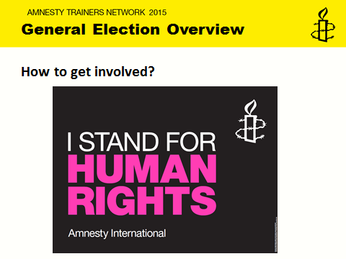
Slide 7: General Election Overview: How to get involved?
This slide informs activists how they can get involved in the General Election campaign. You can encourage groups to order resources by contacting TFS on 01788 545553 and quote the below codes.
Pledge cards - GE001
Posters - GE002
Placards - GE003

You may include the following:
- There are a number of ways you can get involved. We have created a few resources to help with this work. These include the fight for rights pledge, a poster and a placard, which can all be ordered from TFS.
- Firstly, you can use the Fight for Rights pledge. The ask is for activists to sign the pledge, get others to sign and collect them up. When a new MP is elected in your constituency, arrange a meeting and hand them in. This will show the commitment in the constituency to Human Rights and allows an opportunity to engage with the new MP early to raise important human rights issues.
- During the election campaign, we encourage you to meet your PPCs, arrange meeting with all of them or see them individually to raise these issues. It is better to do this earlier as PPCs get busier as the election draws nearer.
- Promote this work on social media, tweet pictures of people signing the pledge, meetings with PPCs etc.
NOTES:
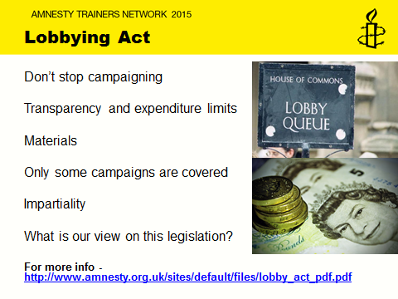
Slide 8: Lobbying Act
This slide outlines how the Lobbying Act affects our activist work and provides tips and guidance on what activists need to do in order to continue with their amazing campaigning and complying with the law. It is important for trainers to emphasise to groups that the new law should not discourage them from campaigning. You could provide the group with the ‘The Lobbying Act: a guide for Amnesty groups’ sheet.
You may include the following:
- In January 2014 a new law called the Transparency of Lobbying, non-Party Campaigning and Trade Union Administration Act 2014, more commonly known as the Lobbying Act, came into law.
This law regulates campaign spending on what is known as ‘regulated campaign activity’. ‘Regulated campaign activity’ is activity that can reasonably be regarded as intended to influence voters to vote for or against political parties or categories of candidates, including political parties or categories of candidates who support or do not support particular policies or issues. Most of Amnesty’s campaigns are ‘unregulated campaign activity’, such as our Stop Torture campaign but our work on the Human Rights Act during this election does fall under regulated activity, but this should not deter groups from campaigning. There is some really useful guideline on Amnesty’s website on how to comply with the Lobbying Act as well as relevant forms you can use to track spending.
- Most importantly, it shouldn't stop you campaigning
This law does not prevent us from campaigning on any issues, including those related to an election. You don't need to change your planned campaigning over this period.
- It is all about transparency and expenditure limits
It sets a limit on our expenditure on any public campaigning that could be seen as seeking to influence election outcomes. It therefore requires us to record and report on that expenditure. This means that you will need to maintain a detailed record of all your expenditure on public activities on 'regulated campaign activity' and keep all receipts that are more than £200 in value. If you receive donations – including goods or services of £500 or more (e.g. venue hire) in value and these are specifically for regulated campaign activity, then you will need to record the donor contact details and tell us straight away so that we can ensure that this is treated correctly under the new law. There is a simple online form provided to record expenditure (http://amnestyuk.wufoo.com/forms/lobbying-act-recording-expenditure/)
- Materials
If you are planning on printing your own materials to use publicly on 'regulated campaign activity', please talk to us first. This is because they may need to carry what is known as an 'imprint', stating the publisher and promoter. This is a simple procedure.

- Only a small part of our campaigning will be covered
As I mentioned only a small part of our campaigning will be covered. We have a team of staff assessing all of our campaigns to check if they are covered by the law. The vast majority of our campaigning work will not be covered.
- Impartiality
We do not try to influence elections – it is one of our founding principles that we are impartial. We must always ensure that we do not endorse any political party or any political candidate. However, we campaign for human rights awareness and for human rights change. Sometimes these issues can be of political interest and can be controversial as they can become associated with one political party or another. The regulations mean that, because of this, aspects of our campaigning may be regulated under this legislation if 'a reasonable person' might think that what we are doing is partly intended to influence the choices of voters, regardless of our actual intentions.
- What is our view on this legislation?
Along with many other UK charities and NGOs, we are concerned about the impact of this law on campaigning during election periods. Our position now is that we will monitor the impact of the law on our own work over the next seven months as well as keeping in touch with the impact on others in civil society.
NOTES:
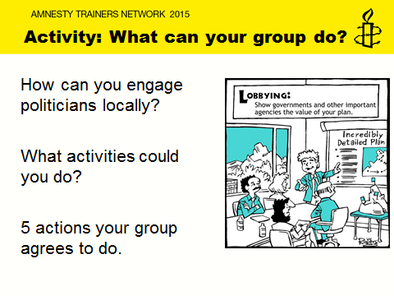
Slide 9: Activity 1: What can your group do?
Objective: To explore different activities groups could do to engage with PPC’s.
To agree on five actions that the group will do during this election campaign.
Resources: Pledge Cards (if provided), flip chart, marker pens, post-it notes
Group size: 3 to 6
Length: 25 minutes
- On Post it notes ask activists to write down ways they could engage PPC’s locally, ranging from direct to indirect engagement. With one activity per post-it. Advise groups that activities could be events, meetings, media opportunities, pledges and social media activity. (10 minutes)
- Prepare the Megaphone devise - On a flipchart sheet draw a megaphone like the following (before and after versions).
Indirect lobbying activity

e.g. Write to the local paper about Amnesty and human rights during the general election
Direct lobbying activity
e.g. Tweet you PPCs
e.g. Organise a hustings
e.g. Invite PPCs to AmnesTea event

- Ask participants from each group to stick their post-it notes on the megaphone with the more direct lobbying activities on the smaller end of the megaphone and the indirect lobbying activities towards the wider end of the megaphone. (5 minutes)
- Ask wider group to feedback on reflections from the megaphone and ask them to choose 5 actions that they as a group can commit to doing. (10 minutes)

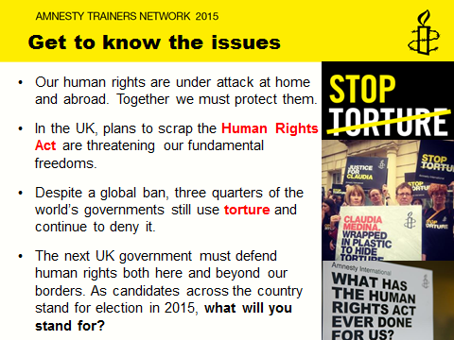
Slide 10: Get to know the issues
This and the following slides will outline the issues we are focusing on during the general election.
You may include the following:
- Human rights are under attack both here at home and abroad. It is important for Amnesty to continue to highlight severe abuses of human rights from around the world but it is equally important that Amnesty hold the UK government to account on its own human rights record.
- With the Human Rights Act under threat with plans to scrap it and replace it with a ‘British Bill of Rights’ and UK involvement in torture and renditions, defending human rights here in the UK is a priority for us during the election.
- In addition, the UK’s position to influence governments around the world and to hold governments to international human rights standards, we want to see our influence strengthen human rights abroad by maintaining that torture prevention continues to be a priority for the next government.
- Through focusing on human rights at home and abroad, Amnesty activists are asking their PPC’s what will you stand for?
NOTES:
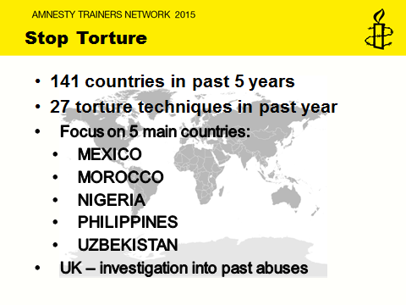
Slide 11: Stop Torture
This slide gives an overview of the Stop Torture campaign and why it is important that it remains a government priority.
You may say the following:
- Torture is not only still happening, it is flourishing. Our latest research shows that over the past 5 years torture or ill-treatment has occurred in at least 141 countries, with 27 torture techniques used in the past year. That’s nearly three quarters of all countries in the world.
- For more than 50 years, Amnesty International has been fighting to stamp out torture. 30 years ago, our movement led the campaign to secure the UN Convention against Torture. Despite the UN Convention torture more needs to be done and that is why we have launched our worldwide “Stop Torture” campaign.
- Five countries have been selected from different world regions where torture is both a major issue and where we think we can genuinely achieve change over the course of the campaign.
- Use of torture and ill-treatment by security and police forces remains widespread throughout Mexico, and impunity rife. Mexico has made numerous commitments to prevent and punish torture and ill-treatment, but these measures are inadequate and largely ignored. Amnesty is calling for independent medical examinations of detainees who make accusations of torture
- Torture and other ill-treatment have been explicitly prohibited and identified as a crime in Moroccan law for several years, but they continue in practice. Judges and prosecutors rarely investigate reports of torture and other ill-treatment, meaning few perpetrators are held accountable. Amnesty is calling for interrogations to be filmed and there to be lawyers in the room, so that ultimately courts don’t rely on torture evidence for convictions.
- There is evidence of increasing use of torture in Nigeria. Amnesty International’s recent research indicates that police and military personnel routinely use torture to extract information and “confessions”, and to punish and exhaust detainees. In contravention of national and international law, information extracted by torture and ill-treatment is routinely accepted as evidence in court. Amnesty is calling for independent access to detainees for example for lawyers and family members.
- The use of torture is widespread in the Philippines. State security forces including law enforcement officers torture suspects and prisoners. Justice is out of reach for the vast majority of people who are tortured. Amnesty wants to see police held to account for their abuses.
- Torture and ill-treatment is rife in Uzbekistan. Amnesty International receives persistent and credible allegations of routine and pervasive torture and ill-treatment by security forces and prison personnel. Reports suggest that people are tortured when arrested, transferred and awaiting trial, and in detention facilities. Very few people are brought to justice for inflicting torture, and the authorities routinely fail to conduct effective investigations into allegations of torture and ill-treatment. Amnesty wants to see international oversight, where permission is granted to the UN Special rapporteur to monitor torture within its borders.
- Many people were allegedly subjected to torture and rendition during the global counter-terrorism programme operated by US government and its allies after the attacks of 9/11. That includes the UK. Yet we still don’t know the truth. We are calling for a thorough, impartial, independent, judge-led inquiry which will finally reveal the truth about the UK’s involvement in this shocking programme of torture and rendition.
NOTES:
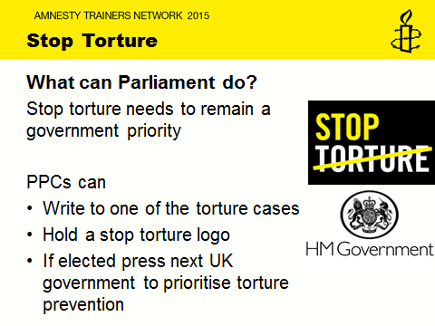
Slide 12: Stop Torture: What can Parliament do?
This slide looks at ways PPCs could get involved with the Stop Torture campaign.
You may include the following:
- We want future Parliamentarians and the next UK government to prioritise torture prevention.
- There are a number of ways you could involve your PPC to support this campaign.
- This could include asking them to write to one of our Stop Torture Campaign cases, like Claudia in Mexico, who wants to see her perpetrators held to account, or Moses in Nigeria, who was arrested when he was 16 and is facing the death penalty after being convicted on ‘confessions’ obtained through torture.
- In addition, your PPCs could take a picture holding the Stop Torture logo which you could later upload to social media.
NOTES:
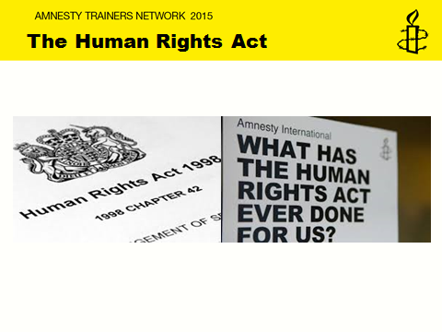
Slide 13: The Human Rights Act
This slide explains the importance of protecting the Human Rights Act and why we have chosen to focus on it during general election campaign.
You may include the following:
- Much is said about the Human Rights Act (HRA) by members of the press, by political parties and members of the public. Some are defiantly in favour of it whilst others strongly oppose it, so much so that some parties have pledged to repeal the Act. It is for this reason that we have included this as one of the key issues for the General Election campaign. The Human Rights Act is under threat and we need to defend and protect it.
- In order to do this we need to make the case for why is it worth protecting? The Human Rights Act ‘incorporates’ into English law most of the rights in the European Convention on Human Rights (‘ECHR’). The ECHR is not an EU treaty but a treaty document from the Council of Europe, a separate and distinct body from the European Union.
- Before the Human Rights Act came into force in the UK in 2000, the only way for individuals to enforce their rights against the UK government was to apply to the European Court of Human Rights in Strasbourg. This was a particularly slow and expensive process. Although the UK was significantly responsible for drafting the ECHR, and ratified it in 1951, being an international treaty it needed to be ‘brought home’. This was the aim of the HRA: to make rights accessible and enforceable in the UK and part of the decision making culture.
- So, how does it work? Under this law, public bodies in the UK were not only held to account in UK courts but it also meant that any new laws had to take into consideration whether they are compatible with human rights. As a result the Human Rights Act affects how our laws are made and interpreted – so new legislation must be ‘compatible’ with the rights in the Convention.
- In addition it affects the actions of those carrying out ‘public functions’. Under the Human Rights Act, public authorities must interpret legislation in a way that is compatible with those rights and act accordingly, if they don’t, they can challenge those authorities in the courts (through judicial review) or even sue.
- In practice, the Human Rights Act gives people the power to press the government to respect their rights. It has been used to ensure mothers experiencing domestic violence have been able to find stable accommodation, for themselves and their children. It has prevented elderly couples from being separated in care homes. It was used to ensure a public inquiry into the Mid-Staffordshire NHS Foundation Trust regarding patient abuse and high mortality rates. But interestingly most cases brought under the Human Rights Act don’t actually go to trial – the public authority often works out a way forward with the individual through dialogue, so you can see how that aim to bring human rights into decision making culture in the UK has been successful. Doesn’t seem particularly objectionable, does it?
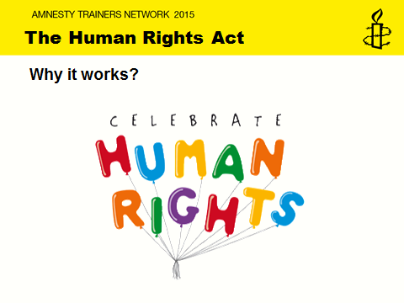
Slide 14: Human Rights Act: Why it works?
This slide looks at HRA cases that have helped people claim their rights. Activists are encouraged to spread the importance of celebrating human rights and therefore the HRA.
You may include the following:
- The real ‘problem’ with the HRA is that it gets attacked frequently and often for political ends, and as a result there are many myths and misconceptions about what it does. So many things are said about it that is untrue or misleading.
- It is important to emphasise that the HRA has a positive effect on ordinary lives. The HRA is not just about the people and issues in the headline grabbing Court cases. In any event the cases you hear about are usually the ones the government decides to fight in public rather than settle or concede beforehand, and are therefore, as you might expect, often the cases that are about less clear cut violations or which involved unpopular people or causes.
- Many HRA cases in the Courts have led to positive changes, such as a focus on dignity for the elderly and others receiving care at home; improved procedures to avoid disabled individuals falling into a gap between social services and housing departments, and an end to blanket Do Not Resuscitate orders in hospitals.
- Individuals have been able to use the Act to protect themselves in numerous ways, in and out of Court, which often have results in procedural changes which benefit many others. The following examples are the kinds of cases we need to draw the public’s attention to when discussing the HRA:
- Keeping elderly couples together:
A couple were both hurt in a fall. The husband could no longer care for his wife, who had Alzheimer’s, because of his injuries. Social Services threatened to move her into a care home that was too far for him to reach. With help, he argued Social Services had an obligation to consider the couple’s right to family life and this convinced them to keep her close to him.
In a similar case, a husband and wife had lived together for over 65 years. He was unable to walk unaided and relied on his wife to help him move around. She was blind and used her husband as her eyes. They were separated after he fell ill and was moved into a residential care home. She asked to come with him but was told by the local authority that she did not fit the criteria. After relying on their family rights, the authority agreed to reverse its decision and offered the wife a subsidised place so that she could join her husband in the care home.

b. Stopping blanket Do Not Resuscitate (DNR) Orders
An elderly man with dementia went into hospital. When his advocate saw a DNR Order on his file she was told everyone on the ward got one automatically. She successfully challenged this policy using the right to life and the right not to be discriminated against.
c. Young learning disabled girl denied school transport
A local authority had a policy of providing school transport for children with special educational needs living more than 3 miles from their school. A young learning disabled girl lived 2.8 miles from the special school she attended. Despite being unable to travel independently, she was advised by the authority that she should instead take two buses to and from school each day. The mother approached the head teacher of the school and explained that the decision was a disproportionate interference with her daughter’s right to respect for private life, given the failure to consider her specific circumstances. The head teacher took the issue to the local authority, and the decision was reversed. Thereafter the young girl was provided with transport to and from school.
d. Removing children from a mother living in poverty and temporary accommodation
A woman living in poverty left her partner after discovering that he had been abusing their children. She and the children were placed in temporary bed and breakfast accommodation but were regularly moved. Over a period of six months, the family was accommodated in three different London boroughs. Eventually, the woman was informed by social workers that the children would be removed from her and taken into care. They claimed that she was an ‘unfit’ parent because she was unable to provide stability for her children and was having difficulty getting them to school. Relying on her and the children’s right to respect for private and family life, and the children’s right to education, she asked the authority to prove, on the basis of its track record, that it was better placed than her to secure these rights for her children. After being challenged in this way, the department decided not to remove the children, although they remained on the ‘children at risk’ register. Within three weeks, stable accommodation was found for the family and they were assisted to purchase the furniture and other goods required to set up a home together.
e. Learning disabled couple challenge the use of CCTV cameras in their bedroom at night
A learning disabled couple were living in a residential assessment centre so their parenting skills could be assessed by the local social services department. CCTV cameras were installed, including in their bedroom. Social workers explained that the cameras were there to observe them performing their parental duties and for the protection of their baby. The couple were especially distressed by use of the CCTV cameras in their bedroom during the night. They successfully invoked their right to respect for private life. They explained that they did not want their intimacy to be monitored, and that, besides, the baby slept in a separate nursery. As a result, the social services team agreed to switch off the cameras during the night so that the couple could enjoy their evenings together in privacy.
f. Protecting trafficking victims
Four girls were trafficked to the UK from Nigeria when they were 11 to 15 years old. They were forced to work as unpaid servants for families in London and subjected to serious physical and emotional abuse. The police did not investigate their abuse claims. The Court found that the police had a duty to investigate credible allegations of ongoing or past slavery and that the failure to conduct an investigation was a breach of the girls’ human rights to be free from torture, inhuman and degrading treatment (article 3 of the Convention) as well as a breach of their human rights to be free from slavery (article 4 of the Convention). The police eventually agreed to undertake an investigation into the girls' abuse. This led to the conviction of the woman responsible.
g. Helping same sex couples’ living arrangements match those of heterosexuals
This was not a case challenging public authority violation of rights, but one which asked the domestic court to interpret a statute compatibly with the HRA or declare it incompatible. A case where man’s long term same sex died. They had been living together in a flat in the deceased partner’s name, and the man wanted to succeed to the tenancy. The old Rent Act 1977 said only that a ‘person who was living with the original tenant as his or her husband or wife’ would be eligible to succeed to the tenancy. The House of Lords used section 3 of the HRA to interpret the provision ‘as his or her wife or husband’ in the Rent Act to mean ‘as if they were his wife or husband’. As a result the court decided the man should have the right to a statutory tenancy in the same way as the survivor of a married couple.
NOTES:
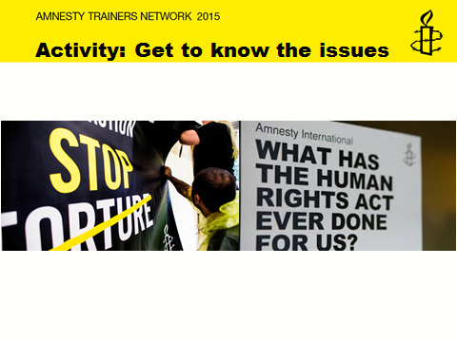
Slide 15: Activity 2: Get to know the issues
Objective: To outline the key General Election issues.
To pull out the key messages from each campaign issue.

Resources: Stop torture briefing, Human Rights Act briefing, Case Sheet – Human Rights Act, flip chart, marker pens.
Group size: 5-8
Length: 30 minutes
- Create two groups, one focussing on HRA and one on Stop Torture. Using the briefings and case sheet discuss each issue and pull out 5 key messages that need to be communicated when campaigning and lobbying on these issues... (10 minutes)
- Discuss how you might prioritise and present them for different types of Prospective Parliamentary Candidates. Discussions may include why is this issue important, why is it relevant now? Why it is relevant to the PPC, what issues might come up in response? (10 minutes)
- Ask each group to feedback on the 5 key messages, how they prioritised and how they would present this to their PPCs. (10 minutes)

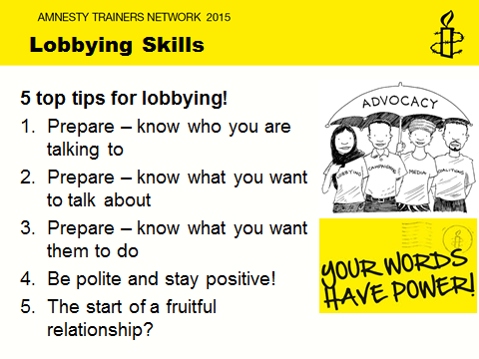

Slide 16: Lobbying Skills: 5 Top Tips
This slide goes through five top tips to lobbying put together by the Advocacy team at Amnesty. These are skills they use in their line of work and are tried and tested methods to successful and effective lobbying. Use examples to illustrate each point and also provide the sheet on 5 Top lobbying Tips.
You may include the following:
- These are five top tips to lobbying that are tried and tested methods used by Amnesty’s Advocacy team, which have proven to be effective.
So TIP 1: Prepare – know who you are talking to
If you can, find out:
- What is their role?
- What are they interested in?
- What activity have they been involved in recently (have they asked questions, taken part in debates, written articles in the media?)
- What angle is likely to appeal to them?
2. TIP 2: Prepare – know what you want to talk about
What are the top three messages you want them to take away? What interesting information that they wouldn’t already know can you give them?
- Prepare your top three messages in advance
- Practice saying them out loud
- Be succinct – you may only have 15-20 minutes in the meeting, get your messages across quickly and clearly
- Think about what the counter-arguments might be and be prepared to deal with them
- Don’t worry, you don’t have to know the answer to every question - you can always offer to get back to them.

3. TIP 3: Prepare – know what you want them to do
At least one of your key messages should be what you want them to do. Otherwise you could have an excellent meeting, successfully persuade them that your issue is important, but have no impact. You will only achieve something from the meeting if they go away and do something as a result. You can ask them what they can do to support you, but better still try and give them suggestions.
Think about what is in their power to deliver
Think about the positive consequences of them acting – for them and more generally e.g. “there are so many people in your constituency who support human rights – showing what you stand for will really appeal to them”, “If you write a supportive statement it could give you positive media coverage”
4. TIP 4: Be polite and stay positive!
It is natural to want to raise criticisms or strong recommendations in meetings; this is what advocacy is all about. But many people respond badly to criticism – they become defensive and are less likely to listen to the value of what you are suggesting. So if you can, always start and end the conversation on something positive.
Remember that sometimes politicians can be very frustrating - you may even fundamentally disagree with what they are saying. The best lobbyists always remain calm, polite and friendly.
Keep calm, smile and avoid being too argumentative or defensive. Press your point, think of different ways to get your message across, but remain polite at all times.
It’s a little known fact, but myth-busting…doesn’t work! ‘Myth-busting’ can boost the morale of those already onside but they struggle to persuade others. On polarised issues use positive language rather delivering facts and try to appeal to the person you are speaking to
5. TIP 5: The start of a fruitful relationship?
The follow up after the meeting is just as important. You need to keep the relationship with the contact going. After the meeting, write/contact them to:
Thank them and remember send a copy of your notes, including a record of action points (yours and theirs)
Follow up on any points you agreed to do.
NOTES:
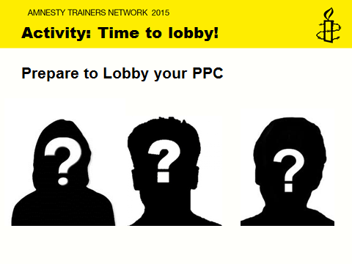
Slide 17: Activity 3: Time to Lobby
Objective: To learn how to effectively plan, prepare and deliver in a lobbying meeting
To be confident about setting up meetings with PPCs and discussing key issues.

Resources: PPC Bios, 5 Top Lobbying Tips Sheet, Stop torture briefing, Human Rights Act briefing, Case Sheet – Human Rights Act, pen and paper.
Group size: 3 group of 3+
Length: 45 minutes
- Create three groups, focusing on each PPC from the PPC Bios. Using the bios, top tips sheets, briefings and case sheet prepare for a 15 to 20 minute meeting with your PPC. Discuss what you will say, who will say it and what you need to do pre and post meeting. (20 minutes)
- Ask each group to read the PPC Bio and present their plan in five minutes. Ask audience to assume the role of the PPC during each presentation and encourage them to be ‘difficult’ or challenging in the middle of presentations. (15 minutes)
- Ask wider group to feedback to reflect on all presentations and challenges and opportunities that arose. (10 minutes)

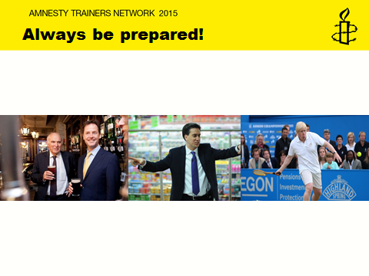
Slide 18: Always be prepared!
This slide illustrates the importance of being prepared to lobby PPCs on behalf of Amnesty regardless of whether groups have organised a formal meeting with PPCs.
You may include the following:
- It is important to always be prepared as you never know when you may bump into your PPCs or MPs, once elected.
- Whether you bump in to your PPCs at the local pub, as you can see with Nick Clegg and Vince Cable, on in the supermarket or at the local sports centre as is the case with Ed Miliband and Boris Johnson, it is always good know what you could say in a very short space of time.
- In addition, to being prepared, make sure the engagement was effective and walk away with something you can follow up with. Whether it a date in the diary for a meeting, or accepting an invite to an event you may be organising or event if it is just a selfie following on from a brief chat about the importance of the HRA, which can then be used on social media to highlight the points raised.
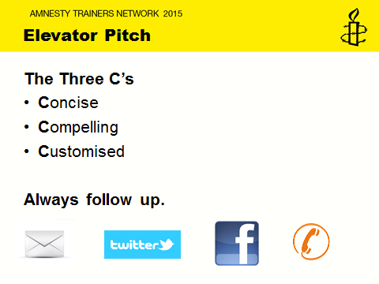
Slide 19: Elevator Pitch
This slide explains the following elevator pitch activity. It gives useful tips on how to deliver a good and effective pitch using the 3 “C’s” technique.
You may include the following:
- An elevator pitch is an extremely useful and effective method to help you prepare for those opportune moments when you bump into your PPC or MP.
- The three ‘C’s’ technique is a really useful method to prepare a good strong pitch.
- The first C is to be Concise or clear. You never know how long you will get with your PPC in these moments. So preparing a one to minute piece which uses as few words as possible which can be understood by your grandparents or your spouse etc. is a really good start. In addition, practicing your pitch until it sounds natural but not memorized or rehearsed.
- The second ‘C’ is to be Compelling. An effective elevator pitch explains the problem your solution solves. Tell a story or choose a relevant and compelling case that you can briefly cover in a very short period of time.
- Lastly, the third ‘C’ is to be Customised. Your pitch should explain why your audience should care about what you do. Think about what information might change depending on the audience. It is important to make you pitch feel personal and making it feel personal to the person you are pitching to.
- After you have delivered your pitch and reached your goal, make sure you follow through. If you requested a business card, then email the contact immediately to set up the meeting and bring up details you discussed so your contact can recall who you are and why it is worth learning more about your organisation. So remember, always follow.
NOTES:
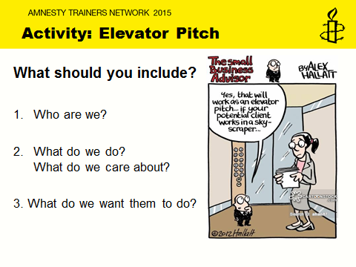
Slide 20: Activity 4: Elevator Pitch
Objective: To prepare a concise, compelling and customised campaign pitch to a PPC.
To be able to highlight key issues and prepare how to follow up on PPC engagements.

Resources: PPC Bios, 5 Top Lobbying Tips Sheet, Stop torture briefing, Human Rights Act briefing, Case Sheet – Human Rights Act, pen and paper.
Group size: 3 group of 3+
Length: 30 minutes
- Create three groups. Ask the groups to select a PPC at a place of their choosing. Write a short one minute pitch to deliver to this PPC using the skills and resources provided in this session. Remind them to be clear, compelling and customised. Advise them on what to include such as who they are, what they do, what and why they care about this issue and what they want from their PPC. (10 minutes)
- Ask each group to nominate someone to deliver the pitch. Presenters must say who they selected to pitch and where. They will then have one minute to deliver their pitch. The audience should place the role of the PPC. As the trainer you must cut them off at the one minute mark. (5 to 10 minutes)
- Ask wider group to feedback to reflect on all presentations and challenges and opportunities that arose. (10 to 15 minutes)

NOTES:

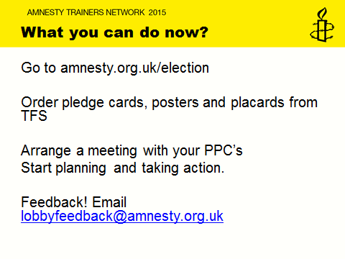
Slide 21: What you can do now?
This slide summarises what groups can now go on to do and encourages them to engage in activities using resources. You can encourage groups to order resources by contacting TFS on 01788 545553 and quote the below codes.
· Pledge cards - GE001
· Posters - GE002
· Placards - GE003
You may include the following:
- Now that you have completed the training it is important that your group now goes out there and starts planning and delivering activities. The elections are very close but there is plenty that you can now go on and do.
- Visit amnesty.org.uk/election and download the Campaign Action Bulletin as well as take the online action.
You can order the campaign material from TFS on 01788 545553 and quote the below codes.
· Pledge cards - GE001
· Posters - GE002
· Placards - GE003
- And you can of course start meeting all your PPC’s but remember to email your feedback or enquiries on activities you have run or would like to run to lobbyfeedback@amnesty.org.uk
- Thank you and best of luck.

